**THE BAT HAT**

**By: Adithya Kumar**

**Eighth Grade**

**Data & Results**

**Data**

I wanted to test my device against the obstacles which a visually impaired person would encounter every day. So I tested my device against obstacles made out of different materials and of different sizes.

The following chart describes the **Responding Distance** (distance at which the Ultrasound Sensor was able to detect the obstacle) at which my device first started detecting the obstacle made of various types of materials and sizes.

|  |  |
| --- | --- |
| **Obstacle/Material** | **Responding Distance**  **(in Inches)** |
| **Window** | **45.5** |
| **Wall** | **46** |
| **Wood** | **39.5** |
| **Tile** | **41** |
| **Metal** | **42.5** |
| **Glass** | **41** |
| **Paper** | **42** |
| **Piano** | **40.5** |
| **Carpet** | **40** |
| **Mirror** | **41** |
| **Granite** | **41** |
| **Plastic** | **42.5** |
| **Rubber** | **40.5** |
| **Felt** | **39.5** |
| **Silk** | **40.25** |

The chart below shows the responding distance for each material.

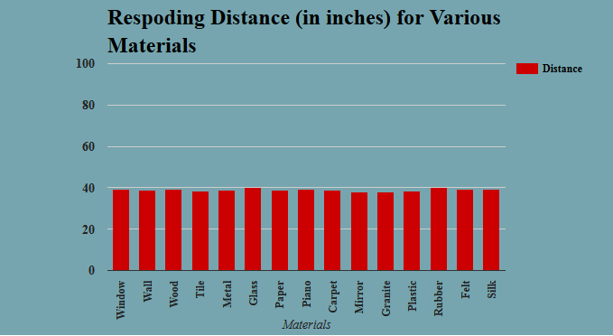

The chart below shows the responding distance with respect to the width of the obstacle.

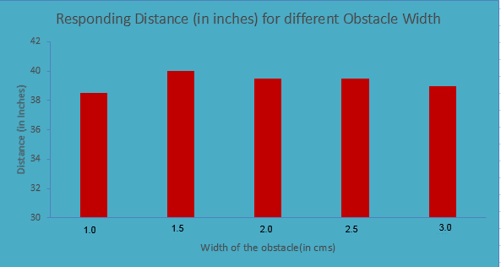

**Results**

From the data I collected, it clearly shows that responding distance are not affected by the type or size of the obstacle. It also proved that my device can be used by the visually impaired people to detect any obstacle they might encounter in daily life.