Wireless Motorcycle Helmet Mounted Display (HMD)
06 September 2010:
As with all sport bikes, the visibility out of the mirrors is poor. Some have attempted to combat this by installing rear view cameras and mounting a display on the front fork between the handle bars. The problem I see with this has several layers. First, sunlight. In order to get a sunlight viewable display that would work in all conditions, it would cost around $700. Next, it’d be easy for nefarious individuals to walk by and steal a very expensive piece of hardware. It would also be far too bright, even with the brightness turned down, to be effective during the evening thereby ruining nightvision and being a distraction. Also, you would have to look down below the speedo and tach to see it, which can take traffic ahead out of your peripheral vision. I thought about a HMD and did a little research with companies that provide them for military and civilian applications. To see why this wasn’t feasible, here’s an example: a company called Liteye quoted me on their entry level commercial system at $2000. This led me to those video glasses to give people private viewing of their movies/youtube channels/porn/whatever.
I got a Myvu Crystal off of Amazon. For a quick product review, the picture quality is very good, adjustable brightness which is necessary for this project (light vs. dark ambient light), and you can move them a couple inches from your face and still see the whole image (also important). The downside is that the RCA connection between the DirecTV and the glasses was kinda crappy, so that’s going to be soldered together later. Field of view is very important for safety, so I took apart the Crystal’s in order to get just one of the displays out to use as a monacle. My reasoning to do this is two-fold. First, the HMD will be mounted on the right since speedo is on the left side of my Kawasaki. Next, during nighttime riding, the LCD will only ruin one eye’s night vision. So, here’s what I’ve been up to:
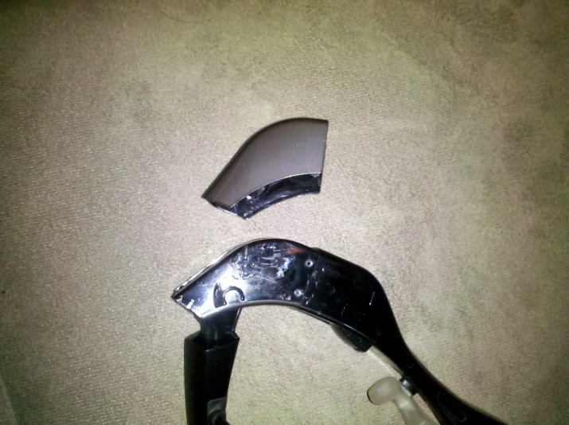
Disassembly was easy. No screws, just glue. Take a very small flat head and wedge apart the seams. There are some videos showing this being done on youtube
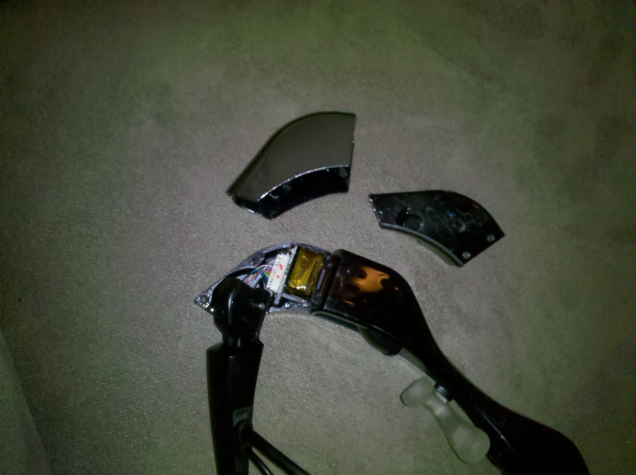
More wedging. The gold wrap holds the display; the circuit board has the backlight. Be careful.
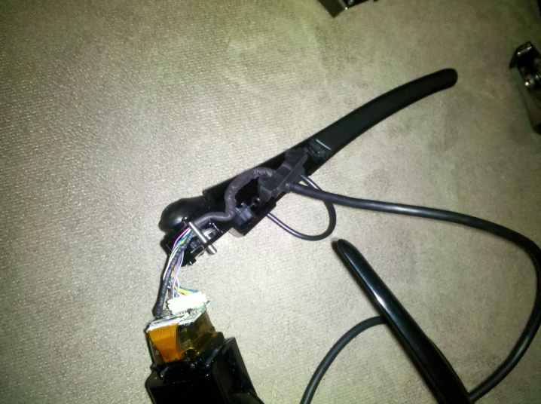
Seam on the glasses, more wedging. I cut off the headphones, because I don’t need them.
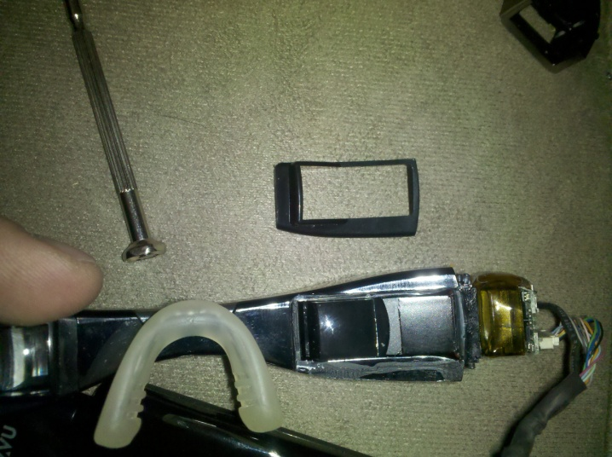
There’s a piece glued in holding the optics that can be wedged apart.
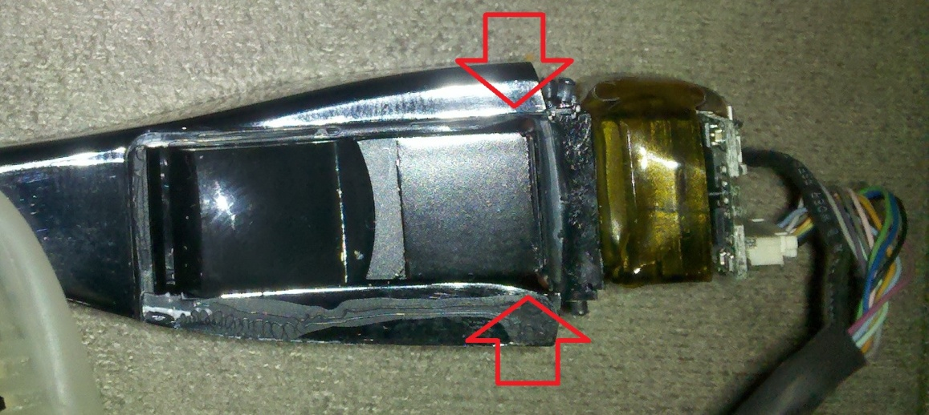
I took the flat head and wedged it in the gap, shown by the arrows, and tried to pry the optics out. Alternated back and forth, it eventually came out. The optics will separate from the LCD, but it’s not a big deal (you can tape them back together)
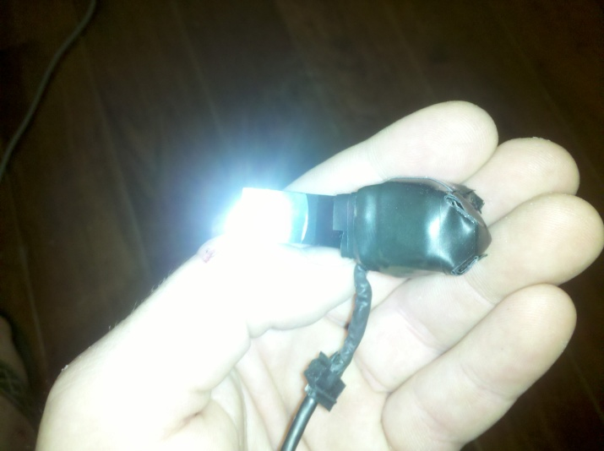
Used a copious amount of electrical tape to stick everything together. Hot glue would probably be neater and thinner, but I just moved and all my crap is in storage (yea yea, excuses). The good thing is, they still work after I voided the warrantee. Roughly disassembled the other side and they still work, so don’t be too timid or they’ll never come apart.
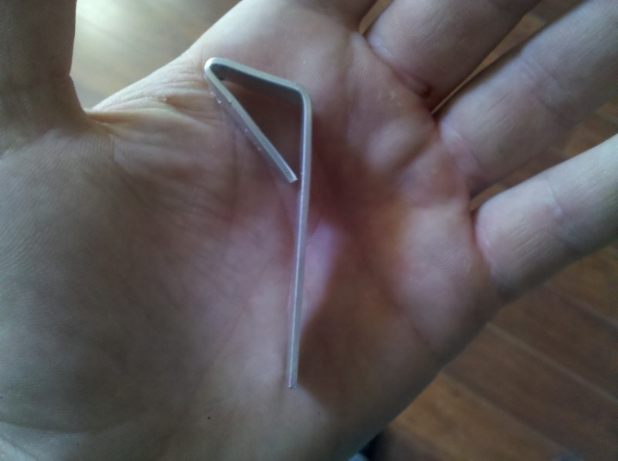
Went to Lowe’s to try and find a suitable bracket to use inside the front of my helmet. I about gave up when I was walking by the scrap metal bin and saw 1/16” by 1/2" aluminum. Pliable (want it to be adjustable when everything’s all mounted) and able to be cut by tin snips. The right side will go against my helmet, the HMD will mount to the top. Test fitting everything, I think I need to make the top longer. Good thing it comes in 6ft strips and each wasted attempt is 5” (not that there’s anything wrong with that).
Now I’m waiting for the camera to come in the mail. I got a Pyle – PLCMB20. Kept doing research on cameras, this one kept coming up. It’s cheap ($34 on Amazon), has a 170deg viewing angle (we’ll see how accurate that is), adjustable mount, compatible with the glasses, 12VDC power required (built as a rear view camera), and a quoted night time infrared viewing distance of 9m/30ft with a min illumination of 0.5 lux. The night time viewing distance would be its weakness. Personally, I’d like a freakin IR spot light shining back there, but I’m attempting to be a minimalist on this build. I’m guessing (read: hoping) that any cars with hot/bright headlights more than 30ft away would at least show up as points of light on the HMD.

8 September 2010
The camera came in the mail today. It works under very low light situations and I’m pleased with the image quality inside the HMD. My EasyCap is also in storage, so no captured images yet. I am disappointed that the quoted 170deg field of view isn’t actually that much (from waving my hand in front of it). Testing to come on what, exactly, it comes out to be, but my guess would be about 100deg. The camera runs off of 12VDC, which means it should be very easy to tap into the bike’s electrics. However, I don’t want to go straight from the battery or else it’ll drain eventually and brick it. So I have to get the power that’s switched on when the key is turned, somewhere near the instrument panel. A bit hesitant about slicing up the electrics, so I’ll do a little more research to see if I can find a wiring diagram so I don’t have to go in and guess and check. More to come.
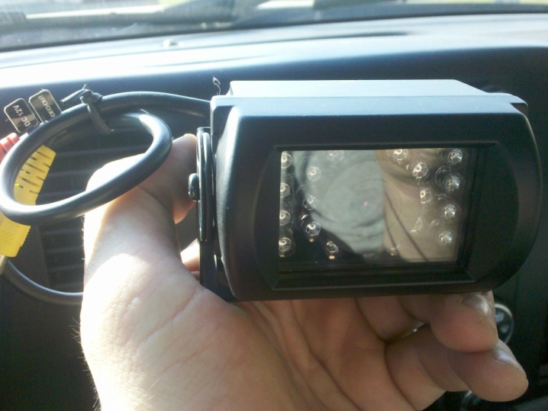

9 September 2010
The goal for today was to get the system completely up and running in a wired configuration. Spent a lot of time during work trying to find a wiring diagram for my 2007 ZZR600 without having to buy the service manual. I found this (don’t ask me where, I lost the link):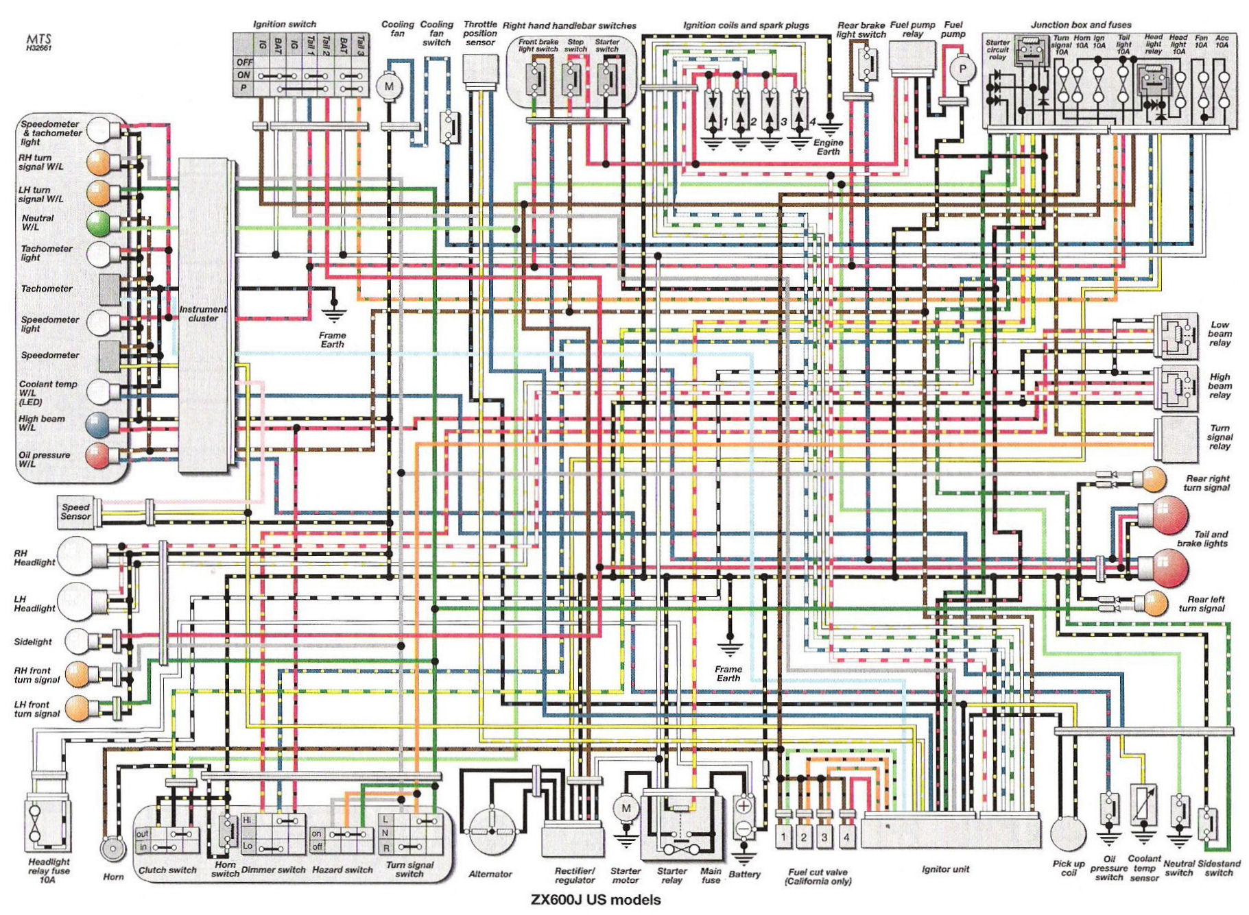Being an electrical engineer, I found this almost completely meaningless in trying to find a source of 12VDC power that was only active when the key is turned. So I did a bit of exploratory surgery on the electrical connector on the back of the instrument panel:
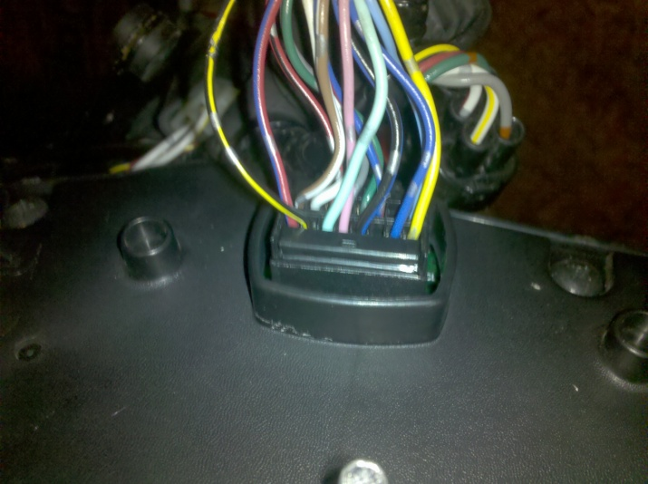
Did a bit of tracing on that wiring diagram to try and make sense of it all. Most of the lights had the red wire with a blue stripe and the black wire with the yellow stripe going into them (left side of the picture), which made me think they were a good place to start with the multimeter. Surprise on the first try:
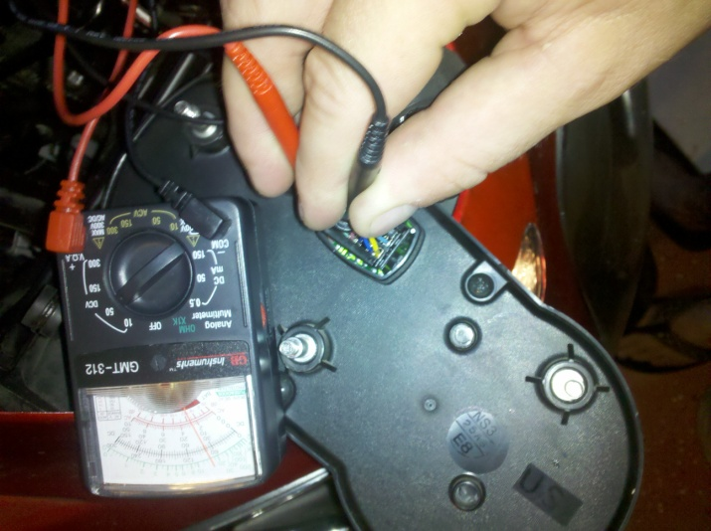
Hard to see, but 12VDC with the key turned (you can see the fog light on underneath) and:
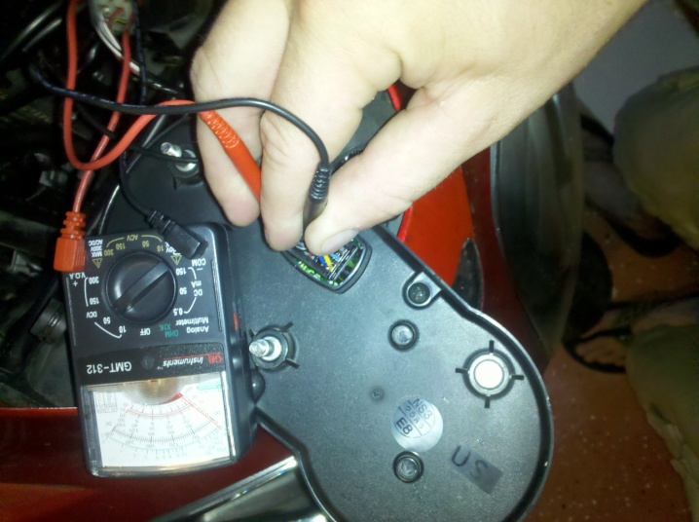
Key turned off, 0VDC. Success!
At this point, I got my old soldering iron warming up and it refused to get warm (made a buzzing noise and generated a lot of heat, but I could touch the soldering tip). So, put everything back together, measured out how much extra wire I’d need to pick up to run everything from the storage compartment over the rear wheel.
Not wanting to stop tonight, I moved on to installing the camera on the rear fender. There was a small reflector mounted above my license plate which already had a couple holes into the storage compartment under the passenger seat. Removed this and discovered that it had 2 holes spaced exactly where I needed them. Widened out the middle to fit the RCA and power connector thru and drilled another matching hole to the one on the right side. Throw on some 6mm bolts with 10mm heads/nuts and tighten it all down (yes, it’s a little crooked in the picture, that has been fixed).
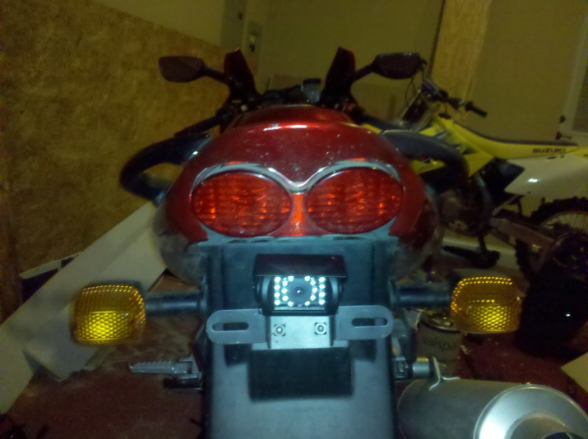
Pardon the mess, also involved in building a home theater upstairs (138” diagonal 2.35 screen, giggity)
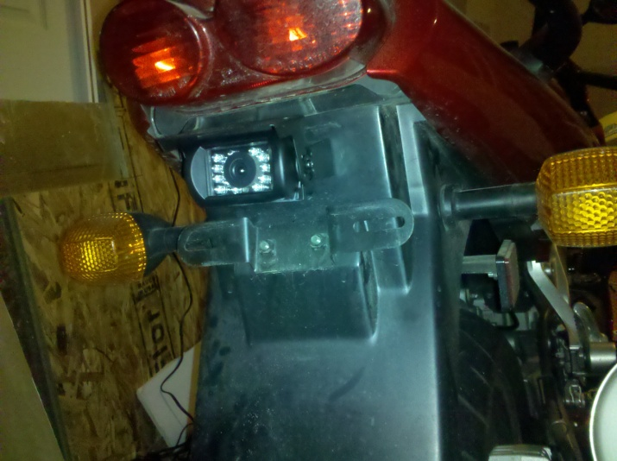
Tomorrow will involve buying the wire, some rubber washers to try and dampen a little vibration, and a soldering iron to tap into the electrics. Then, if all goes well, I’ll have the bike side done, cut/bend a new mount for the helmet, glue everything together, and go for a ride!

10 September 2010
Used the soldering iron to burn off the insulation covering the +12VDC and GND wires highlighted yesterday. Soldered everything together, did an initial power on check, and had success! Hooked up the HMD and everything was running off of the bike’s electrics. Then I slapped just enough panels back on to take it for a quick ride in order to exercise everything (turn signals, brakes, high/low beams, gears) in a real environment. The HMD was not mounted to my helmet yet so I couldn’t check it out. Brought the bike back in and everything seemed to be working properly. Gave it a quick ops check while idling in the garage and noticed that the taillight wasn’t working. Then saw that some of the instrument panel lights were out. Consulted the wiring diagram and it was the red wire with the blue stripe (+12VDC) causing the problems, which makes sense. Traced it to the “Tail light” fuse (10A) and sure enough, it was blown. Ran to the auto store and grabbed some 15A fuses and put one in. Cranked the bike quick, did a quick check and everything was good, then shut it off. Now I’m hoping the wire can take a 50% higher current load without shorting thru the insulation, or something bad. The wiring job looks sloppy running along the frame to the back of the bike. Found a better place to tap into those two wires which will clean up nice, but this’ll do for the time being. Onto the helmet.
Built the new bracket. Fit it in the right spot. Glued it to the helmet. That’s about all there is to say about that. I started cutting off the left eye display from the Myvu assembly and the right began flickering. Cut all the way thru, and the right display whited out. Restarted it, works fine. Damm EE magic. Here’s a couple pictures to show you what I’m talking about.
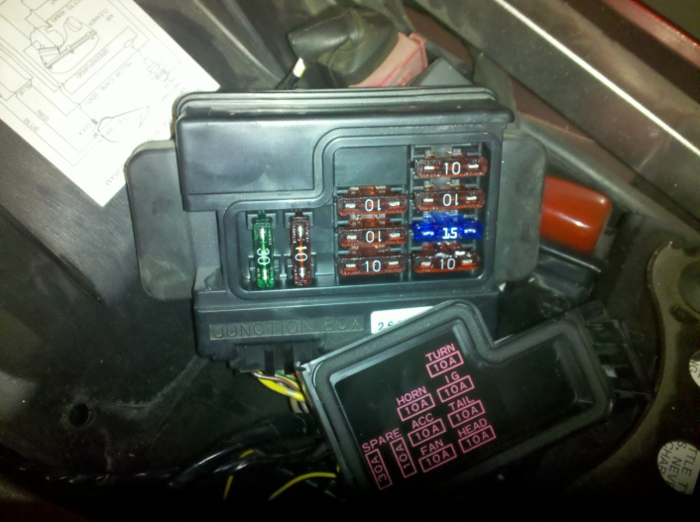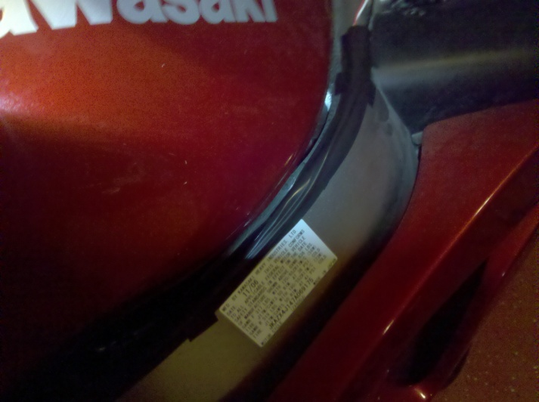

11 September 2010
Woke up this morning and reinstalled the electrics and put the bike back together. Here’s some pictures:
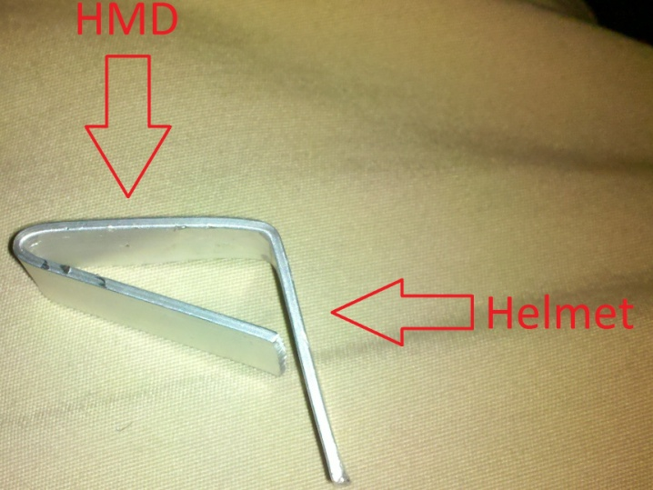
Here’s the new clip. It’s about 1 ¼” where the HMD goes. Placement will become clearer in the next pic:
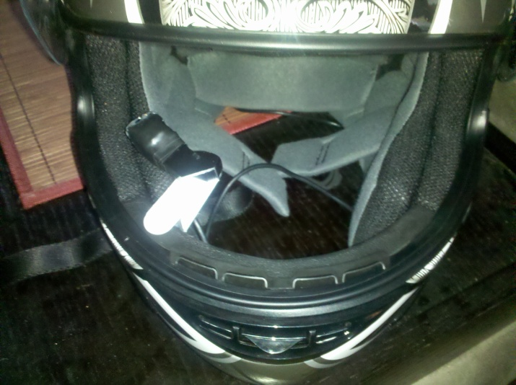
Ok, maybe not. Too lazy to get a better pic. Basically, mount it to your preference.
Grabbed my riding gear and put my helmet on for a test drive. Ran great (no burnt fuses) and I was impressed with the HMD. However, there’s several improvements that need to be made. The first problem was something I could fix easily. As you know, when you have an LCD screen out in the direct sunlight, it gets washed out by the sun. Instead of this happening, the sunlight is constricting my pupils and making it difficult to see the darker LCD screen. Solution is either to boost the backlight (complicated and tiny wires) or block out the sun. Being lazy, I went to buy a darker face shield.
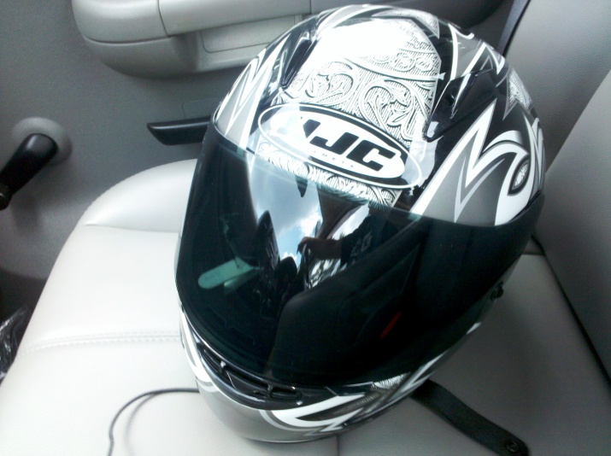
Used that 3M stuff to mount hooks on a wall to attach the HMD to the mount. It’s temporary and I can move it around.
Took it out for another quick ride around the neighborhood, and all is well. The next couple problems are related to the optics. First, the field of view to see the whole LCD screen is very narrow and the optics are pretty close to my face. This also makes it so my head has to be in just the right spot in order to get the right sight picture. Using a bigger lens would give my head some play and I could move the HMD closer to the shield (i.e. away from my face). I wouldn’t advocate a larger screen since the one on the Myvu looks roughly the same size as the rearview mirrors. And on the subject of optics and rearview mirrors, the method of mounting places the tiny LCD driver right in the viewing path to the right side rear view mirror. Switching the optics from horizontal to vertical would place just the lens in the way.

