Title
Automatic Assistive Feeder Device

Field of Invention
The invention relates to an automatic assistive device for physically disabled to help them assist in having their meal on their own. More particularly, the invention relates to an automatic assistive feeder which works on haptic feedback from the physically disabled individual.

Background of Invention

According 2001 census statistics, approximately 21 million people in India suffer from different locomotion disorders and face difficulties in performing their day to day activities. The physically disabled people need constant attention from caregivers while performing the daily activities like eating, drinking, walking etc. The physically disabled people are dependent on the caregivers for all these daily activities. The assistive technologies help them in minimizing the dependency on others by letting them perform some of the activities on their own.

Various attempts have been made to provide a feeder device which will assist or help the physically disabled individuals to have their meal independently and these devices are bulky and hence needs to be affixed at a single position and cannot be carried from point to point where the patient/ physically disabled or the end user is located.

US3907126 discloses a feeder apparatus for physically handicapped persons which mainly comprises of a table for supporting the food, a food receptor in which the food to be consumed is received which is movable towards and away from the aperture through which the food is served, an electric motor operated spoon to convey the food from food receptor to a position where the food will be consumed, a touch operated switch for operating the all the electric motor operated components. The apparatus is bulky and complex in terms of operating and usability point of view. The arrangement of the overall apparatus consumes a lot of space and is not portable.

US5282711discloses an assistive dining device, system and method for automatic self operated self feeding having a predetermined depth below an upwardly projecting lip, a rod having an end rotatable about an axis, substantially parallel to and above the upward projecting food receptacle lip, a feeding utensil being the spoon having a rotatory and linear movement and angularly disposed such that the food collection face is horizontally downwards and comprises of a motor operatively associated with rod and utensil and a switch to automatically operate the said dining device and system.

The present invention offers an affordable and convenient device which will reduce dependency and boost self-esteem of the physically disabled by providing a device which automates the entire process of feeding. It’s an automatic assistive feeder which can make someone have a meal.

Objects of the Invention

The primary object of the invention is to provide a portable and automatic assistive feeder for physically disabled people including children, elderly persons

Another object of the invention is to provide an automatic assistive feeder with height adjustment mechanism

Yet another object of the invention is to provide a vertical as well as horizontal height adjustment mechanism.

Still another object of the present invention is to provide an automatic assistive feeder with battery power source

Yet another object of the present invention is to provide an automatic assistive feeder with haptic feedback button for giving the commands to the said feeder

Another object of the present invention is to provide a haptic feedback system depending upon the disability which could be in the form of a pressure sensor or capacitive touch

Yet another object of the present invention is to provide an automatic assistive feeder with a motorized spoon, which can be changed as per the type of food (Solid or Semisolid)

Add..

Summary of the Invention

The present invention discloses an automatic assistive feeder device with the haptic feedback system and a height adjustment mechanism. Wherein the height adjustment is performed in a vertical direction and distance adjustment is performed in horizontal direction with the help of a cross scissor lift and sliding mechanism respectively.
Said automatic assistive feeder is powered with a battery and is attached with a motorized spoon which replicates the scooping action of the spoon. The feeder device is divided into three levels viz. level 1, level 2 and level 3.

Level 1 consists of base and gives the support to the device and further consists of a switch mode power supply, battery level indicator and handle to hold the device while moving it from one place to another.
Level 2 consists of height adjustment mechanism in vertical direction using cross scissor mechanism and horizontal movement with the help of linear bearing/ sliding mechanism or rails etc.
Level 3 is the topmost part of the device and is pointed U shaped so as to accommodate the solid and semisolid food material to be fed and the pointed U shape of the bowl help the food falling from the spoon directly to the bottom of the bowl. This level also consists of main central processing unit of the automatic assistive feeder device.

The level 3 also has the main central processing unit further comprising of:
- MCU to store and run the code and to perform all the functions
- Motor Driver to drive the motors wired with MCU and power supply to run the motors at specific angles
- Battery Management for recharging and draining battery. It will also convert voltage from low to high level
- Battery indicator to check the battery level

- Wireless receiver for haptic feedback to repeat the loop of scooping food once the user gives a haptic feedback
- Heat Sink
- Protection Circuit

The device as disclosed is motorized device and has servo motors attached to perform bowl rotation, spoon movement, scooping movement.

Brief Description of the drawings

Figure 1 shows an isometric view of the automatic assistive feeder device
Figure 2 is the front view of level 1 (15) and the base (1) of the automatic assistive feeder
Figure 3 is the isometric view showing the level 1 (15) and the upper rim of the base (2)
Figure 4 is the isometric view of the level 2 (16) showing the channels for distance adjustment (4) and rotation adjustment (3)
Figure 5 is the top view of the device showing motor 3 (5) for rotating the bowl after regular time intervals and a bowl (6) which contains the food material to be consumed by the user.
Figure 6 is side view of showing the pointed U shaped bowl (6)
Figure 7 is the isometric view of the device showing Motor for guiding the spoon to scoop the food (7), Motor for spoon movement (8) and Spoon (9)
Figure 8 shows the customized spoon (9) used to scoop the food out of the bowl (6)
Figure 9 shows the haptic feedback button (10)
Figure 10 explains the battery pack (11) meant for charging the automatic assistive feeder device
Figure 11 is the side view of the level 1 (16) showing the arrangement of the level (16) comprising of the rotation adjustment (3) and battery pack (11)
Figure 12 is the side view of the cross scissor lift (12) for the height adjustment
Figure 13 is the side view of the connection of between the cross scissor lift (12) and the level (15) and level 2 (16)
Following Table No. 1 describes the legends used in the drawings and their description

Legend No. | Legend Description
1 | Base
2 | Upper rim of the base
3 | Rotation Adjustment
4 | Channels for distance adjustment
5 | Motor for rotating the bowl
6 | Bowl
7 | Motor for guiding the spoon to scoop the food
8 | Motor forspoon movement
9 | Spoon
10 | Haptic Feedback Button
11 | Battery Pack
12 | Cross scissor lift
13 | Electronic housing
14 | Camera
15 | Level 1
16 | Level 2
17 | Level 3
18 | Assistive feeder device
19 | 220-230 V plug

Detailed description of the drawings

Working of the invention
The present invention provides an automatic assistive feeder device for the physically disabled people to help them have their meals independently.
The automatic assistive feeder device comprises of three levels namely Level 1 (15), Level 2 (16) and Level 3 (17).
One of the embodiments of the present invention comprises a camera (14) affixed on level 1 assists in avoiding spoon clashing with teeth by detecting the face depth and detects lip movement and automates height adjustment.
One of the embodiments of the automatic assistive feeder comprises of cross scissor lift mechanism which helps in achieving the height adjustment as per the user’s seating height. The camera (14) detects the face of the user and signals the cross scissor lift (12) for height adjustment and comprises of two parallel bars pivoted on each other at the center for height adjustment. The bars expand vertically to raise and achieve the required height till it attains the level parallel to the user’s mouth. The extension of the lift is achieved by applying the pressure on either of the bars of the cross scissor lift (12). The camera (14) after reaching to the required height analyses face depth and signals the level 3 (17) to move horizontally parallel to the base (1) or Level 1 (15) and horizontally perpendicular to the user’s mouth with the help of channels for distance adjustment (4).
In one of the embodiments of the present invention, the physically disabled person sends a feedback from the haptic feedback button (10) which is a wireless or wired device. The feedback is received from the said feedback button (10) and Motor 1 (7) and Motor 2 (8) attached to the side of the bowl (6) are signaled to activate. Motor 1 (7) for guiding the spoon (9) to scoop the food and Motor 2 (8) for spoon movement, where Motor 1 (7) bolsters Motor 2 (8) and the Motor 1(7) scoops the food out of the bowl (6), wherein the scooping action is achieved by fixing the customized spoon (9) at an calibrated angle on the Motor 1 (7).
The Motor 3 (5) attached to the base of the bowl (6) rotates the bowl (6) in 180⁰after regular intervals of time to concentrate the food in the center so as to make it accessible.
Advantages

Dated this 13thday of October 2015
Drawings:
Application No.: | Total No. of sheets:
Name of Applicant: | No. of this sheet :
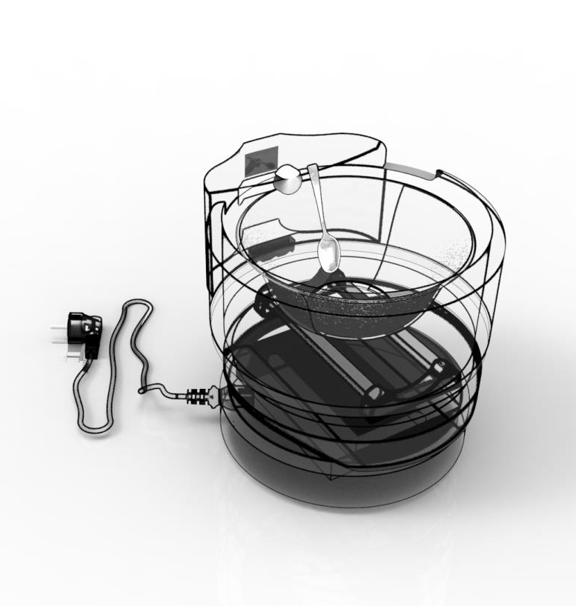
17
16
15
19
18
4
6
9
1

Fig. 1

Application No.: | Total No. of sheets:2
Name of Applicant: | No. of this sheet : 2
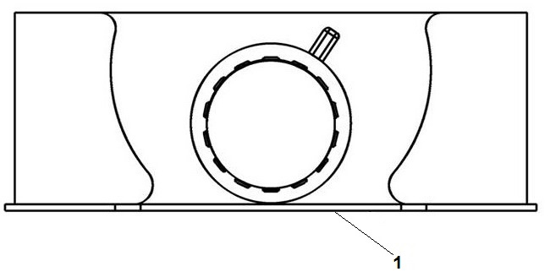
Figure 2
Application No.: | Total No. of sheets:2
Name of Applicant: | No. of this sheet : 2
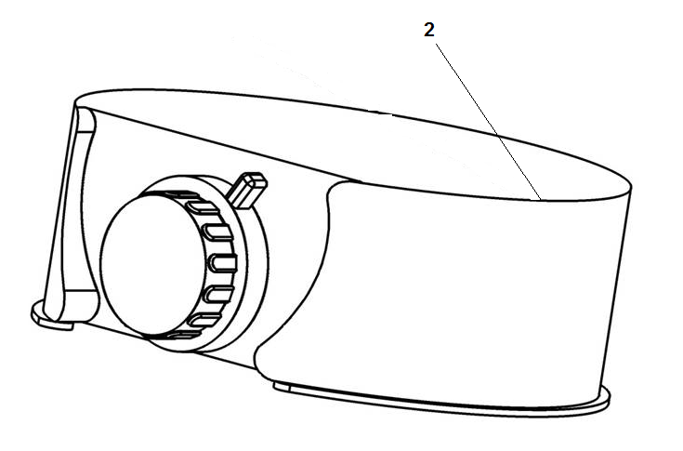

Figure 3

Application No.: | Total No. of sheets:2
Name of Applicant: | No. of this sheet : 2
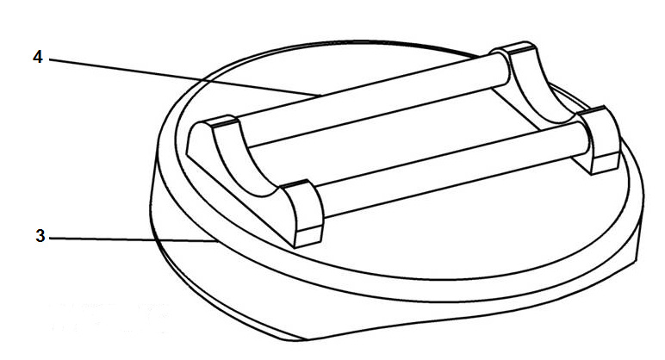

Figure 4

Application No.: | Total No. of sheets:2
Name of Applicant: | No. of this sheet : 2
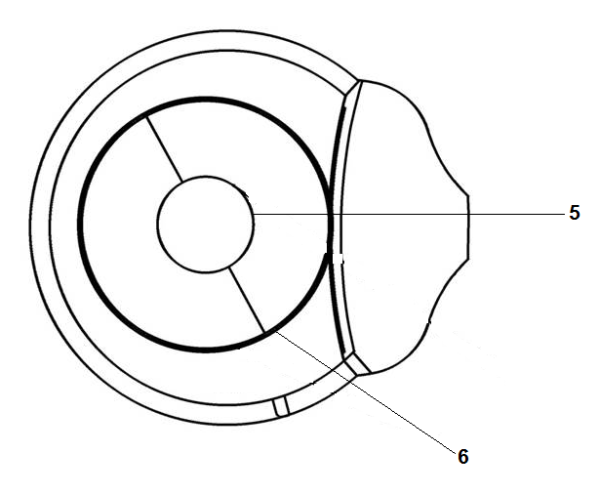

Figure 5

Application No.: | Total No. of sheets:2
Name of Applicant: | No. of this sheet : 2
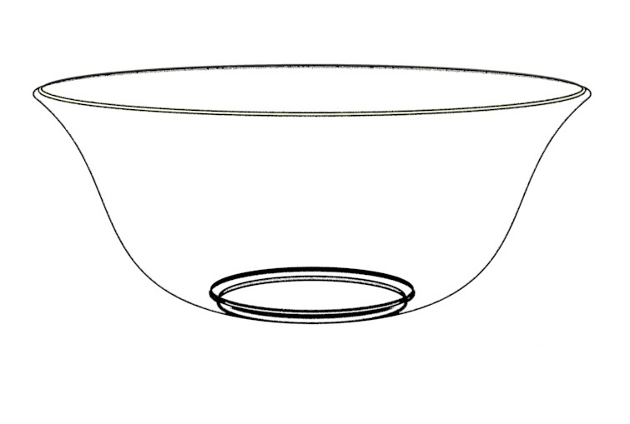
6

Figure 6

Application No.: | Total No. of sheets:2
Name of Applicant: | No. of this sheet : 2
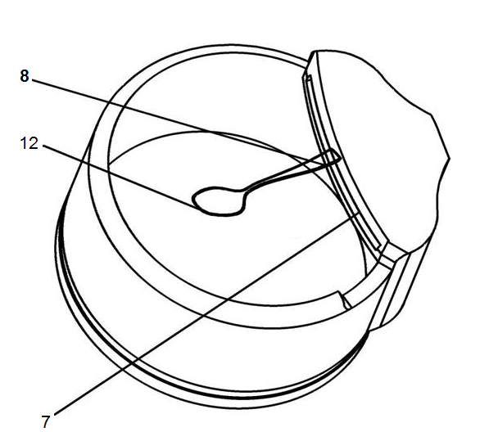
9

Figure 7

Application No.: | Total No. of sheets:2
Name of Applicant: | No. of this sheet : 2
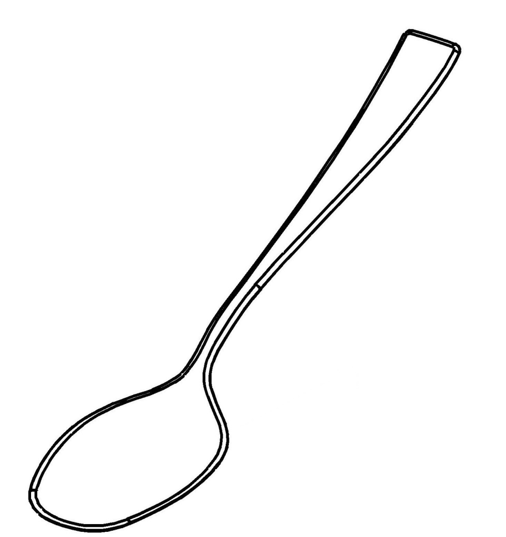
9

Figure 8

Application No.: | Total No. of sheets:2
Name of Applicant: | No. of this sheet : 2
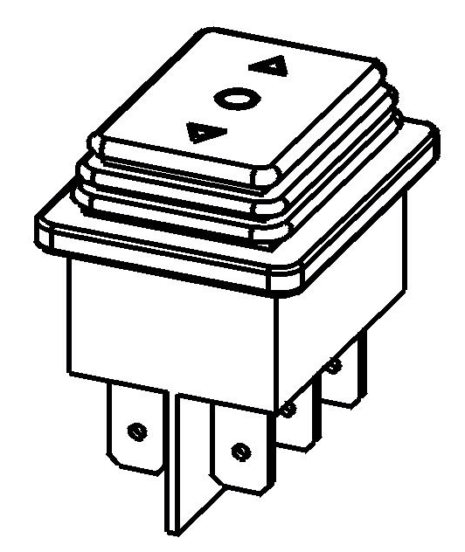
10

Figure 9

Application No.: | Total No. of sheets:2
Name of Applicant: | No. of this sheet : 2
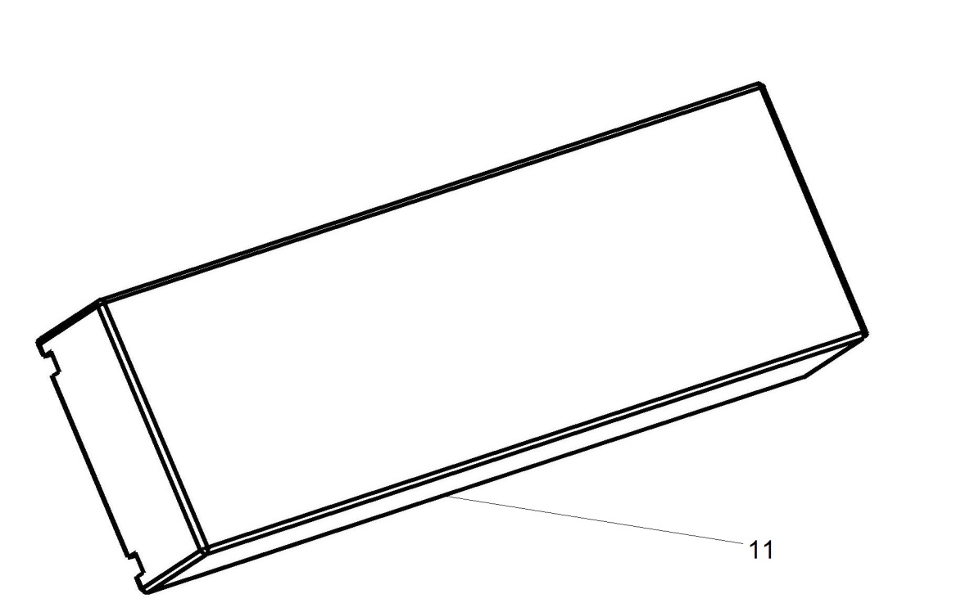

Figure 10

Application No.: | Total No. of sheets:2
Name of Applicant: | No. of this sheet : 2
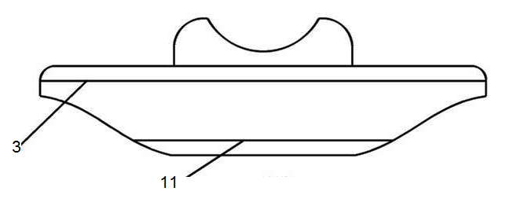

Figure 11

Application No.: | Total No. of sheets:2
Name of Applicant: | No. of this sheet : 2
12

Figure 12

Application No.: | Total No. of sheets:2
Name of Applicant: | No. of this sheet : 2
16

15

Figure 13

Abstract

