DEVELOPMENT BOARD FOR STM8S003F3
By Nitin Chand M S(2018H1400171P),Rohith Krishnan P(2018H1400180P)

DESCRIPTION
This project aims to build a development board for STM8S003F3P6 (20 pin SMD) microcontroller. STM8 microcontrollers are 8-bit general purpose microcontrollers from STMicroelectronics (STM). They are robust, has a lot of features and are highly economical when it comes to price. STM8 MCUs are one of the most unexplored yet efficient microcontrollers and this project aims to provide a platform for enthusiasts to learn and appreciate them.

The development board features STM8S003F3P6 microcontroller (with 8-Kbyte flash memory, 1-Kbyte RAM, 128-byte EEPROM), external crystal for clocking, type B mini USB port, a USB to UART converter, voltage regulator, LED, switch , buzzer, potentiometer for ADC input and general purpose IO ports for user applications.

DETAILS
The STM8S003F3 microcontroller development board is designed primarily for general purpose applications. The microcontroller features 16 GPIO pins all of which can be accessed easily by the user through the male header pins provided along the sides of the board. Separate header pins are provided for programming the board through ST-Link programmer as well as for switching the operating voltage between 5V and 3.3V. The board can be powered up through USB cable as well as through the ST-Link programmer. The on-board 3.3V voltage regulator has a current capacity of 800mA and can power up the board as well as interfaced external peripherals. The Type-B mini USB port along with USB to Serial chip (CH340G) provides communication with PC.
Features of the development board:
- STM8S003F3P6 microcontroller.
- On-board 16MHz crystal oscillator
- A Buzzer interface
- One switch
- One reset button
- One user LED
- A 10kohm potentiometer for ADC interface
- USB Type-B mini port for powering up as well as for data transfer
- On-board 3.3V voltage regulator - LM1117
- On-board USB to serial chip CH340G for communication via UART
- A 4 pin SWIM port for programming via ST-LINK programmer
- On-board power selector pins for switching the operating voltage between 5V/3.3V
- On-board power indicator LED
- All port pins available through male header strips
- Highly compact with dimensions of 4.53 cm x 7.6 cm
BLOCK DIAGRAM: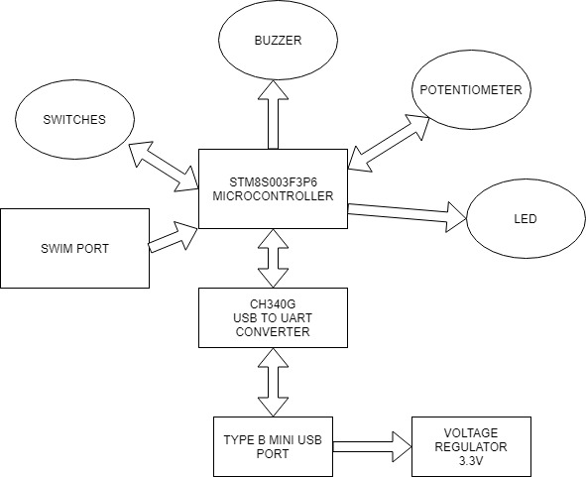
Fig.1
SOFTWARES USED:
- Eagle PCB Design software
- Gerbview software
- IAR Embedded Workbench
IMPLEMENTATION:
- Schematic and layout designing
Schematic and layout designing is done on the Eagle PCB design software. The design is made taken into consideration of the different requirements of the ICs used in the board. The schematic and the layout files are given below.
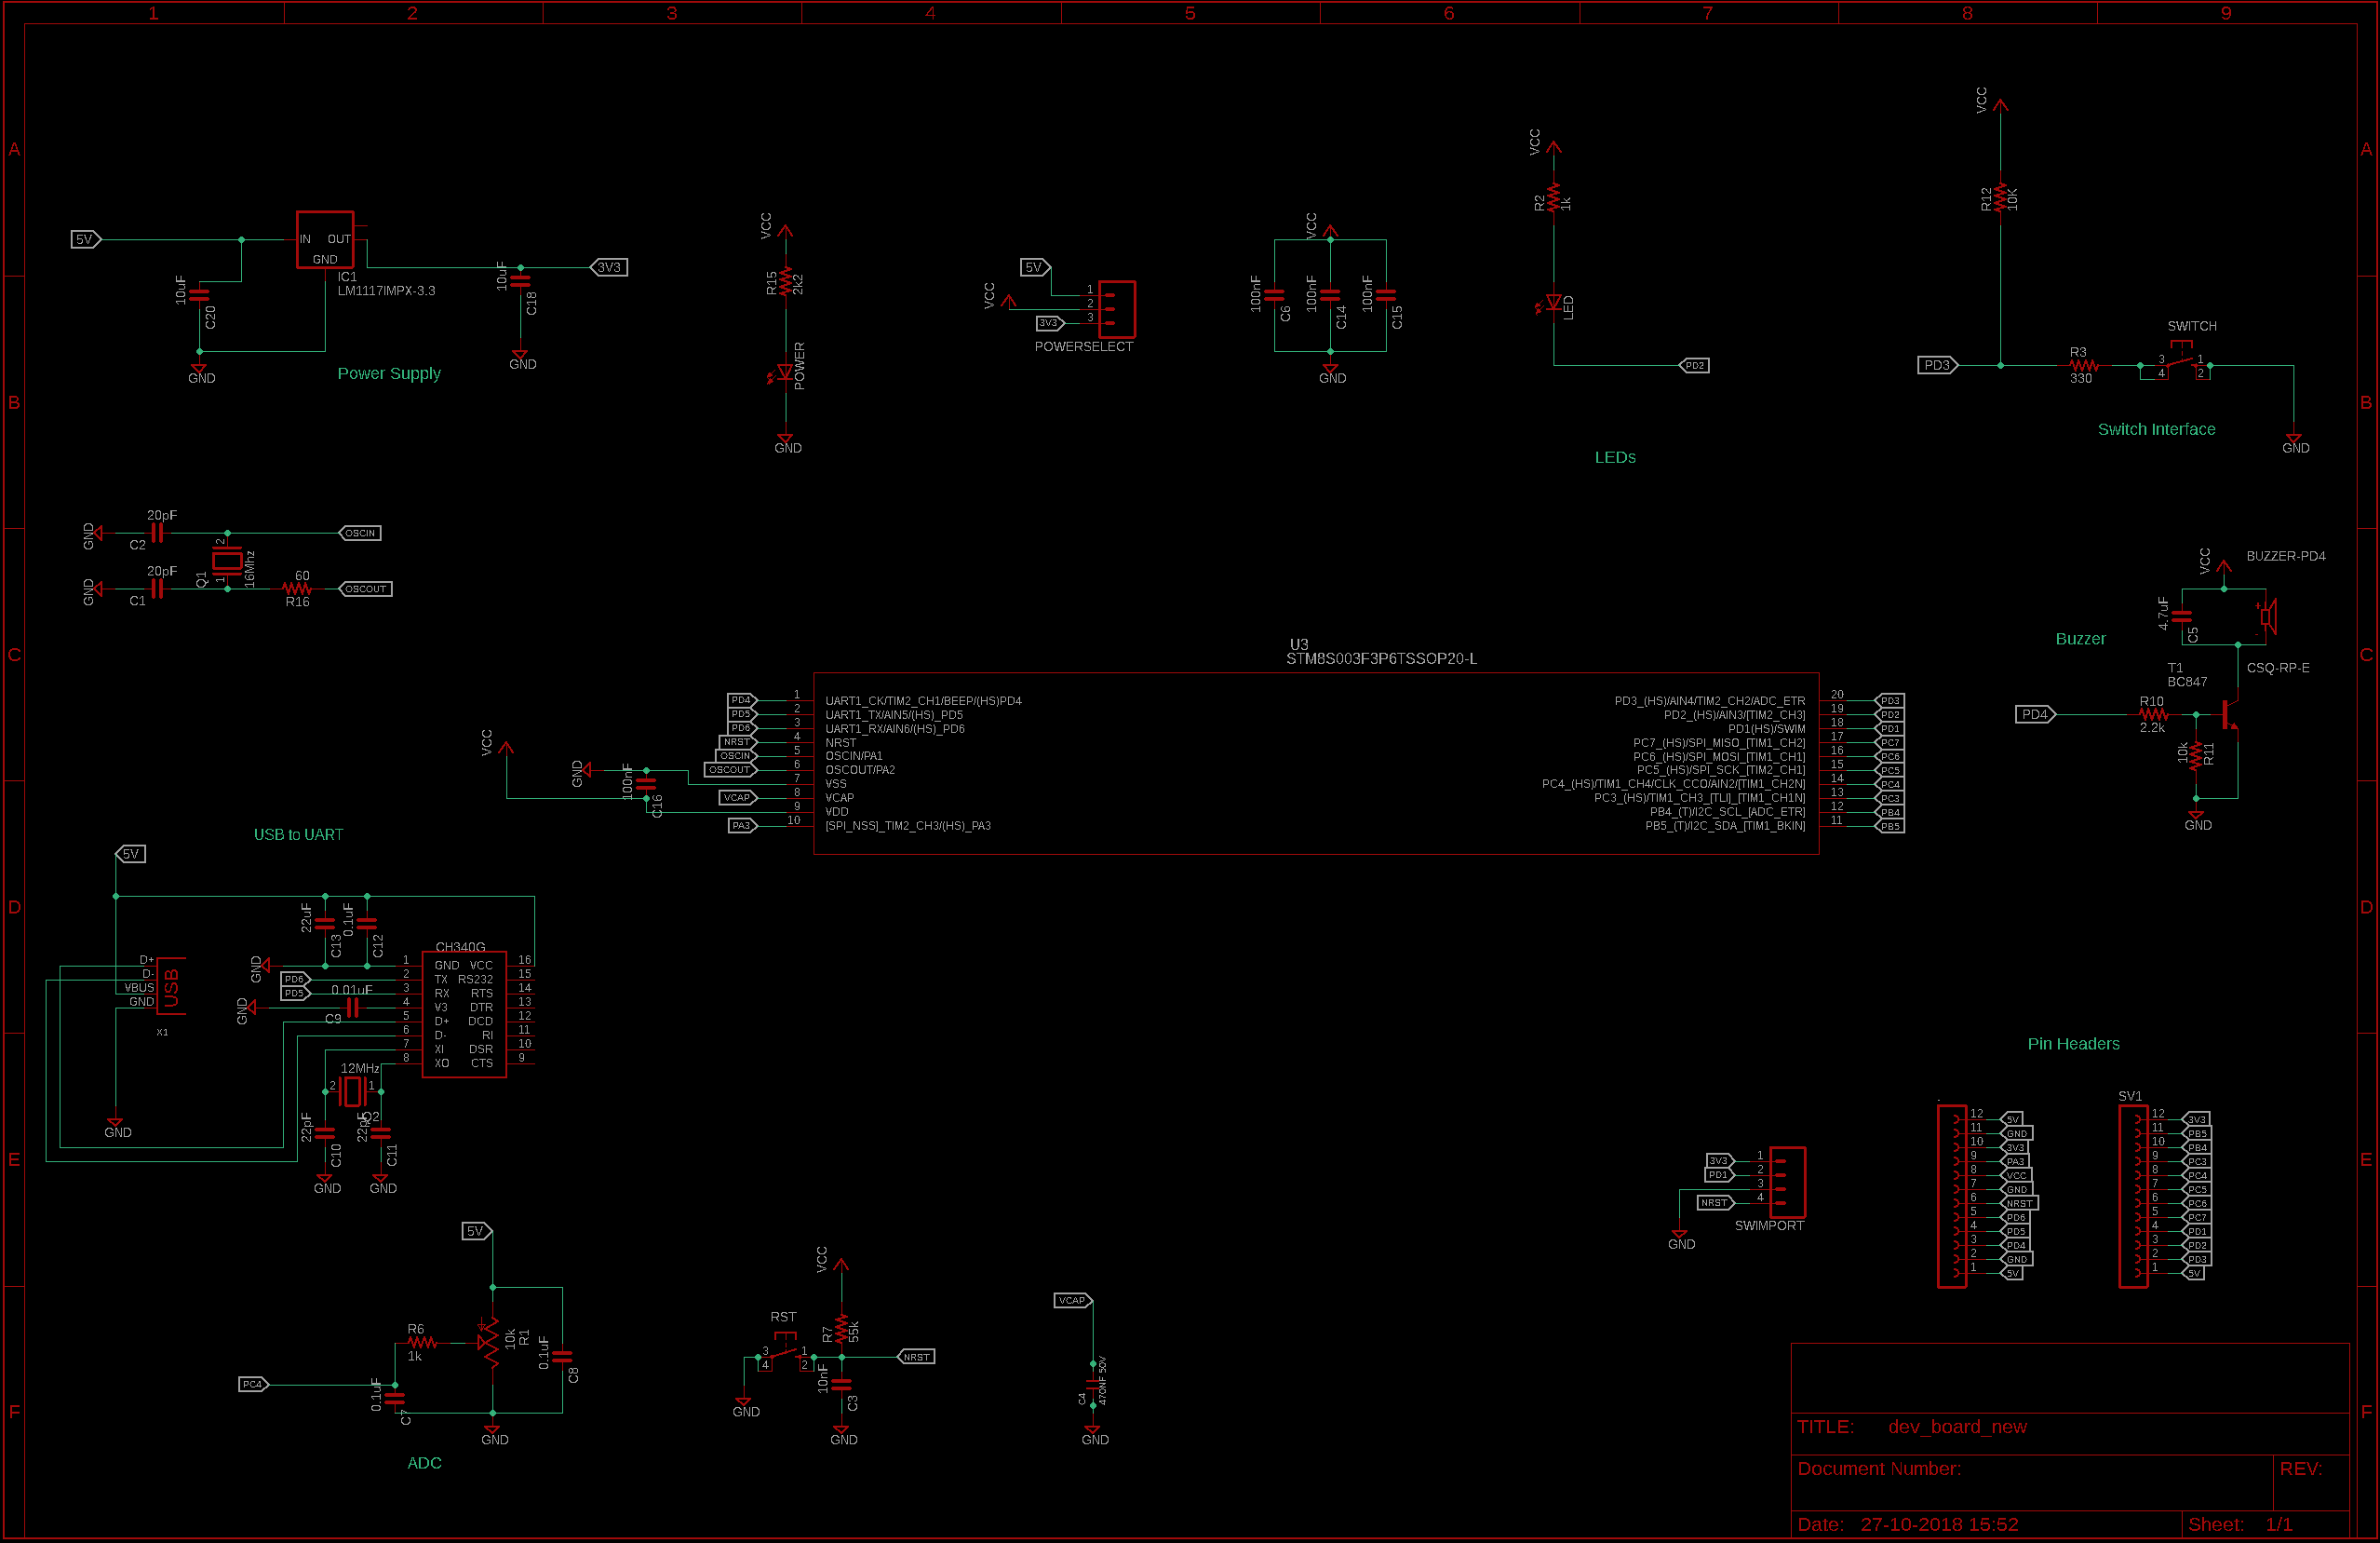
Fig.2 Schematic

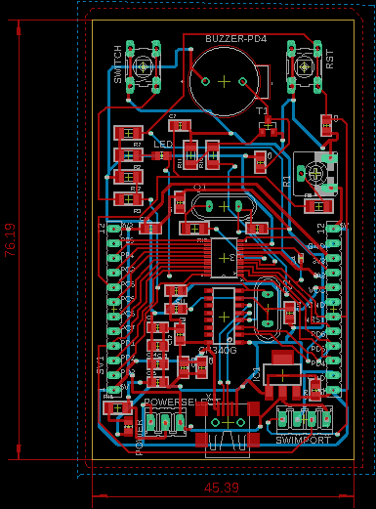
Fig.3 Layout
- PCB fabrication and soldering of the components
The layout is checked and each layer is verified using Gerbview software. Then it is given for the fabrication. After the PCB is received, the components are soldered in the main PCB and are checked for any short connections.
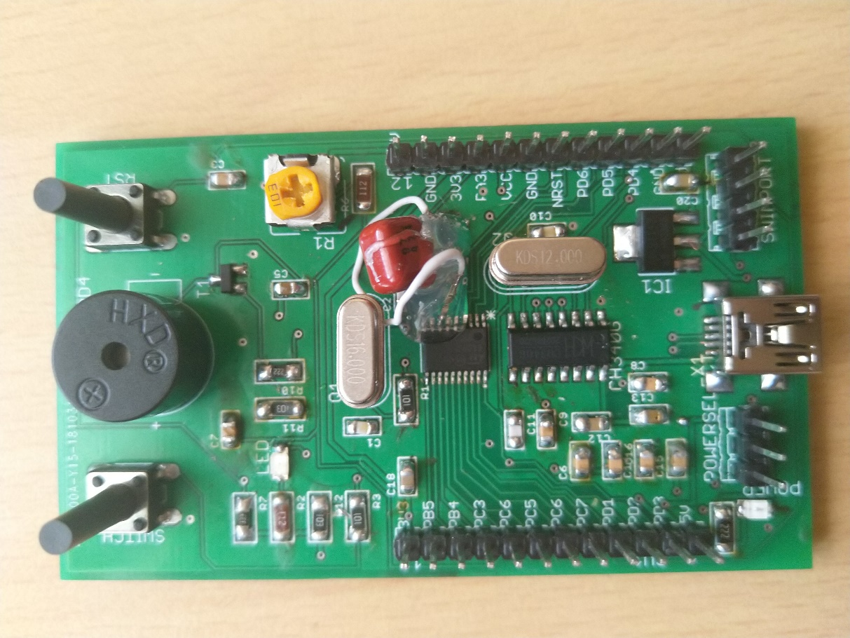
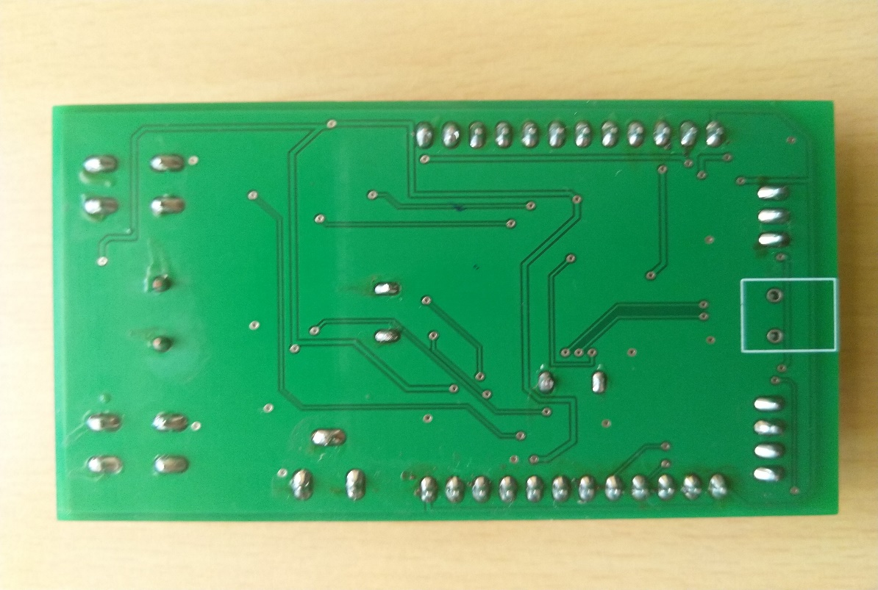
Fig.4 Top layer of PCB

Fig.5 Bottom layer of PCB
- Testing of development board and working of the peripherals
The development board and the working of the peripherals is tested using the codes which are uploaded. The programmer used is ST-Link V2 and is programmed using the SWIM port. The compiler used for the codes is IAR Embedded workbench.
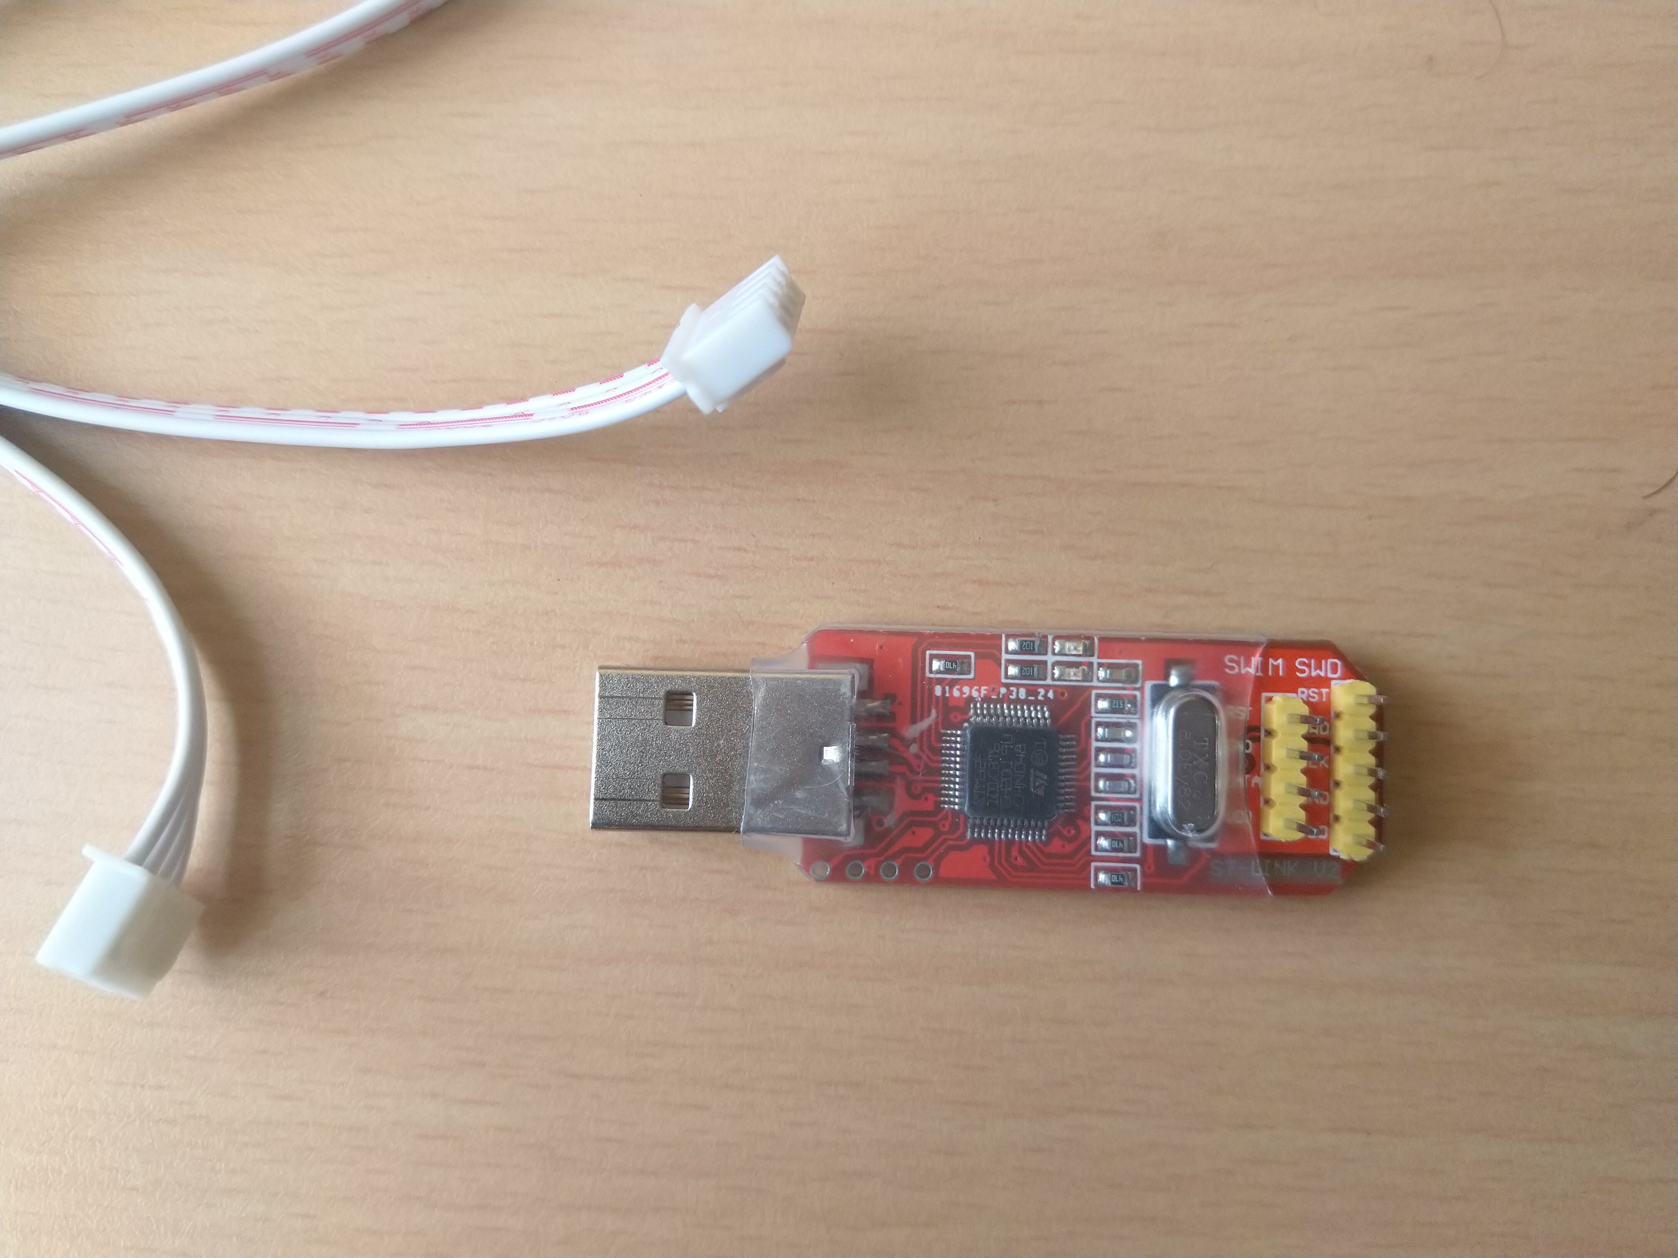
Fig.6 ST LINK V2
PRECAUTION:
The important design aspect which is to be taken care of is to choose the value of V_{CAP} of the microcontroller. The value of the V_{CAP} is to be choosen between 470nFand 1uF. If the value is not choosen carefully then the whole design won’t work.
Testing results:
- GPIO pins
The GPIO pins are checked with the help of a LED. We can program the pins of the GPIO to become ON and OFF alternatively for fixed amount of time. By connecting the LED to the Particular GPIO will make it blink.
The code snippet is
#include <iostm8s003f3.h>

void delay(unsigned int n)
{
while (n-- > 0);
}

int main( void )
{

PD_ODR = 0; //Turn off all pins
PD_DDR_DDR3 = 1; //PortD, Bit 3 is output (PD3 - Data Direction Register)
PD_CR1_C13 = 1; //PortD, Control Register 1, Bit 3 (PD3) set to Push-Pull
PD_CR2_C23 = 1; //PortD, Control Register 2, Bit 3 (PD3) set to Push-Pull

while (1)
{
//Turn on and off the output and then delay
PD_ODR_bit.ODR3 = !PD_ODR_bit.ODR3;
delay(30000);
}
}

Circuit diagram:

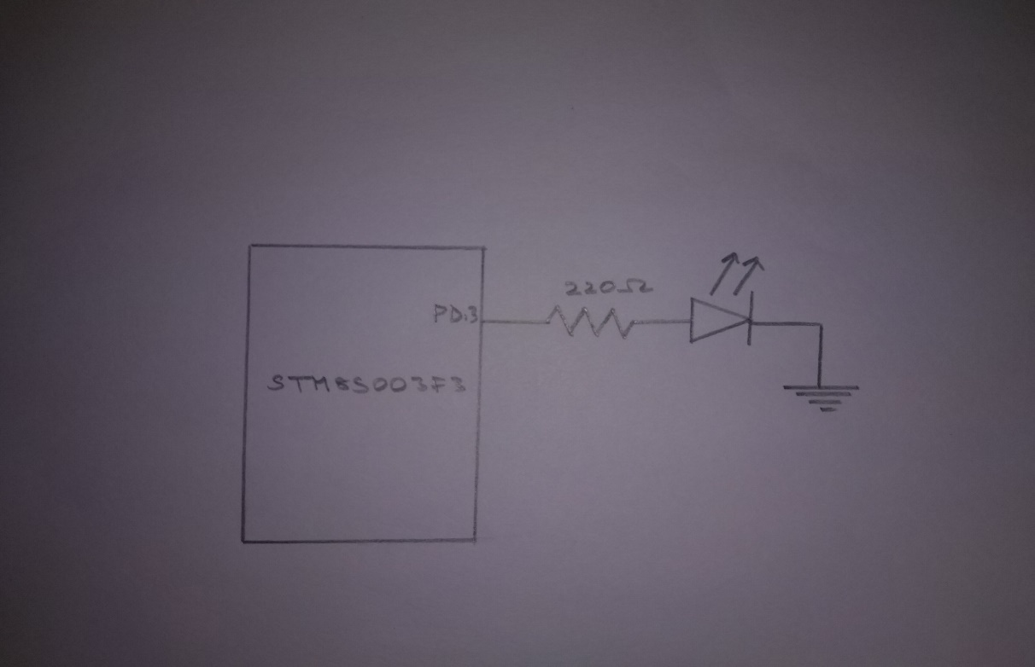
Fig.7 LED blinking circuit diagram

Results:
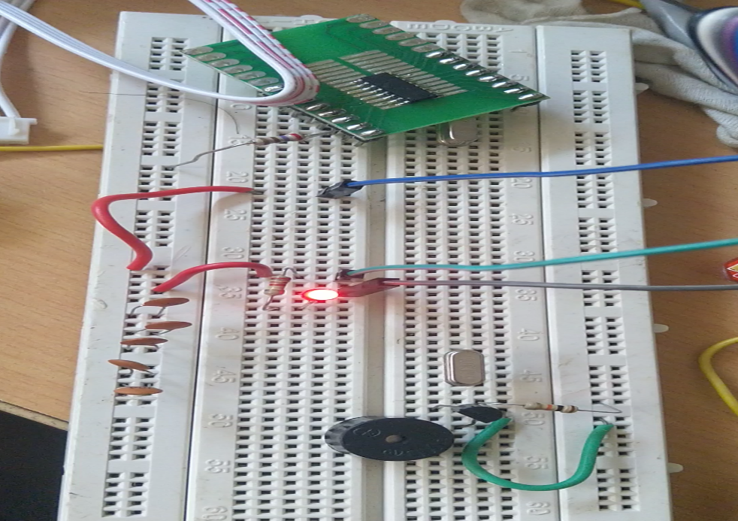

Fig.8 LED ON

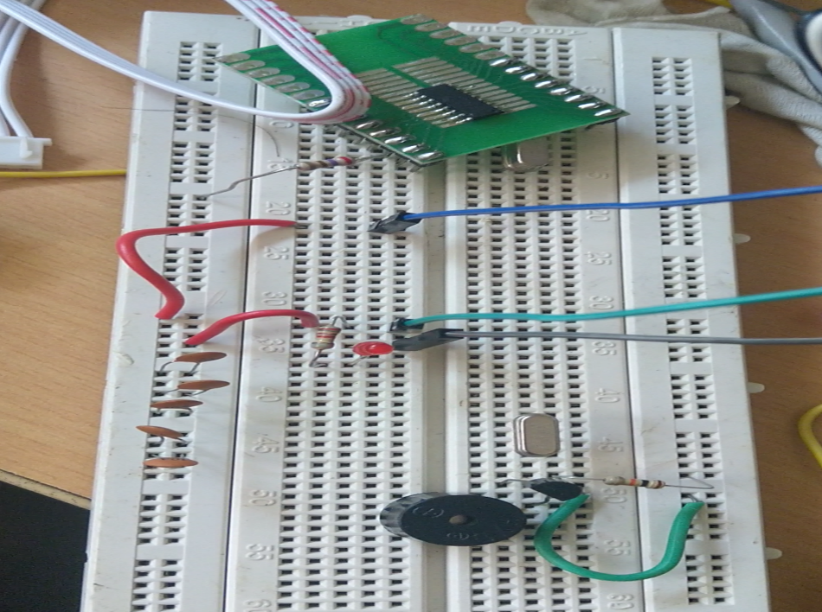
Fig.9 LED OFF
- ADC, UART and TIMER
The potentiometer in the development board is used to give the analogue input to the ADC channel 2 port. By varing the potentiometer, we can vary the input signal given to the ADC. The value from the ADC register is printed on the PUTTY screen using the UART module. The timer is used to trigger the ADC as regular intervals of time to start the ADC conversion.

The code used is :
#include <iostm8s103f3.h>
#include <intrinsics.h>

// Delay function

void wait(int x)
{
for(int i=0;i<1000;i++)
{
for(int j=0;j<x;j++);
}
}

//Setup the system clock to run at 16MHz using the internal oscillator.

void InitialiseSystemClock()
{
CLK_ICKR = 0; // Reset the Internal Clock Register.
CLK_ICKR_HSIEN // Enable the HSI.
CLK_ECKR = 0; // Disable the external clock.
while (CLK_ICKR_HSIRDY == 0);// Wait for the HSI to be ready for use.
CLK_CKDIVR = 0; //Ensure the clocks are running at full speed.
CLK_PCKENR1 = 0xff; // Enable all peripheral clocks.
CLK_PCKENR2 = 0xff; // Ditto.
CLK_CCOR = 0; // Turn off CCO.
CLK_HSITRIMR = 0; // Turn off any HSIU trimming.
CLK_SWIMCCR = 0; // Set SWIM to run at clock / 2.
CLK_SWR = 0xe1; // Use HSI as the clock source.
CLK_SWCR = 0; // Reset the clock switch control register.
CLK_SWCR_SWEN = 1; // Enable switching.
while (CLK_SWCR_SWBSY != 0); // Pause while the clock switch is busy.
}

//
// Setup the UART to run at 115200 baud, no parity, one stop bit, 8 data bits.

void InitialiseUART()
{
unsigned char tmp = UART1_SR;
tmp = UART1_DR;
//
// Reset the UART registers to the reset values.
//
UART1_CR1 = 0;
UART1_CR2 = 0;
UART1_CR4 = 0;
UART1_CR3 = 0;
UART1_CR5 = 0;
UART1_GTR = 0;
UART1_PSCR = 0;
//
// Now setup the port to 115200,n,8,1.
//
UART1_CR1_M = 0; // 8 Data bits.
UART1_CR1_PCEN = 0; // Disable parity.
UART1_CR3_STOP = 0; // 1 stop bit.
UART1_BRR2 = 0x0a; // Set the baud rate registers to 115200 baud
UART1_BRR1 = 0x08; // based upon a 16 MHz system clock.
//
// Disable the transmitter and receiver.
//
UART1_CR2_TEN = 0; // Disable transmit.
UART1_CR2_REN = 0; // Disable receive.
//
// Set the clock polarity, lock phase and last bit clock pulse.
//
UART1_CR3_CPOL = 1;
UART1_CR3_CPHA = 1;
UART1_CR3_LBCL = 1;
//
// Turn on the UART transmit, receive and the UART clock.
//
UART1_CR2_TEN = 1;
UART1_CR2_REN = 1;
UART1_CR3_CKEN = 0;
}

// Send the message in the string to UART1.

void UARTPrintF(char *message)
{
char *ch = message;
while (*ch!='\0')
{
UART1_DR = (char) *ch;
while (UART1_SR_TXE == 0);
ch++;
}
}

void SetupTimer2()
{
TIM2_PSCR = 0x05; // Prescaler = 32.
TIM2_ARRH = 0xc3; // High byte of 50,000.
TIM2_ARRL = 0x50; // Low byte of 50,000.
TIM2_CR1_CEN = 1; // Finally enable the timer.
}

void timer_contrl(void)
{

while( TIM2_CNTRH!=0x3A && TIM2_CNTRL!=0x98); //For every 15000 clock cycles the adc conversion will take place

//UARTPrintF("int_start");
PD_ODR_ODR3 = !PD_ODR_ODR3; // Indicate that the ADC has completed.

ADC_CR1_ADON = 1;
ADC_CR1_ADON = 1; // Second write starts the conversion.
TIM2_CNTRH=0X00; //Resetting the timer counters
TIM2_CNTRL=0X00;

}
int adc_read(void)
{
unsigned char low, high;
int d;
ADC_CR1_ADON = 0; // Disable the ADC.
UARTPrintF("adc_value:");
TIM1_CR1_CEN = 0; // Disable Timer 1.
ADC_CSR_EOC = 0; // Indicate that ADC conversion is complete.

//UARTPrintF("adc_read_end");
low = ADC_DRL; // Extract the ADC reading.
high = ADC_DRH;
d=(high * 256) + low;

return d;
}

//--------------------------------------------------------------------------------
//
// Setup the ADC to perform a single conversion and then generate an interrupt.
//
void SetupADC()
{
ADC_CR1_ADON = 1; // Turn ADC on, note a second set is required to start the conversion.
wait(1000);
// UARTPrintF("adc_setup_start");
ADC_CSR_CH = 0x02;

ADC_CR3_DBUF = 0;
ADC_CR2_ALIGN = 1; // Data is right aligned.
ADC_CSR_EOCIE = 1; // Enable the interrupt after conversion completed.

// UARTPrintF("adc_setup_end");
}

void SetupOutputPorts()
{
PD_ODR = 0; // All pins are turned off.
PD_DDR_DDR3 = 1;
PD_CR1_C13 = 1;
PD_CR2_C23 = 1;
}

int main( void )
{

InitialiseSystemClock();
InitialiseUART();
SetupTimer2(); //Timer 2 is used to trigger the ADC
SetupOutputPorts();
SetupADC();
int delay;

while (1)
{
timer_contrl();
SetupADC();
int num=adc_read();
int temp=num;
int j;
for(j=0; temp!=0;j++)
{
temp=temp/10;
}

char data[5]={48};
for(int i=1; i<=j;i++)
{
data[j-i]=(char)(num%10)+48;
num=(num)/10;
}
data[4]='\0';
UARTPrintF(data);
UARTPrintF("\n\r");

}

}

Circuit diagram:

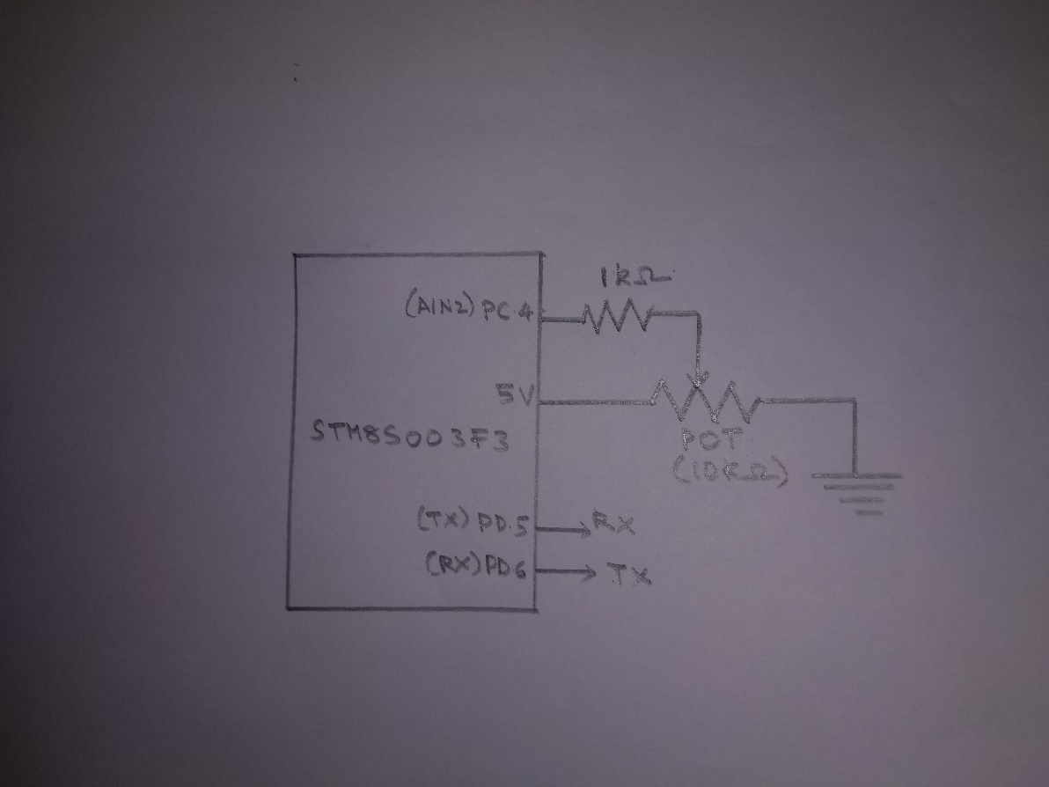
Fig.10 ADC, UART and Timer testing Circuit diagram

Result:
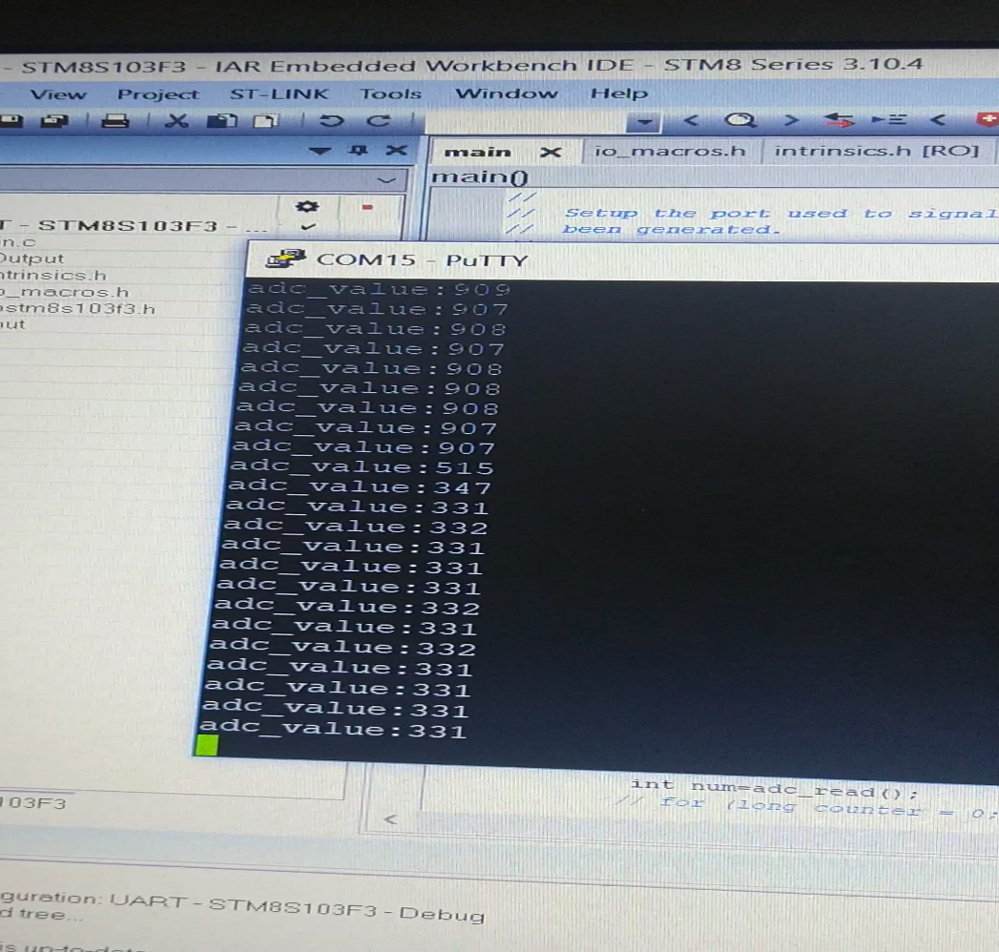
Fig.9 ADC value obtained in putty screen

