CNC Router

Operation Manual

By

Hammad Nasir & Saba Iqbal

Dated

12/20/2019

Contents

Introduction 3
Description 4
Components 5
Software’s required 6
How to Use 8
Step 1: 8
Step 2: 9
Step 3: 10
Step 4: 11
Step 5: 12
Step 6: 13
Step 7: 14
Step 8: 14
Step 9: 15
Step 10: 16
Step 11: 17
Debugging 18
Case 1: 18
Case 2: Bed not Calibrated 18
Case 3: Printer not Connected to Laptop/Computer 18

Introduction

A computer numerical control (CNC) machine is a computer-controlled cutting machine related to the hand-held machine used for cutting various hard materials, such as wood, composites, aluminium, steel, plastics and glass.
Computer numerical control (CNC) machines use directions from a computer to complete machining processes. Machining equipment takes a piece of material and cuts away parts of it by machining tools (drills, boring tools and lathes) to achieve the specified results.
CNC machines are electro-mechanical devices that can manipulate tools around a varying number of axis, usually 3 or 5, with high-precision per instruction from a computer program. Usually engineers use CAD software for designing models that needs to be cut or engraveed and sends it to the CNC machine via G-code, a form of sequential program of machine control instructions.

Description
We have transformed our old IdeaWerk 3D printer into CNC Router machine. The idea behind is to make a machine that can engrave customized designs on different materials like wood and acrylic but we have only tested it on acrylic yet.
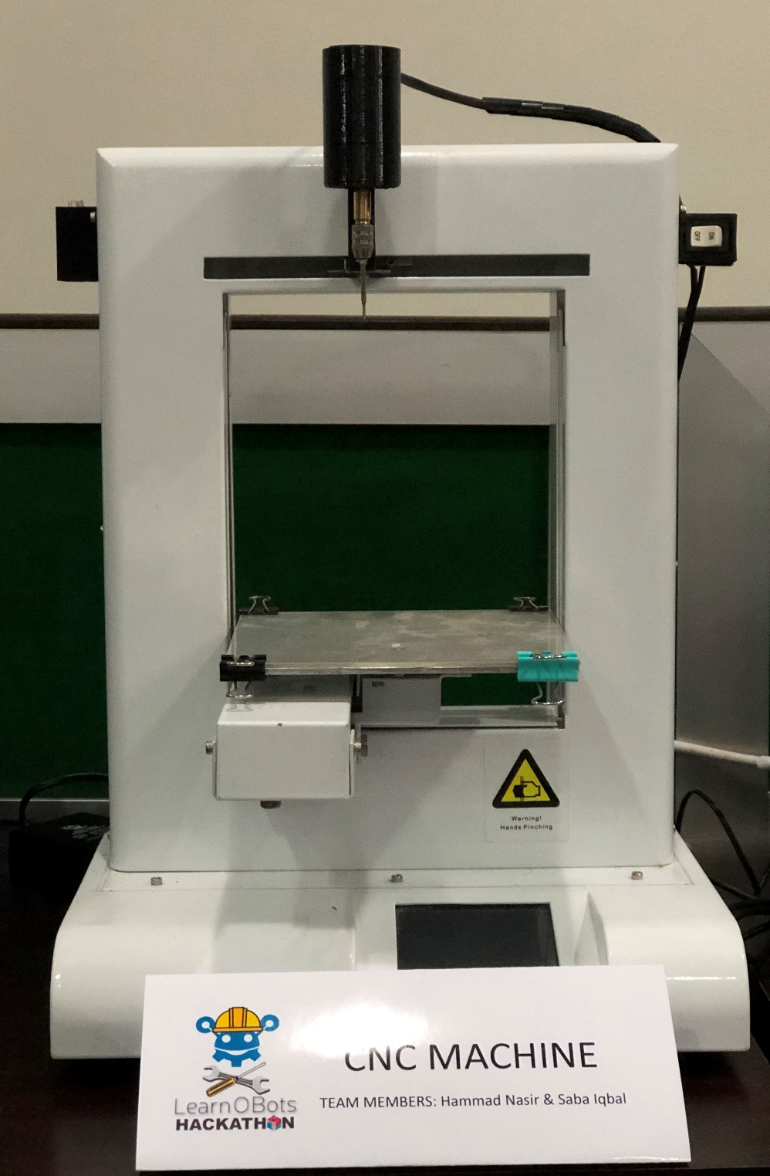

Components
The components we used for making of CNC machine are as follows
- 12V DC Motor

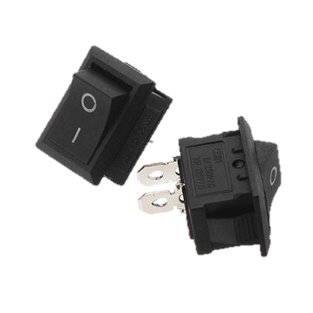
- On/Off Switch

- 3D Printer
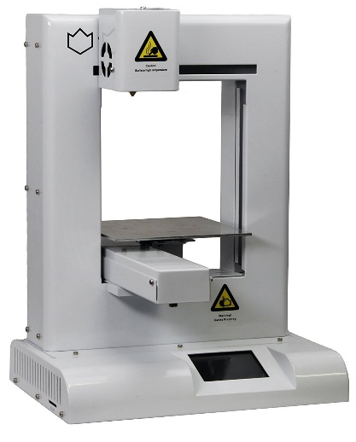

- 3D Printed Holders for Motor, Switch and bits

Software’s required
- TinkerCAD
Online Software for making 3D Models, which can then export to DoraWare for execution.
www.tinkercad.com

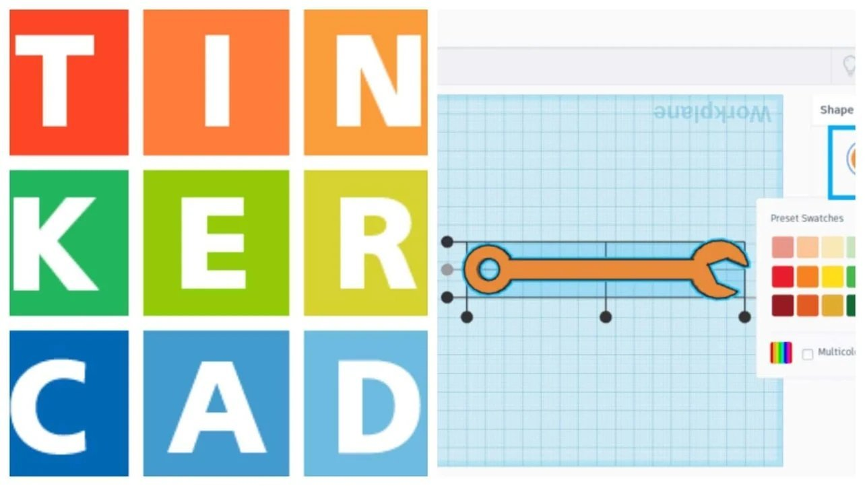

- DoraWare
Software which is only compatible with IdeaWerk 3D Printer for generating GCodes for the machine.

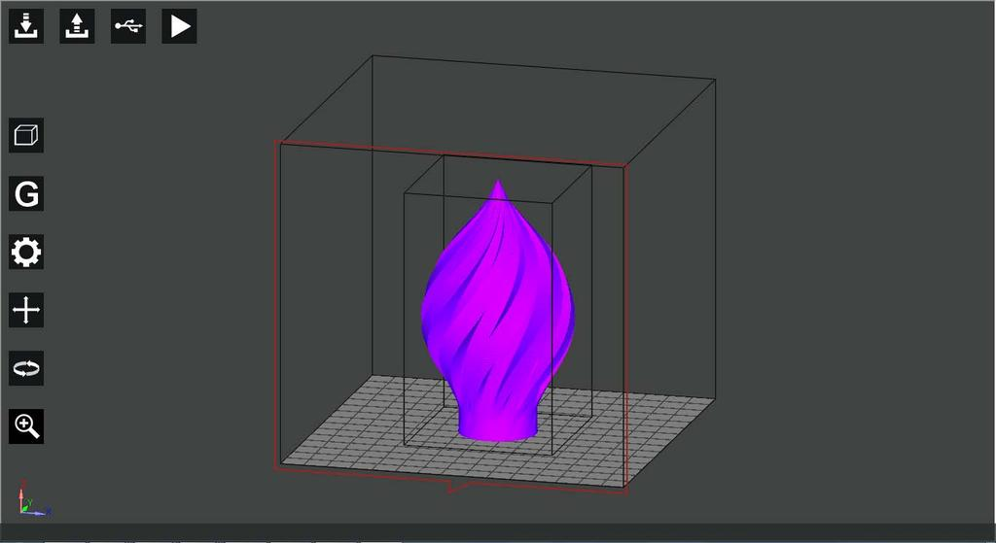

- Inkscape
Software in which you can create and import any model/design and jpg/png file respectively and save it in svg format which can then import in TinkerCAD for making it a STL file. Then the STL file will be given to DoraWare for execution.

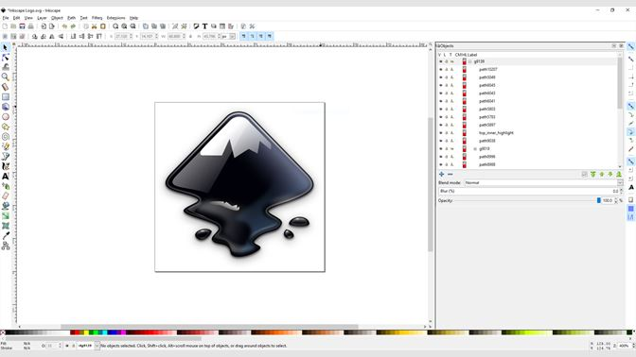

How to Use

Step 1:
If you want to import any image then open Inkscape first.
Then, Go to File > Import.

Step 2:
After that your desired image has been imported.
Go to Path > Trace Bitmap, following screen will be opened up. Change Edge Detection to 0.100 and click on update.

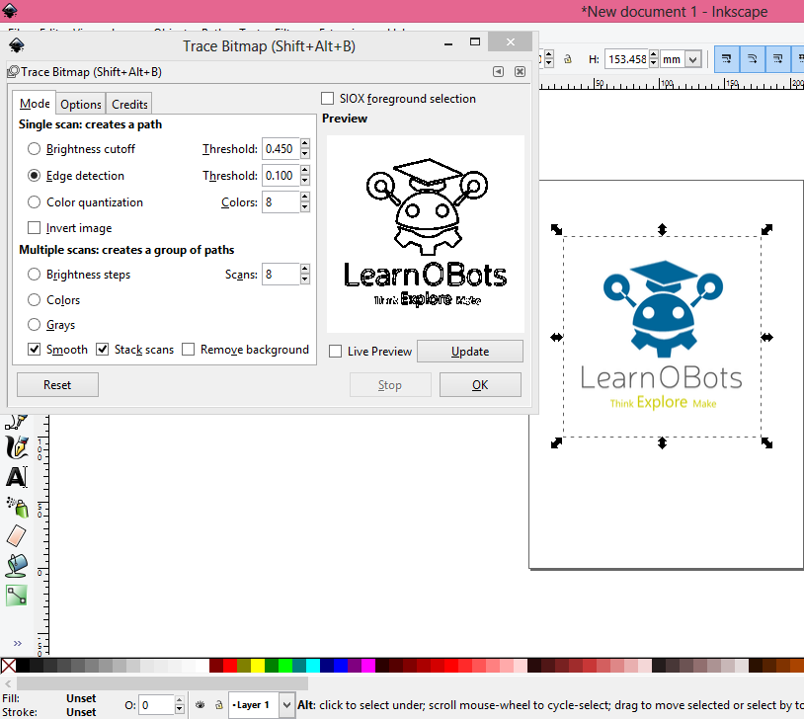

This step is only required when you want the edges or outline of your image only otherwise this step is not necessary to perform.

Step 3:
Now your design looks like this.
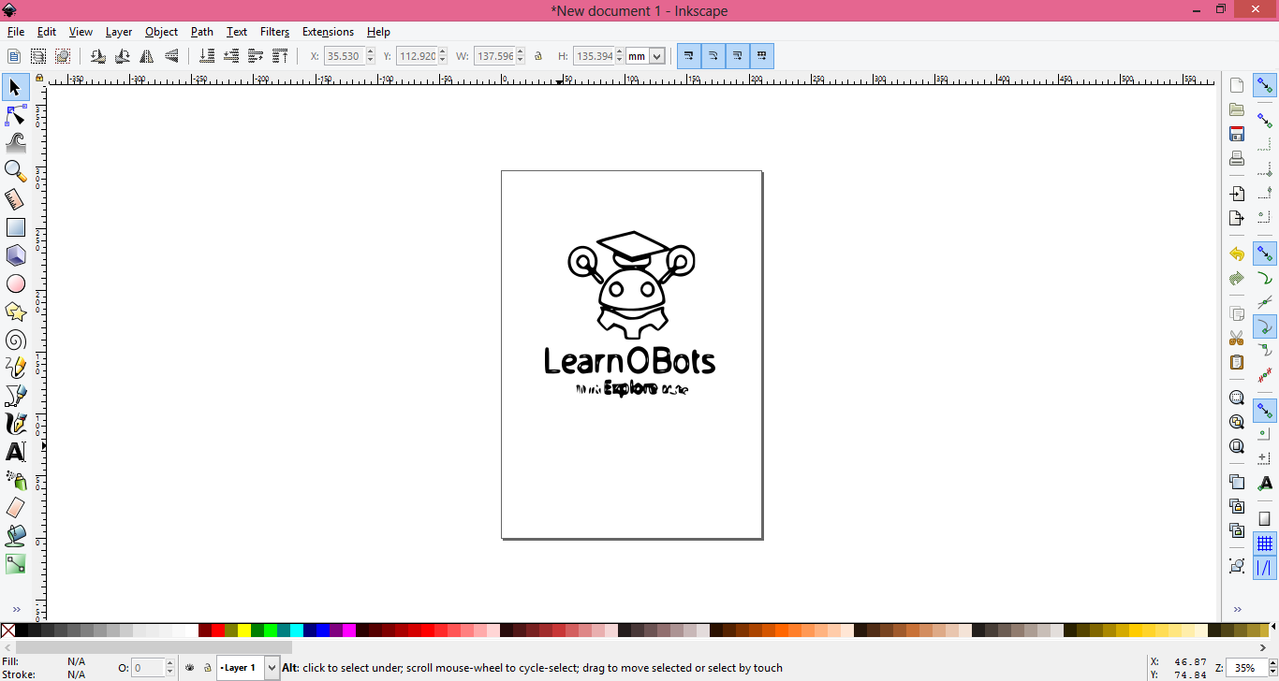
Go to File > Save As, and save the following drawing in the SVG format.

Step 4:
Now, go to TinkerCAD (www.tinkercad.com) and login via Google Account.
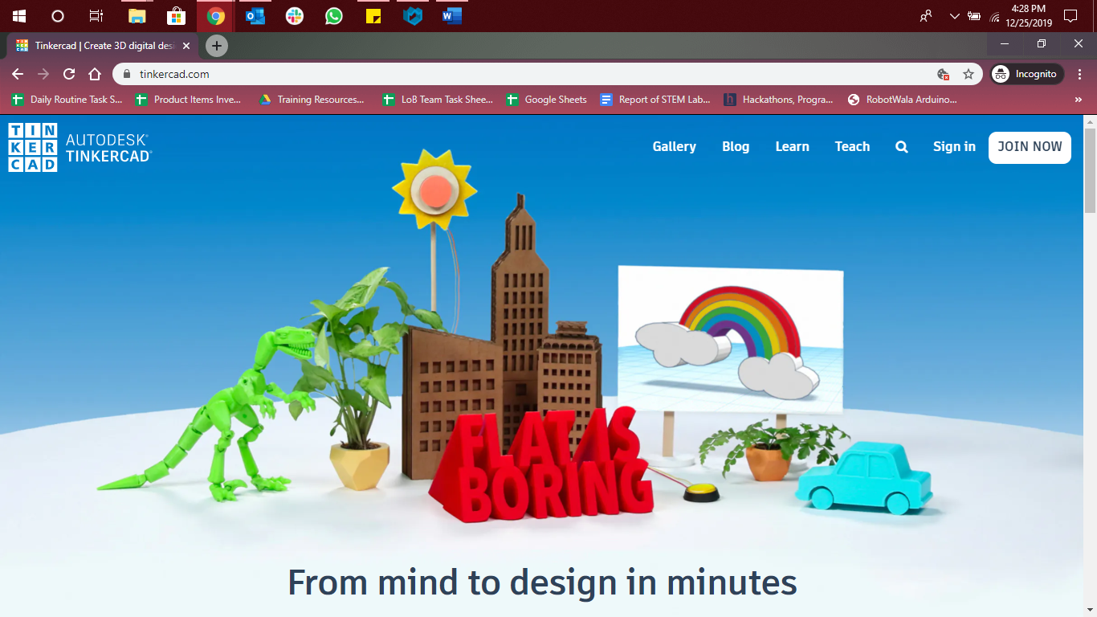

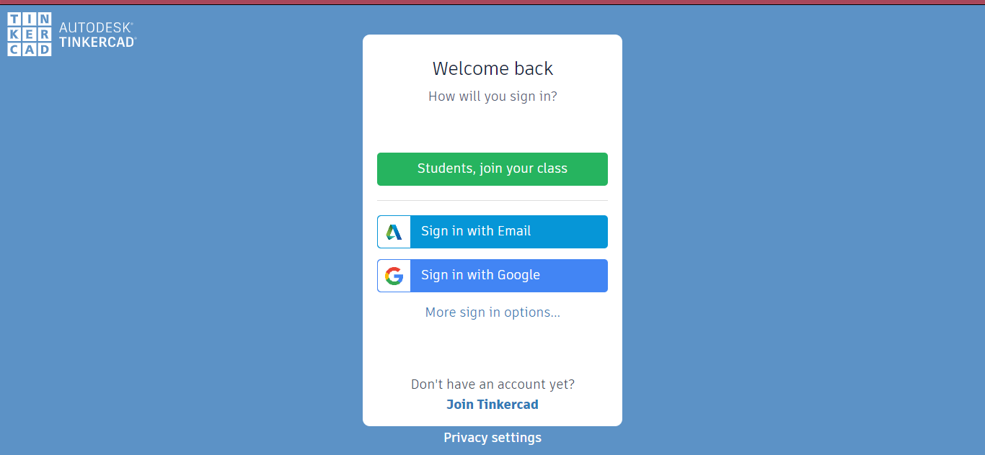

Step 5:
After successfully logging in, Click on Create New Design.
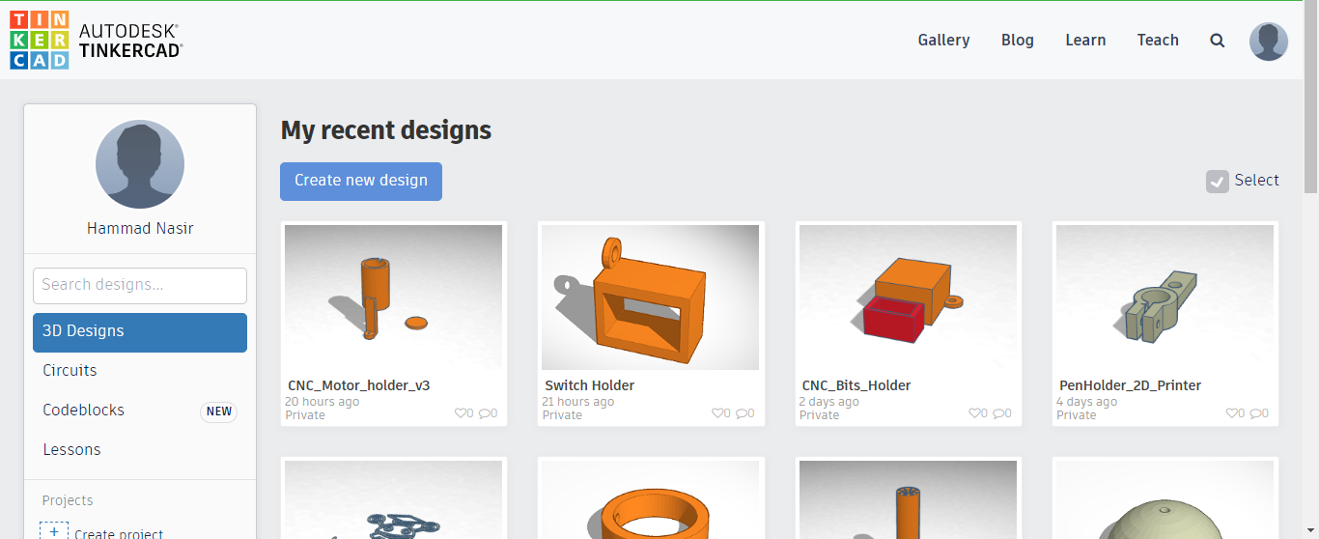
On the right side you will see the Import, click on it and import the SVG file you saved via Inkscape. Then you have to click on Art, so that only the model/drawing will be imported not the whole board.
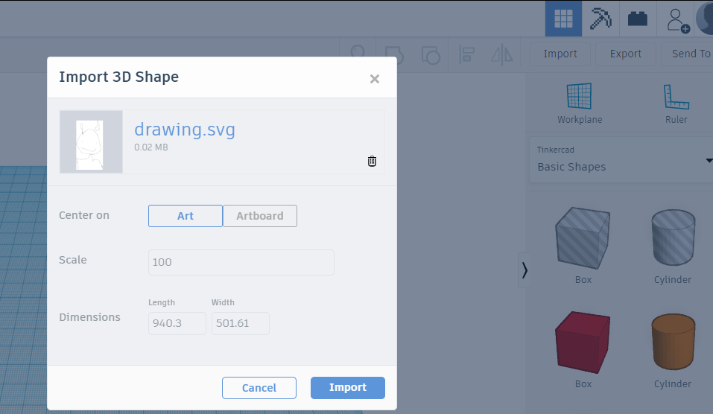

Step 6:
After importing the drawing into the workspace, set its height to 1mm (as our CNC will only make 1 layer so it doesn’t matter whether the height of your drawing will be 1mm or 10mm).
I will suggest to make it 1mm or minimum 0.2mm so that our GCode will generate quickly.

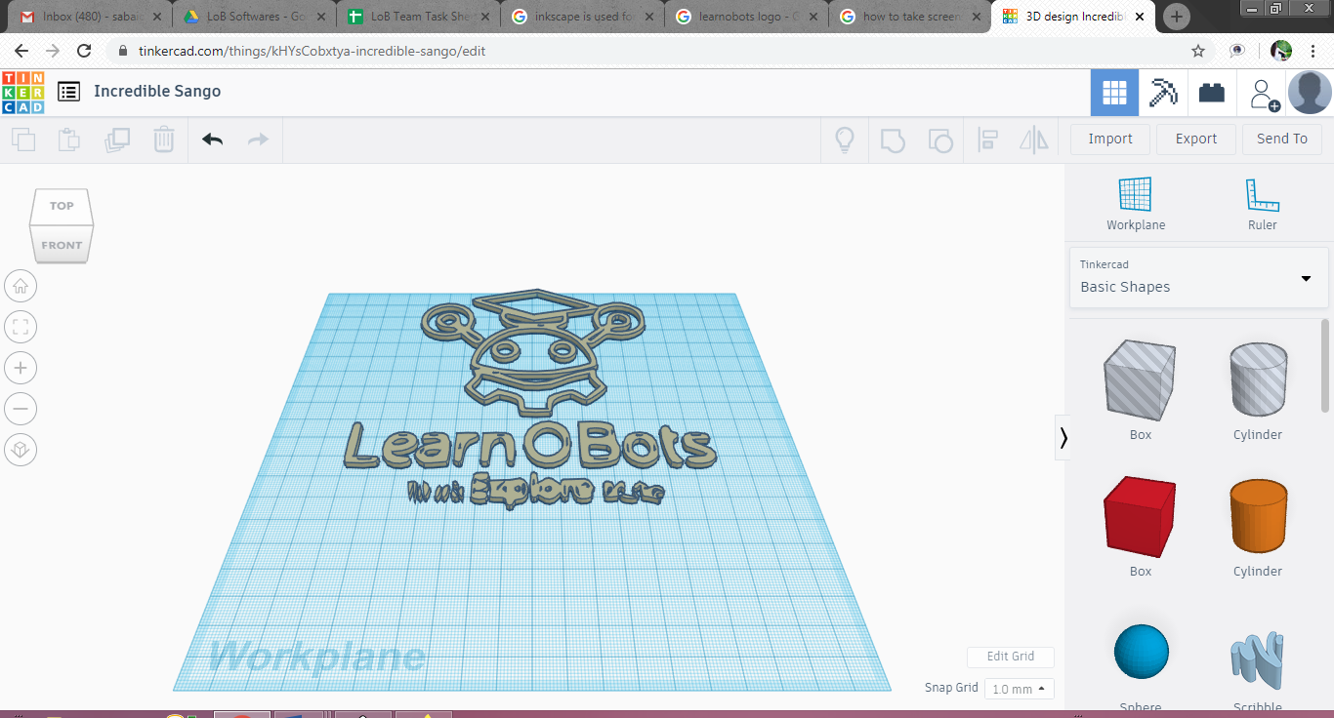
Now export your model as an STL file and open DoraWare.

Step 7:
When you opened, DoraWare, click on the USB icon and select the port. (Make sure that your laptop/computer is connected with the printer via USB Cable). After selecting the port, clock on Connect and you will see “Machine Connected” written on the window.

Step 8:
Import your STL model in DoraWare.

Step 9:
Now before generating GCode of a model, calibrate the bed of the printer by clicking on Settings Icon.
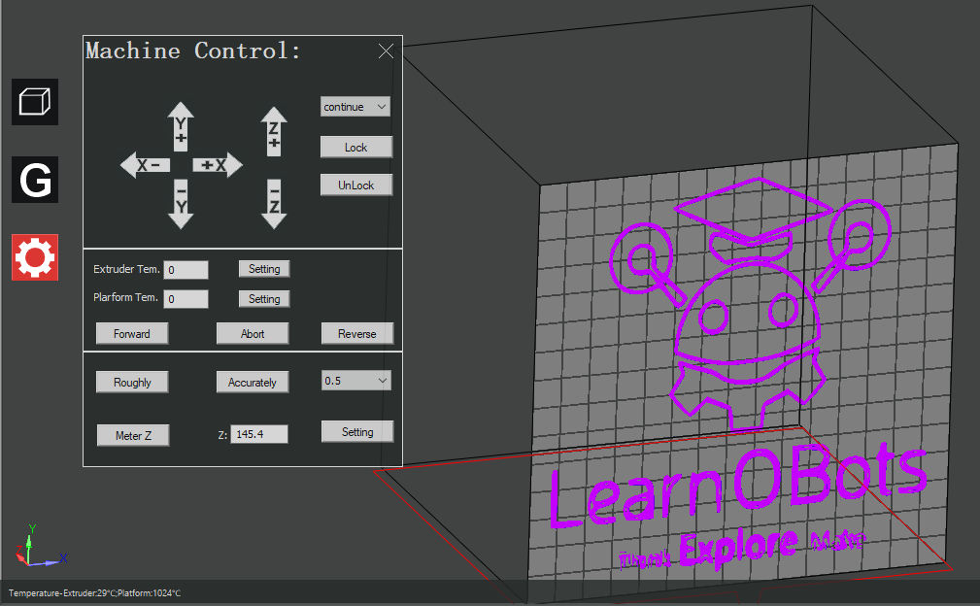
Move the Z-axis by clicking on Z+ icon and take the bed upwards till the tip of the bit touches the plate placed on the bed.
Now click on MeterZ in order to measure the height which you will be setting while generating GCode.

Step 10:
Now generate GCode of the model by setting following parameters.
- Uncheck the Raft Box.
- Height: What was measured in the Setting
- Extruder Temp (℃): 0
- Platform Temp (℃): 0
Click on Generate GCode.

Step 11:
After successfully generating GCode, click on OK and then click on Play button.
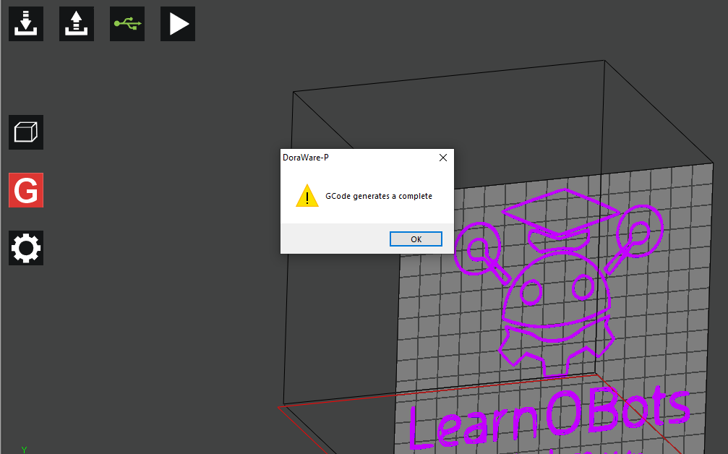

Below picture is a sample of what we tried on small acrylic piece.

Debugging

Case 1: Motor is not working
Make sure it is powered ON via 12V 2A DC Charger. The button is switched ON and its connections are soldered.

Case 2: Bed not Calibrated
Make sure that you have performed Step 9 carefully.

Case 3: Printer not Connected to Laptop/Computer
If the COM port is not showing then try to change the port on laptop/computer and click on Rescan, then search for the ports. If still it is not connecting, then restart your laptop.

