V2.0f Solar Tracker and Robotics Board

1 A new vision 2

2 The “Magnetic CPV Tracker V2.0f” board 3

2.1 On board features 4

2.2 Pin headers explained 4

2.2.1 V+ and GND 4

2.2.2 M1 A/B M2 A/B 5

2.2.3 Light Sensor 7

2.2.4 Pins intended for wind sensing 8

2.2.5 Serial communication 8

2.2.6 RS485 communication 8

2.2.7 Extra Pins for ATMEGA328PB 9

2.2.8 I2C communication 9

2.2.9 In Circuit Serial Programmer ICSP and AREF 10

2.3 Thermal management, encapsulation and mounting 10

3 Prior Art 11

4 Ordering the board 12

5 License 13

Ruediger Loeckenhoff, Ermanno Antonelli, issue: 23.10.2022

# A new vision

We have a new vision! We want this board to become widely available through many shops in Asia and anywhere. It should become the standard solution for solar trackers and we want to build an active community around it. Solar tracking alone won’t do that trick and it doesn’t need to. It’s not just a tracker controller, it’s

A GENERAL ROBOTICS BOARD

It’s an **ATMEGA 328pb board** with a powerful **12-38.5V 8A 3-phase motor controller** that can also be used to run two DC motors at different speeds at the same time. The **inbuild accelerometer** and **magnetometer** allow for orientation sensing without external sensors. The **RS485 communication** and the **real time clock** are ideal for remote automation. There is also a **current monitor** to detect abnormally high currents. And there is the **4-channel light sensor** connected to ground or VDD with pullup/pull-down resistors. **Two I2C ports** are available externally together with all unused pins of the µC. The second port can turn the board into an I2C slave for a RasPi. We are not aware of any other board with such versatile components. And all this will be available

AT A PRICE AS LOW AS $40.  
NOW IMAGINE WHAT YOU CAN DO WITH THAT!

The board is ideal for building up a community because it will make the replication of your projects so easy. There won’t be any sourcing issues because most things you need are already on the board. Just make the external connections and upload the code. We will love to see what you will come up with. Here are some cool ideas.

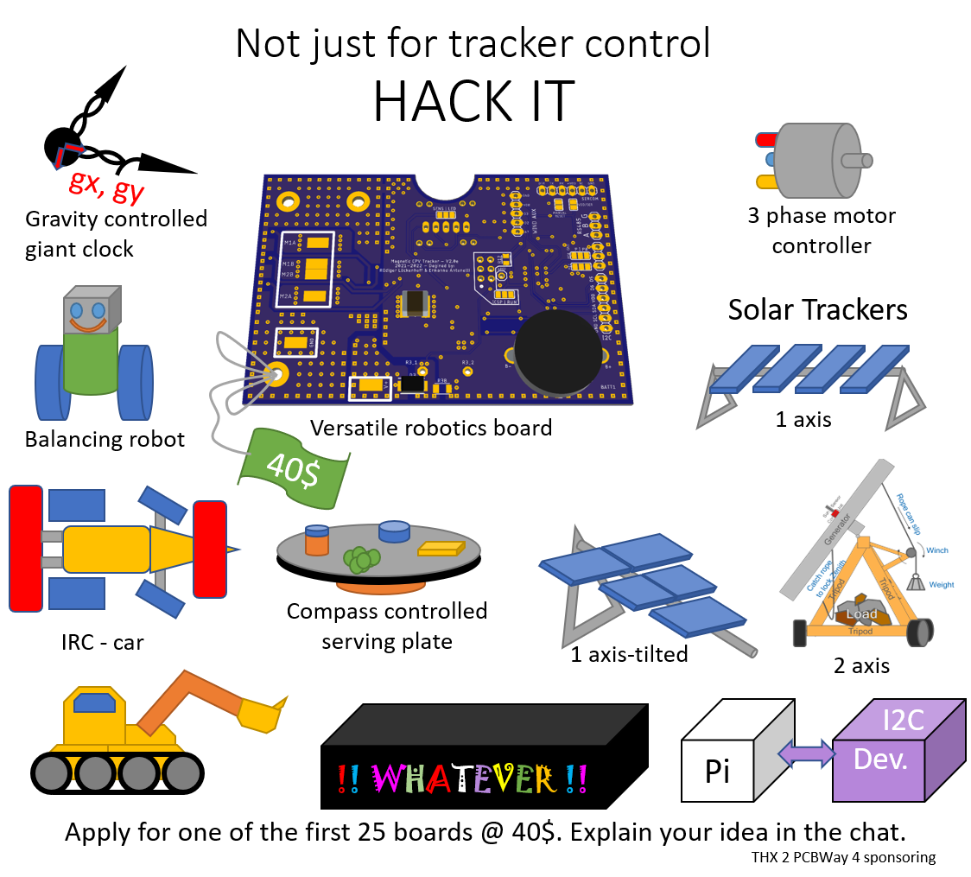

NOW THIS IS STILL ALL ABOUT SAVING THE WORLD

But why shouldn’t we have fun in the process.

APPLY FOR IT NOW!

Our sponsor PCB-Way will sponsor this first set and will allow us to give the parts away for $40. So, you can get it now for a price which will only be reached again in mass production! Apply for a piece in the chat and explain your idea. We cannot wait to hear about it! If you want to build a solar tracker – even better. You will just have to wait some extra weeks until I have perfected the code for the new sensor chips. The code and the board drawings will be open source soon. We promise!

Here is a preview of the board with all features explained.

# The “Magnetic CPV Tracker V2.0f” board

This is the board in close up:

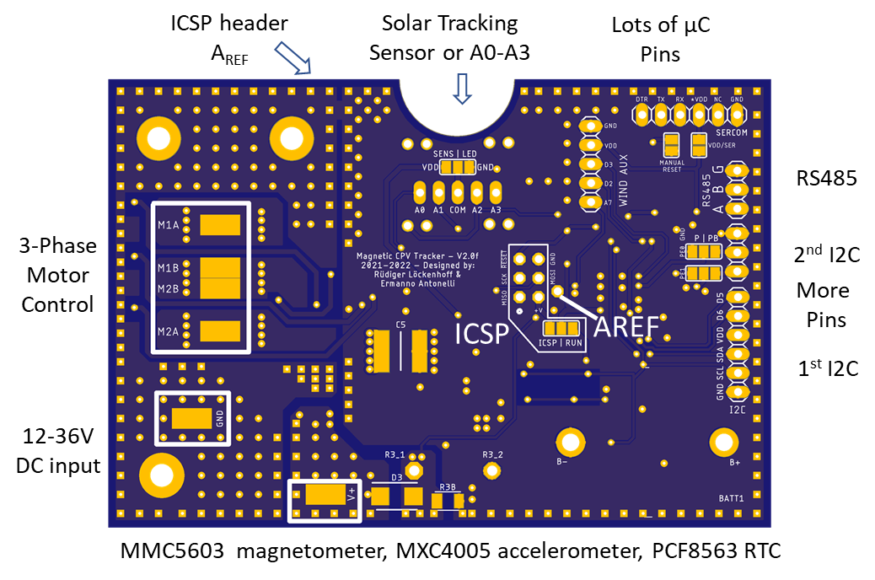

The idea for this board is based on <https://github.com/SolHunter/Open_CPV_Solar_Tracker_Control> and it will run very similar code. Yet all chips were replaced by alternatives keeping cost and long term availability in mind.

## On board features

**6-axis compass**

We had bad experience with the availability of compass chips. The MPU9250 9 axis compass was a great and cost effective assembly but it went out of production. We tried the ICM20948 and even got it to work, even so the registers are very complicated. Yet it is rather expensive and hardly available. We therefore replaced them with two separate chips by MEMSIC which are readily available: the MMC5603 magnetometer and the MXC4005 accelerometer.

Upsides: very simple I2C registers, very cost effective and a good signal to noise ratio for the magnetometer. Availability and “recommended for new products”

Down-Sides: They are too small for hand soldering. The z-axis of the accelerometer has a zero offset and the signal to noise ratio of the accelerometer is not so good. We will need to do oversampling.

**Real time clock PCF8563RTC**

Just another RTC with very low power consumption. It does the job.

**RS485 communication**

We are using a half-duplex RS485 chip for long distance communication.

## Pin headers explained

### V+ and GND

Connect V+ and GND to a 12-38.5V power supply. The FETs can cope with 60V and the voltage is clamped with a 36.9V rated transient voltage suppression diode D3 and a 2.7V Z‑Diode Z1. Thus, the transient voltage spikes cannot damage the FETs. The spillover current is measured through the resistor R3 which is preset to 4.7MOhm. If you need a lower resistive value, add an SMD resistor to R3B or a discrete resistor between R3_1 and R3_2 in parallel. The voltage is measured through the Arduino A6 pin.

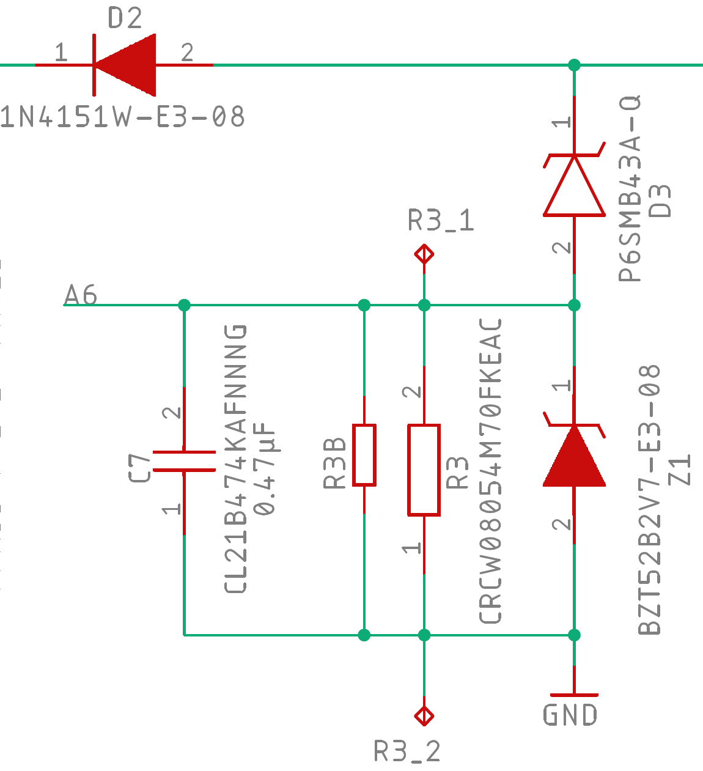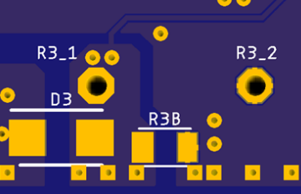

V+

The voltage is clamped to 2.7V with the z-diode to prevent damage to the analog input.

This is a fairly indirect method to measure the voltage. You measure the spillover current which depends on the rate of the PWM pulses and the inductivity of the lines from the DC power supply and the battery. However, once you know its usual value, you can detect a raise in the input current which may indicate a jammed motor.

### M1 A/B M2 A/B

These are the outputs to the motors. I feel that I need to explain a bit more here. We are using the DRV8300DIPWR which is meant for driving a 3-phase motor control. We are using it to drive up to 3 DC motors. In the schematic below, two motors M1 and M2 are connected. For instance, GHA and GLA are driving the half-bridge on the left where GLAis an inverted input. In state a) all motors are at full stop. They are short circuited through the lower FETs for breaking or “free wheeling”. “Free wheeling” is the state of the motor at reduced PWM between two pulses. Basically, it is the same as breaking only that it lasts for a shorter time. In state b) M1 is running forward while M2 is free wheeling with the lower FETs closed.

Make it a general rule that motors should be short circuited when not being driven. If you leave them completely unconnected while they are still turning, they will drive current through the body diodes of the FETs which they may or may not tolerate. State c) is interesting because both motors are being driven at the same time. Here they are shown turning in one direction which is, of course, just a convention. Reverse the polarity and the motors may run full speed in one direction. This allows for 2-wheeled robots. In case d) M2 is driven and M1 is breaking or free-wheeling. Please note that we need to break/free-wheel with GHA and GHB rather than the lower FETs which would provoke a “shoot through” in the middle half bridge. It wouldn’t happen, the DRV8300 series comes with a shoot through protection. But driving the motors wouldn’t work either.

You may alternate state d) with e.g. state b) and thus have two motors running half speed in any direction at the same time. In case e) a third motor between M2A and M1A is running. Yet, running more than two motors at a time becomes messy.

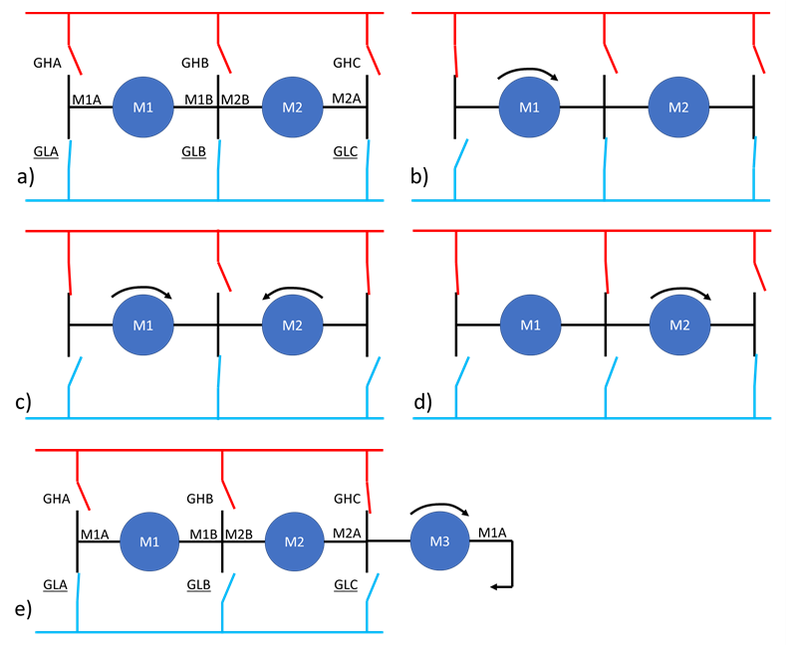

I am handling these states through direct port manipulation of port B and I suggest that you should do the same in your robotics project. I am presently using timer1 for the motor driver ISR and this will create a conflict with the servo library. In case of robotics projects servos are important and I would therefore suggest to move the ISR to timer 2 which is only used by the tone library.

The DRV8300 gate driver uses the bootstrap method to generate the voltage to drive the higher FETs. This requires that all the half bridges are sometimes in a state where the lower FET is closed such as in state a). This can actually be a very short time of a few µC cycles, but it is necessary. Otherwise, the bootstrap capacitors run empty and the motors stop. One way to achieve this is to go into state a) for a microsecond or so before you assume the desired motor drive state again.

### Light Sensor

The light sensor detects the direction of the sunlight. There are two different options available. The original sensor on the left is a sun sensor that might be available through AZUR SPACE. It is an imaging sensor and not an official product yet. If you want to test it, please contact me through the forum. The middle picture shows the photodiode based sun sensor. The diodes will sit within holes in the front plate and be shaded by a shading beam. Actually, the photo diodes are simply LEDs because they are cost effective and generate the right kind of signal. The AZUR SPACE sun sensor needs 2.2K pull up resistors while the LED sun sensor needs 47K pull down resistors. The first 50 boards will come with the LEDs. To select this option, please connect the middle and right connector pads. This is the gap with “LED” written over it.

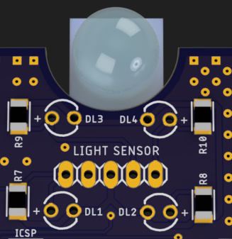 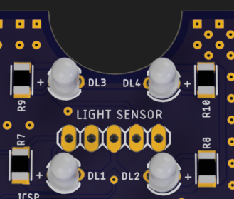 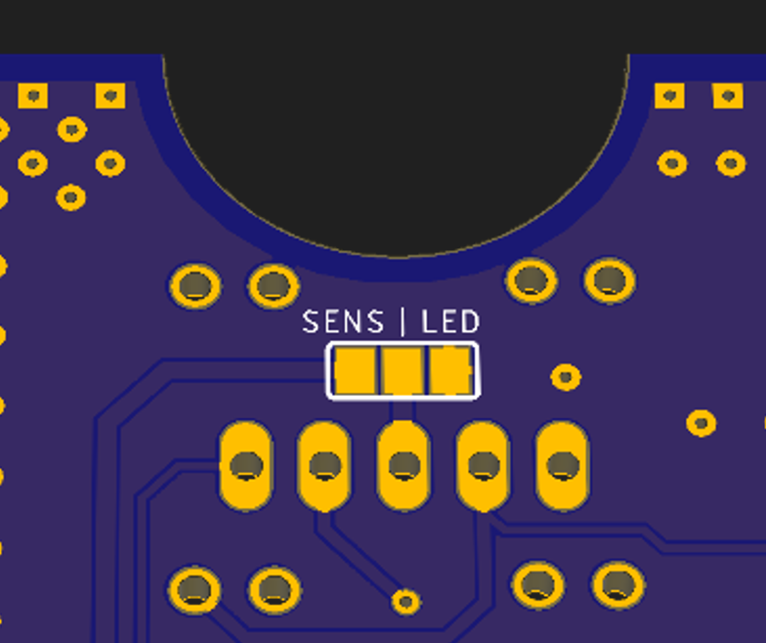

How the shading beam works is best explained by pictures. The left hand side shows the solution for the present Open CPV Solar Tracker on Github. I don’t believe that 3D-prints are the best choice for a 25 years outdoor operation so I would rather opt for the shading beam turned from a 15x15 mm aluminum on the right hand side below.

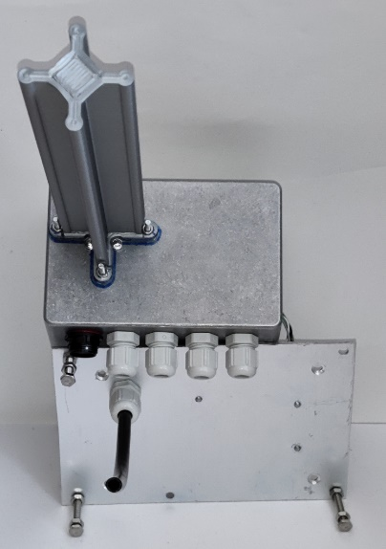 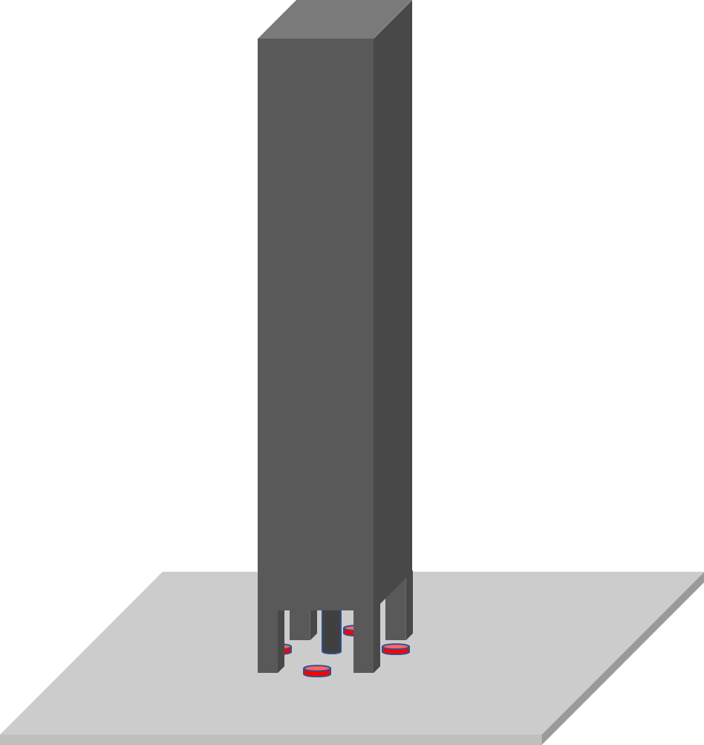

If you don’t want to use the board for general robotics, remove the resistors R7..R10 and use the analog pins any way you like.

### Pins intended for wind sensing

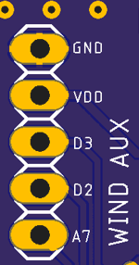

Solar trackers require wind sensors that tell them when to go to store as the wind gets too strong. Commonly, these sensors either generate a voltage signal or they close a reed switch several times per rotation. The voltage may be detected by A7 while the short circuit pulses can be detected by one of the interrupt pins D2 or D3 with internal pull up resistors. If you want to do general robotics, these pins are free for general use.

### Serial communication

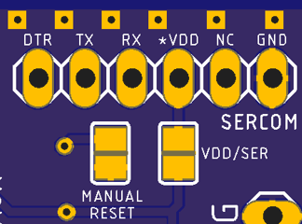

This port may be connected to a FT232 USB to serial adapter. For uploading code, you need to install MiniCore and select the chip ATMEGA328pb running at 8 MHz. The board expects an external power supply. If you want to run the ATMEGA on USB power you need to close the gap between the VDD/SER pads with solder. Be careful, it may happen that the internal 3.3V controller burns if you have the board running at USB power and you then connect an external DC supply. This happens to Arduino Nano boards and it may also happen here. There are two more pads “manual reset” that will do a hard reset when connected.

### RS485 communication

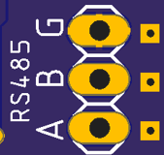

The Arduino serial port is connected to RS485. RS485 uses the differential channels A and B and G is for Ground. We don’t have an internal termination resistor since this resistor needs to fit the impedance of the cable and only the last board in the row should have a termination resistor. You can read about RS485 elsewhere. An important thing to note is that the serial port buffer will quickly fill up with gibberish when the RS485 is in receive mode but no other device controls the bus.

### Extra Pins for ATMEGA328PB

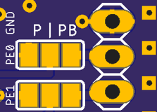

The ATMEGA328PB comes with two extra pins PE0 and PE1 on PortE. They will come handy if you should run out of pins and they even provide another I2C port. With this second I2C port you can turn the board into an I2C slave device which constantly reads the sensors / RTC and controls the motors. This board should therefore be particularly useful in combination with a raspberry Pi robot project. Please bridge the gaps underneath PB if you want to use these pins. If you should have a board with the P chip, you need to close the gaps underneath p and there will not be any PE pins available.

### I2C communication

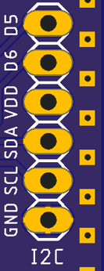

These are the usual I2C pins A4 for SDA and A5 for SCL together with 3.3V VDD and ground. D5 and D6 are unused Arduino digital pins for general use. Concerning I2C, the following 7-bit addresses are already in use

#define PCF8563_ADDRESS 0x51 //< I2C address for PCF8563 real time clock

#define ACC_ADRESS 0x15 // I2C address for accelerometer MXC4005XC,

#define MAG_ADRESS 0x30 // magnetometer address MMC5603

### In Circuit Serial Programmer ICSP and AREF

Front 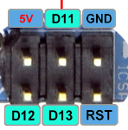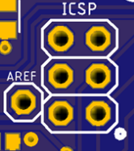  Back 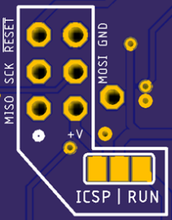

The board comes with an ISCP header in the usual configuration as seen from the frontside. The white spot marks MISO=D12. On the back side, the pin header is mirrored, of course. Many ICSP programmers run on 5V and you would need to do level shifting to adapt the voltage levels to 3.3V. Furthermore, it is not quite clear whether ICSP is reliable for all versions of the ATMEGA328. We therefore included a selector pad to chose the voltage supply to the ATMEGA328. If you close the gap above “ICSP” with solder, the ATMEGA is running on V+ from the ICSP header. Closing the gap above run will put it in normal operating mode powered from the 3.3V voltage regulator on the board. Closing both gaps at the same time is NOT recommended. The effect would be that all chips on the board are powered from the V+ pin when the ICSP programmer is connected.

Following our approach of making all potentially useful pins available, we also provided a pin for AREF.

## Thermal management, encapsulation and mounting

The board is designed to be glued onto an aluminum plate with silicone rubber. The front side should face the plate. We kept it very flat for this purpose and made sure, that the highest parts are plastic housings. You cannot make a short circuit by pressing the board against a metal cooler. The back side can be coated with silicone too, to achieve a hermetic seal.

When the board is used for its primary purpose as a solar tracker controller, the board will be equipped with a shading beam on top of the LEDs as shown in the cross section below. In any case proper precaution needs to be taken that there is a sufficient heat dissipation from the power FETs and the voltage controllers.

The aluminum plate should rest on 3 mounting rods with countered nuts that allow a fine adjustment of the tilt. This tilt adjustment is necessary in the calibration routine on the tracker.



# Prior Art

There are some robotic boards that share some aspects of this board – in particular boards with ATMEGA328 and motor outputs.

* “Arduino Uno R3 Based Robot Control Board” by robokitsworld.com and
* “DFRobot Romeo All In One Robot Controller V1.1”.

Both boards integrate dual dc motor drivers for up to 12V 2A and don’t contain any position sensors or real time clock. In contrast, at 36V, 8A, our board is 12 times more powerful and it contains a 3 axis magnetic compass and accelerometer. Furthermore, the prior boards were not made with encapsulation and heat managment in mind. Certainly, those are great boards for educational robotics projects but they are certainly not meant to drive solar trackers. Therefore, we believe our board fills a gap – certainly concerning solar trackers but also for other projects in the field of outdoor automation.

# Ordering the board

The following screenshots were taken from a quotation request at PCBWay.com.



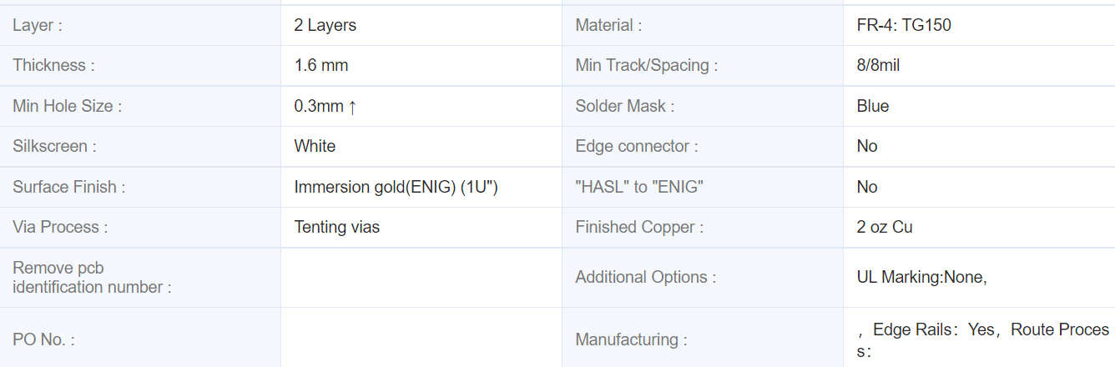

The zip file should contain all necessary data. The increased copper thickness of 2 oz is necessary for sufficient cooling of the FETs and voltage controllers.

# License

The “Magnetic CPV Tracker V2.0f” board and all associated CAD CAM files, parts list, documentation and microcontroller code is published under the MIT license on behalf of Ermanno Antonelli and Ruediger Loeckenhoff. October 2022.

Copyright (c) 2022, Ruediger Loeckenhoff, Ermanno Antonelli

Permission is hereby granted, free of charge, to any person obtaining a copy

of this software and associated documentation files (the "Software"), to deal

in the Software without restriction, including without limitation the rights

to use, copy, modify, merge, publish, distribute, sublicense, and/or sell

copies of the Software, and to permit persons to whom the Software is

furnished to do so, subject to the following conditions:

The above copyright notice and this permission notice shall be included in all

copies or substantial portions of the Software.

THE SOFTWARE IS PROVIDED "AS IS", WITHOUT WARRANTY OF ANY KIND, EXPRESS OR

IMPLIED, INCLUDING BUT NOT LIMITED TO THE WARRANTIES OF MERCHANTABILITY,

FITNESS FOR A PARTICULAR PURPOSE AND NONINFRINGEMENT. IN NO EVENT SHALL THE

AUTHORS OR COPYRIGHT HOLDERS BE LIABLE FOR ANY CLAIM, DAMAGES OR OTHER

LIABILITY, WHETHER IN AN ACTION OF CONTRACT, TORT OR OTHERWISE, ARISING FROM,

OUT OF OR IN CONNECTION WITH THE SOFTWARE OR THE USE OR OTHER DEALINGS IN THE SOFTWARE.