Didel SA, Mouette 5, CH-1092 Belmont
Fax ++41 21 728-6157
info@didel.com www.didel.com

www.didel.com/Turtle.pdf

Miniature Turtle bot
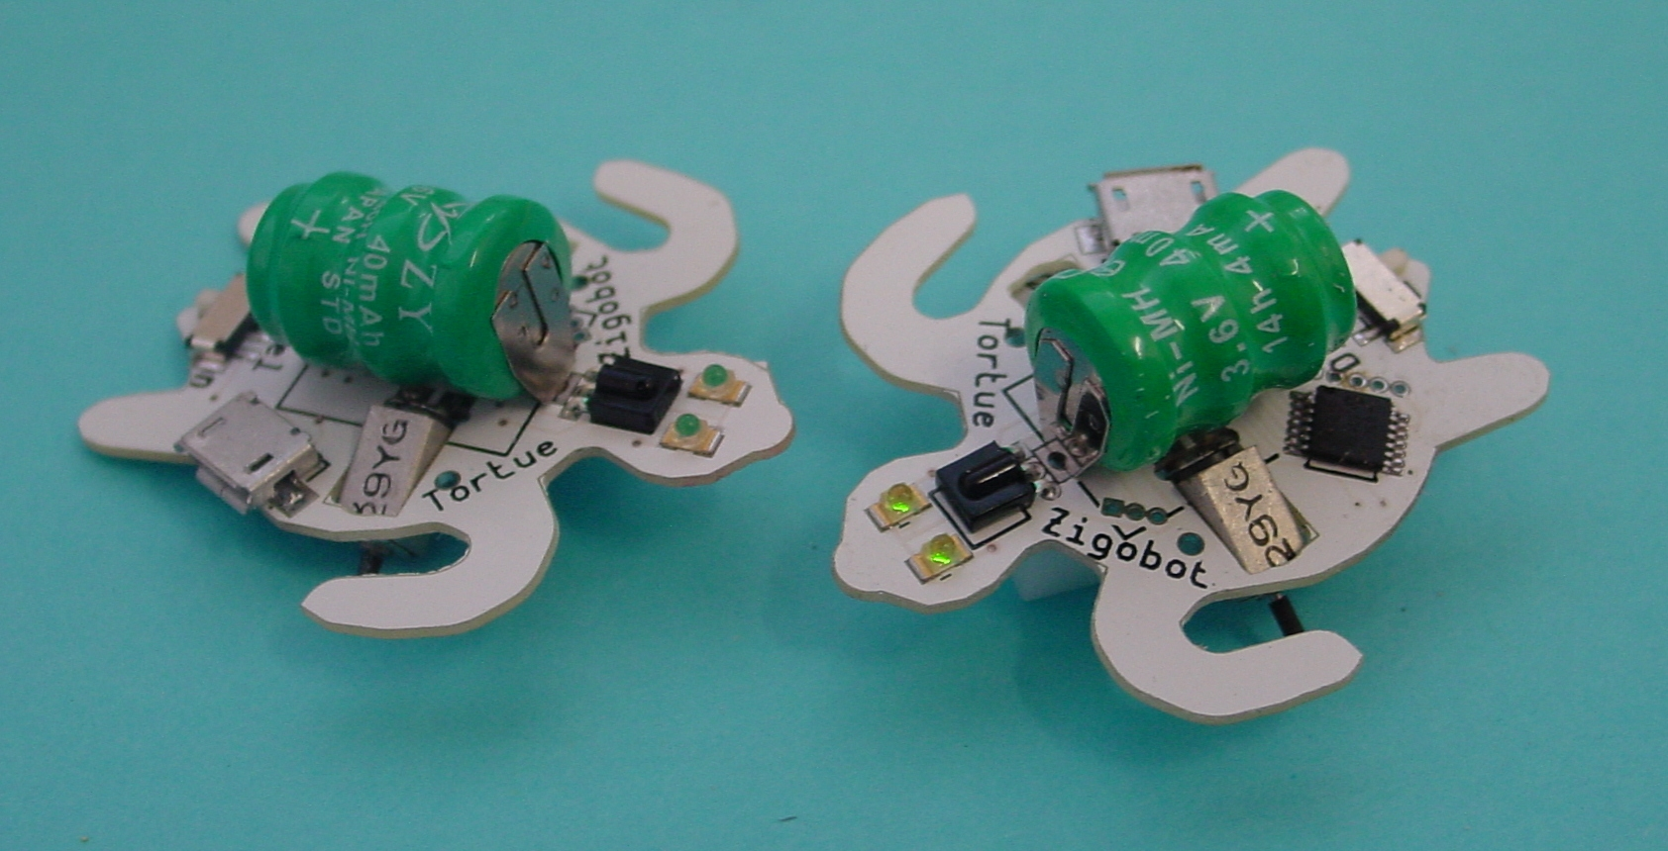

Video under https://youtu.be/ZIXC-oZ3zlI
Recharge in 5-10 h..  Demo 1 Ballet 25 sec  Demo 2 Ballet 15 sec  Demo 3 Ballet 20sec  Demo 4 Cycles 2 minits, 5 stops of 10-20s  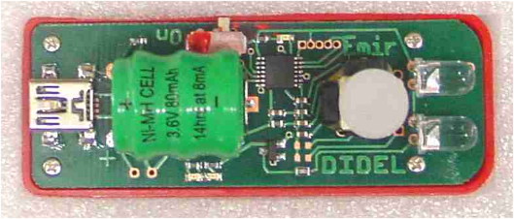 | 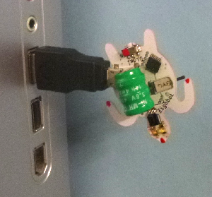

Emir Ir controller (above) or
www.didel.com/Ir/RolloverCommandeArduino.pdf et
www.didel.com/digrove/DgIrIrm.pdf

Demos use 300 bytes of memory. Each movement is encoded inside one byte

\prog;GlDemo.asi  Traj1: ;  Move PtTraj,W  Inc PtTraj  Add W,PCL  Bouge 2, a1,a1  Bouge 1, a2,a  Bouge 1, a2,a  Bouge 2, a1,a1  Stop 1  Bouge 2, r1,r1  Bouge 1, r2,r2  Bouge 1, r2,r2  Bouge 2, r1,r1  Stop 1  etc | 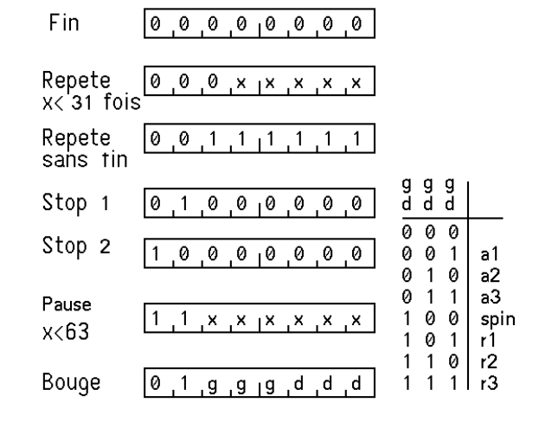
More in French www.didel.com/TortuePub.pdf Contact info@didel.com if you are interested.
Processor is a PIC 16F630. Language is Calm assembler, with easy instructions. IDE is SmileNG, developped at the EPFL.

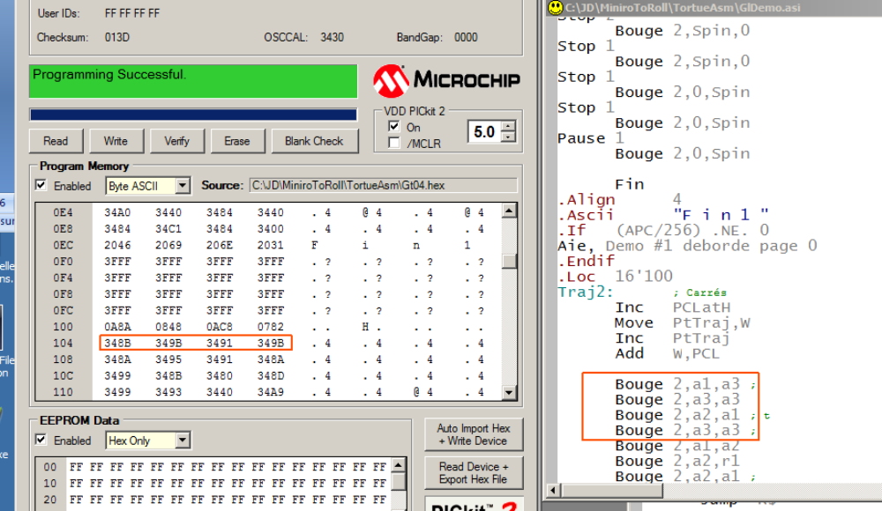
jdn 161210

