Autentification window
- > reset password/ username recovery

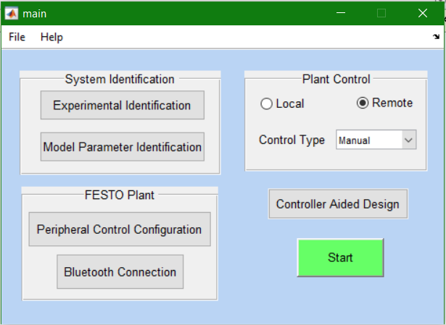

Control type panel – the user will select whether the control is local or remote by ticking a radiobutton. Furthermore, the user selects from a dropdown menu whether the control is manual or automatic.
System identification panel – button for experimental identification and button for model parameter identification
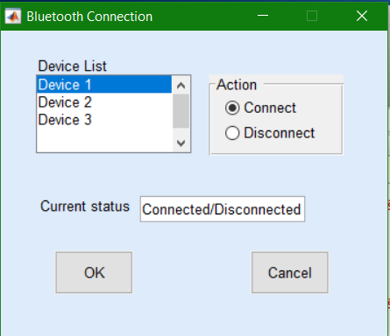
Bluetooth connection – will open the following window in which the user can view the device list and the connection status.
The current connection status of the chosen device will be displayed and the user can choose to connect ( if the current status = disconnected ) or to disconnect ( if the current status = connected ).
The Command&Output window should be displayed for each connected device. If the user chooses to connect to 3 devices, the Command&Output window should open 3 times
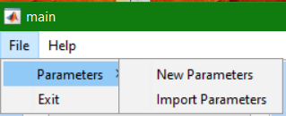
In the bar menu there will be 2 submenus :
- File:
- Parameters -> New Parameters, Import Parameters
- Exit

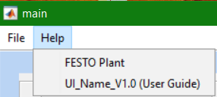
- Help :
- FESTO Plant
- UI user guide

“Experimental identification” button – opens the following window:
The name of the connected device will be displayed.
It will allow the user to set up the PRBS signal used in the identification procedure: the length, the magnitude, the register length and the frequency divider.
The user can also choose the structure of the model and in the panel next to the radiobuttons list, the chosen structure schema will be displayed.

“Start” button - opens a new window which displays the following: the current command and output values, their plots , the current control algorithm, the reference, the sampling period, the performance parameters. Should look like in the following image:
The current control algorithm and current command and output values will be displayed. Furthermore, the user is allowed to select the reference, the sampling period.
Plots – they will be generated using the data acquired from the process.
Plot selection – panel which contains 3 checkboxes; the user can select which plot to display by ticking the desired checkboxes.
Performance parameters – displays the overshoot, settling time, rise time
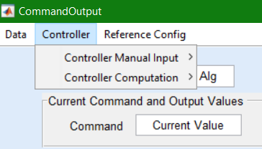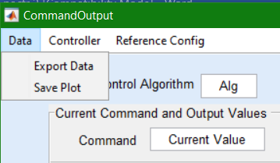
In the bar menu from the Command&Output window, the user can do the following:
- export the data and save the plot;
- insert the parameters for a controller – Controller Manual Input;
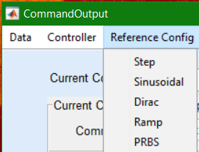
- compute a controller – Controller Computation.
In the same menu, the user can choose the reference type from a dropdown menu.
On selecting the reference from the dropdown menu, a new window for configuring the reference will open. The reference options in the dropdown menu are: step, ramp, Dirac, sinusoid. The user can type in the magnitude (step, ramp, Dirac, sinusoid), initial phase, frequency (sinusoid).

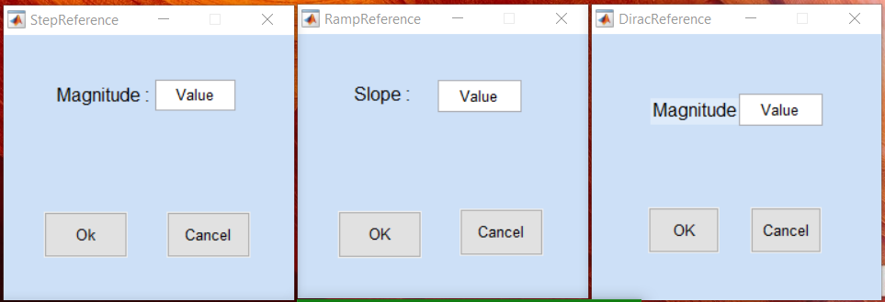
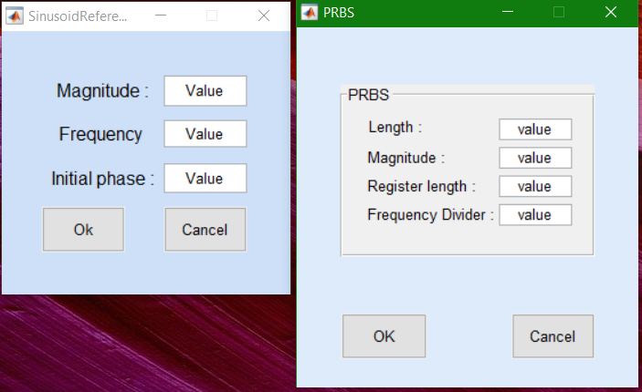
Execution Element Control – opens a window in which the user can choose which valve to oopen or close and which pump to use.
Controller Manual Input – the user can choose a PID or a RST controller.
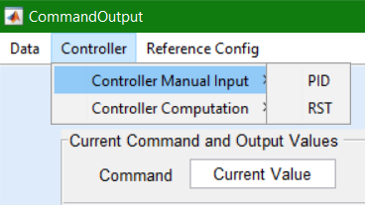
On selecting the option, a window for inserting the controller’s parameters opens. Should look like in the folowing picture:
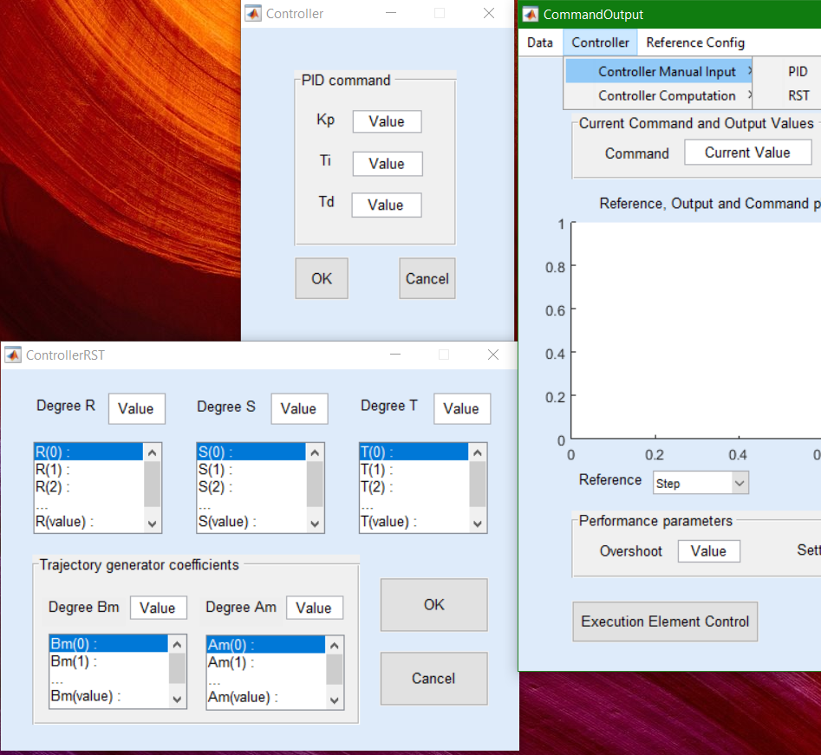
The user can insert the PID controller’s parameters or the R,S,T polynomials’coefficients, depending on the selected option.

Controller Computation – the user can select to compute a PID controller or a RST controller from a dropdown menu.
The window that opens when selecting to compute a PID controller should look like in the picture. It should allow the user to choose the controller type (P,PI,PID), the design method and the discretization method, considering that the application designs the controller in continuous time.
The window which opens when selecting to compute a RST controller should look like in the picture. It should allow the user to select the tracking and regulation roots and to specify the HR and HS filters in order to create a robust command. The ‘’R-S-T coeffcients’’ button will display the coefficients of the R,S,T polynomials.
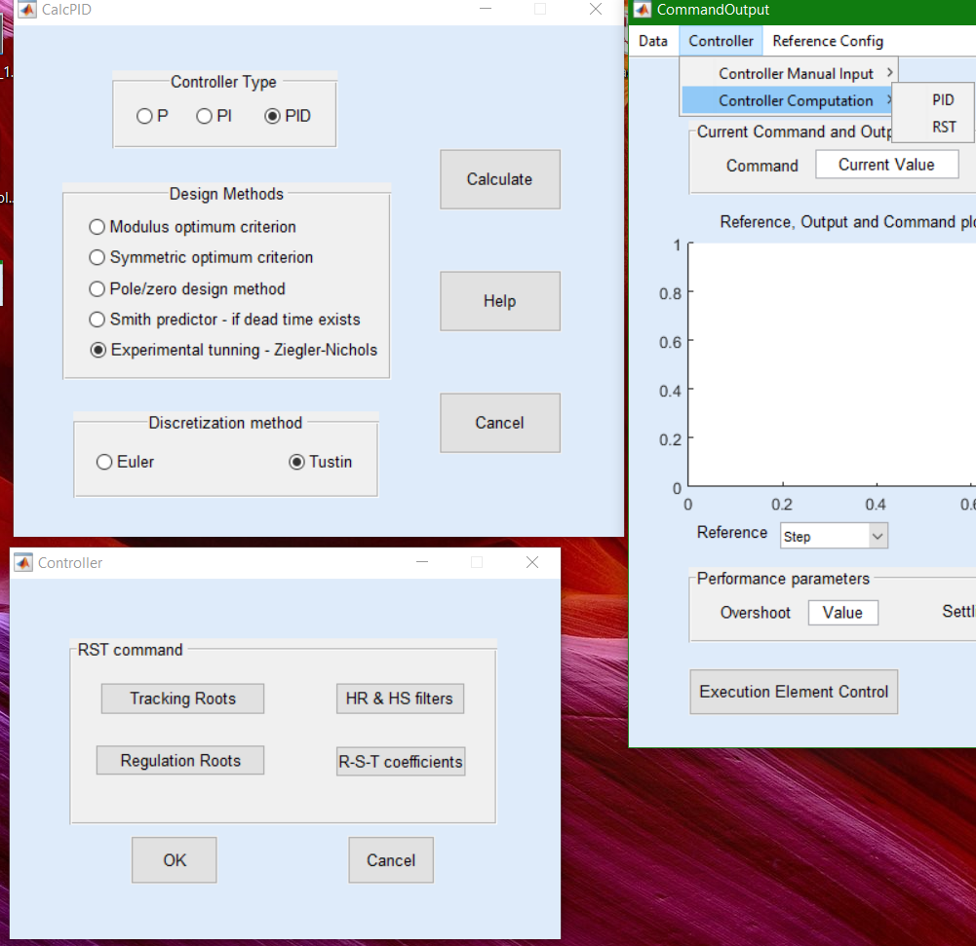
Tracking Roots – opens a windows in which the user can choose the desired poles.
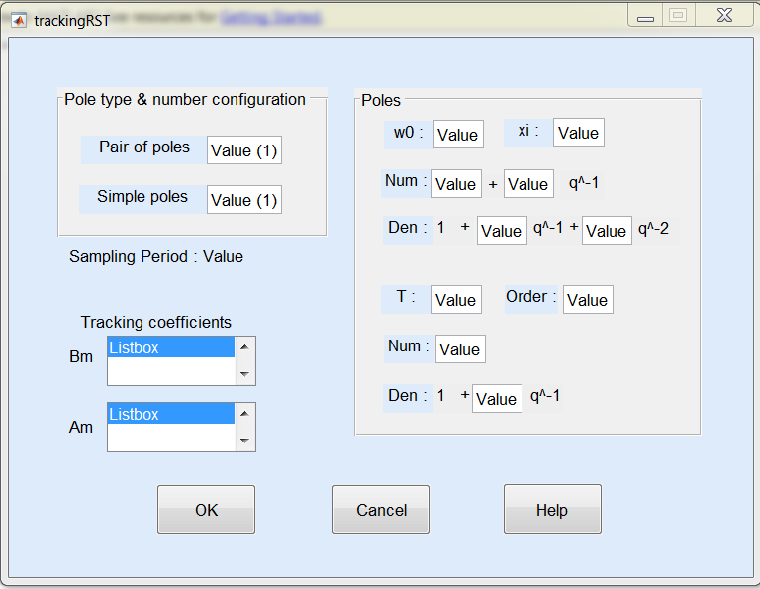
Sampling Period : Value – the sampling period is displayed in order to remind the user of its value.
The user inserts the number of simple poles and the number of pole pairs . In this example, there is one pair of poles and one simple pole with the corresponding fields in the right panel named “Poles’ being displayed.
If the user chooses to have 2 pair of poles instead of one, the field for w0,xi,Num,Den are displayed twice (first field group, from the line w0,xi, to the line Den).
If the user chooses to have 2 simple poles, the fields for T, Order, Num, Den (like in the second field group) are displayed twice.
The maximum number of fields on the ‘Poles’ panel on the right should be 4. This means that the user can insert 4 pair of poles and 0 simple poles or similarly, 4 simple poles and 0 pair of poles. The user can insert as well any combination of numbers of pole pair and simple poles as long as the sum of the number of fields for each pole type is 4 at most. This means : 1 pole pair and maximum 3 simple poles ( however the user can choose from 0 to 3 simple poles), 2 pairs of poles and maximum 2 simple poles, 0 pair of poles and 0-4 simple poles and so on and so forth.
Furthermore, the ‘Poles’ panel from the right should be adjustable to the number of generated fields.
In the Bm,Am listboxes, the coefficients of the trajectory generator’s polynomials will be displayed immediately after the user inserts the specifications for the desired poles.
Help button – should open a document which should contain useful information regarding the pole choosing procedure.
Ok – saves current configuration and closes the window
Cancel – doesn’t save the current configuration and closes the window
Regulation Roots – opens a windows in which the user can choose the desired poles.
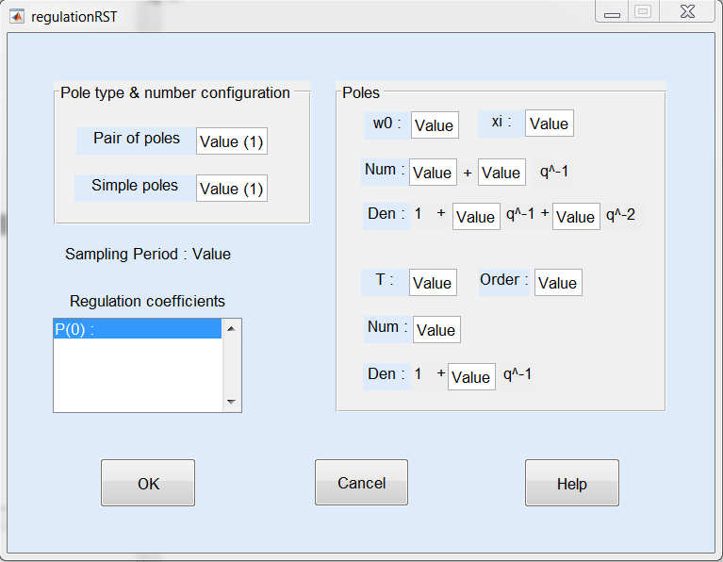
‘Pole type & number configuration’ panel – same as for the ‘Pole type & number configuration’ panel in the Tracking Roots window
‘Poles’ panel – same as for the ‘Poles’ panel in the Tracking Roots window.
‘Regulation coefficients’ listbox – displays the coefficients of the polynomial P after the user inserts the desired specifications for the poles.
Help button – should open a document which should contain useful information regarding the pole placement procedure.
Ok – saves current configuration and closes the window
Cancel – doesn’t save the current configuration and closes the window

Peripheric Device Configuration

-> definire/inregistrare device periferic specific ( exp: creez un device nou: are HWAddress, Name, Config default pentru conexiunea BT : frecventa => acestui device ii asociez un id unic pentru aplicatia mea de exp: DevicePresiune, Device 1, etc) . In final o sa am o table de mappare intre Device Name si phisical parameters.
-> stergere/editare device periferic;

