Formula Student
In the world of automotive academia, Formula Student embodies a blend of youthful zeal and engineering prowess. With wrenches in hand and dreams in mind, students craft racing marvels from raw concepts. It's more than just speed; it's a symphony of collaboration and resilience. Amidst the clang of metal, bonds are forged, and camaraderie thrives. To the spirited Formula Student teams, I salute your ingenuity and wish for harmonious engines, soaring innovations, and a fulfilling academic journey.
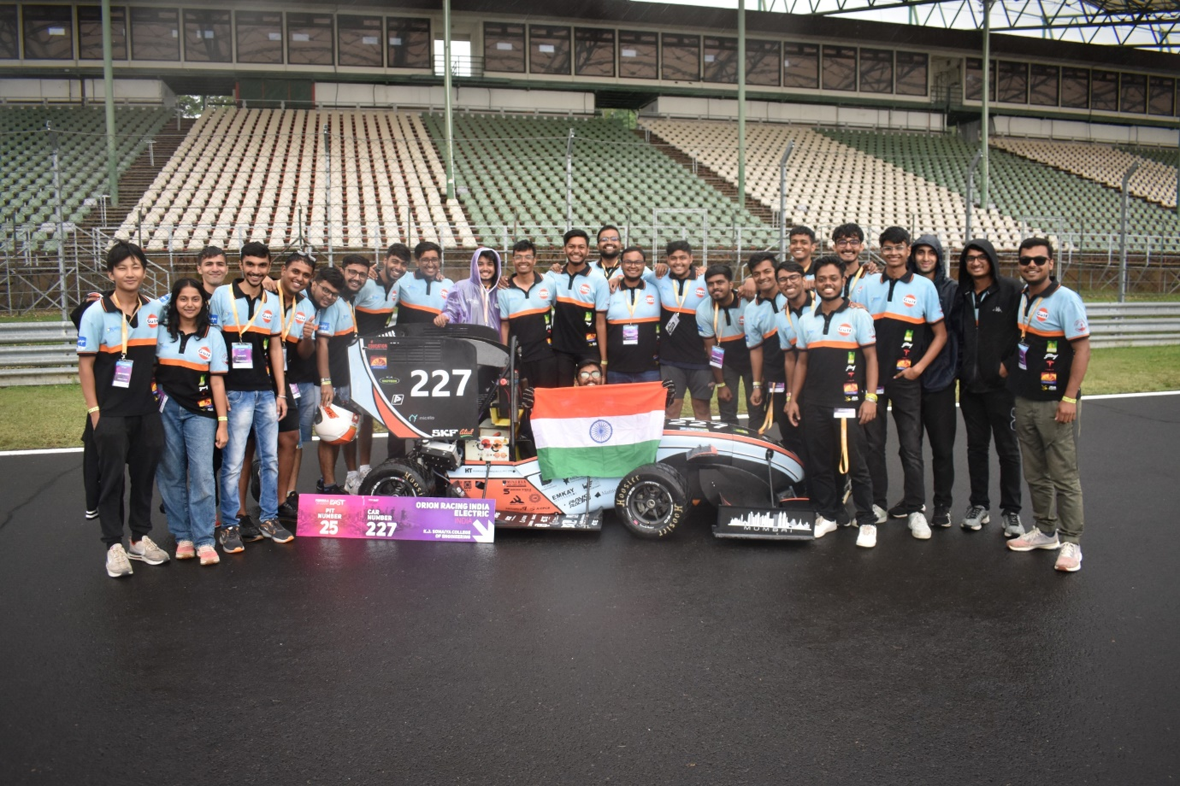
A student team building a Formula style car!
In the world of Formula Student, Orion Racing India, a team hailing from Mumbai's K. J. Somaiya College of Engineering, has been a dominant force since 2006. With over sixty dedicated undergraduates, they've crafted Pegasus, a marvel of engineering excellence. Their prowess extends beyond local acclaim, leaving tire marks on circuits worldwide.
Despite their achievements, Orion Racing India refuses to rest on their laurels. As they gear up for the 2025 season, whispers of groundbreaking ventures into autonomous driving technology echo through their workshop. Their relentless pursuit of innovation sets them apart as a formidable contender in the Formula Student arena.
Orion Racing India stands as a testament to the indomitable spirit of engineering ingenuity and teamwork. With each lap, they push the boundaries of what's possible, proving that in the world of motorsport, the pursuit of excellence knows no bounds.
So just another student project?
Wrong, Orion Racing India distinguishes itself from conventional student projects through its participation in Formula Student, a highly competitive program that pits student-built racing cars against each other on international circuits. With a team of over sixty dedicated undergraduates, Orion Racing India operates on a scale that allows them to tackle complex engineering challenges and refine their designs to professional standards. Their track record of success on the global stage and their commitment to pushing the boundaries of automotive technology set them apart as a premier student-led engineering endeavour.
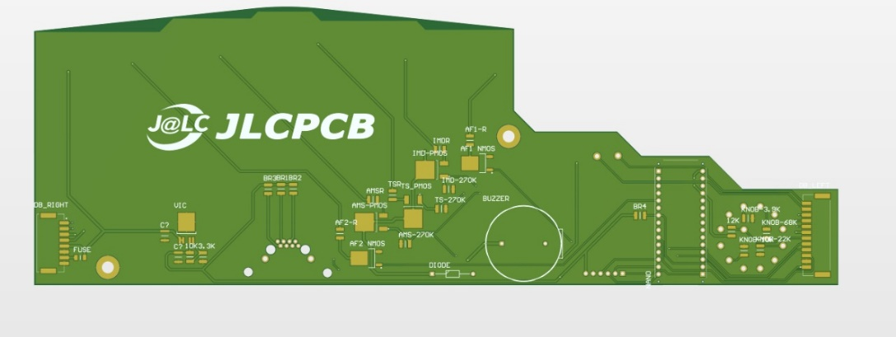
Unlike typical student projects, Orion Racing India's endeavours extend beyond the confines of academic exercises. Their participation in Formula Student provides invaluable real-world experience in vehicle design, manufacturing, and racing, preparing team members for careers in the automotive industry. This blend of academic rigor and practical application elevates Orion Racing India beyond just another student project, positioning it as a beacon of innovation and excellence within the Formula Student community and beyond.

Gratitude to Our Valued Sponsor: JLCPCB
In the realm of motorsport, Orion Racing India from Mumbai's K. J. Somaiya College of Engineering stands as a juggernaut of engineering prowess, rewriting the rulebook in Formula Student since 2006. Amidst the chaos of the racetrack, our valued sponsor, JLCPCB, emerges as a silent hero, offering unwavering support as we prepare for the challenges of the 2024 season in Formula Student Austria.
"The team at JLPCB has been so helpful from every step...the realization of our dreams has been witnessed by JLCPCB," expressed an engineer at Orion Racing India. With their belief in our vision and commitment to our cause, JLCPCB serves as a source of inspiration, propelling us forward with renewed vigour and determination. Together, we look forward to conquering new horizons on the track, proving that when passion meets determination, the sky's the limit, and there's no finish line in sight.

