From Schematic to Reality: Designing and Ordering Your Custom PCB with JLCPCB

Have a brilliant electronic project in mind? Bringing your vision to life often starts with a Printed Circuit Board (PCB). This article guides you through the exciting process, from designing your PCB using user-friendly software to placing an order with JLCPCB, a leading manufacturer known for its high quality and fast turnaround times.

Design Your Dream PCB
The journey begins with planning. Identify the components needed for your project and select them using PCB design software. Popular options include Altium Designer, KiCad EDA, and Autodesk EAGLE (the focus of this article). These programs allow you to create a schematic – a blueprint for your circuit – by placing and connecting components virtually.

Once your schematic is complete, it's time to translate it into a physical layout. This phase, called "PCB routing," involves strategically positioning the components on the board and connecting them with copper traces. The goal is to minimize wire crossings for optimal performance and a clean aesthetic. Autodesk EAGLE offers various routing tools to help you achieve this, including vias (holes that allow connections between different board layers).
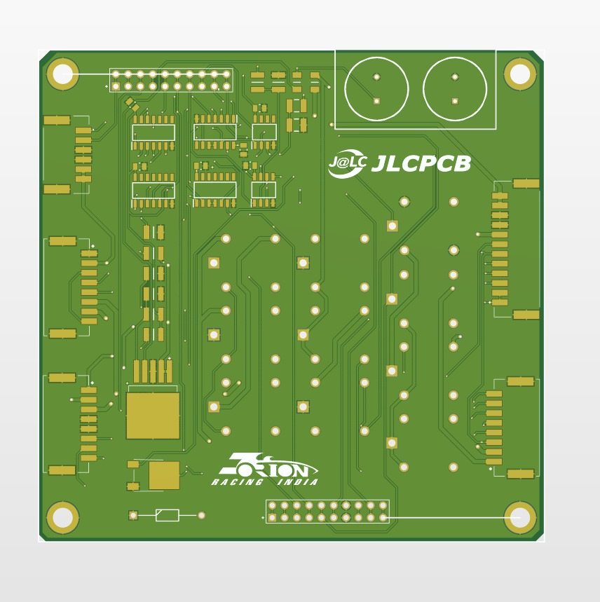
Soldering and Beyond: Bringing Your PCB to Life
With your design finalized, it's time to order the PCBs! JLCPCB is a great choice, offering exceptional quality and speedy production. Here's a step-by-step guide on placing an order:
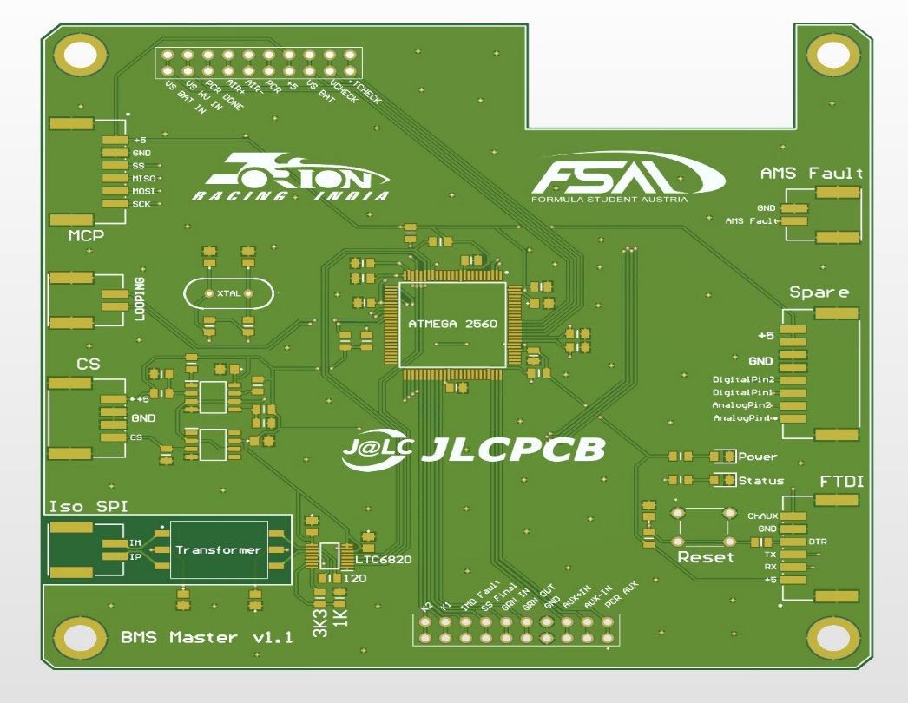

Head to JLCPCB's website
Simply visit [JLCPCB homepage: https://jlcpcb.com/RAT]. Sign up for an account if you're new, or log in if you're a returning customer.
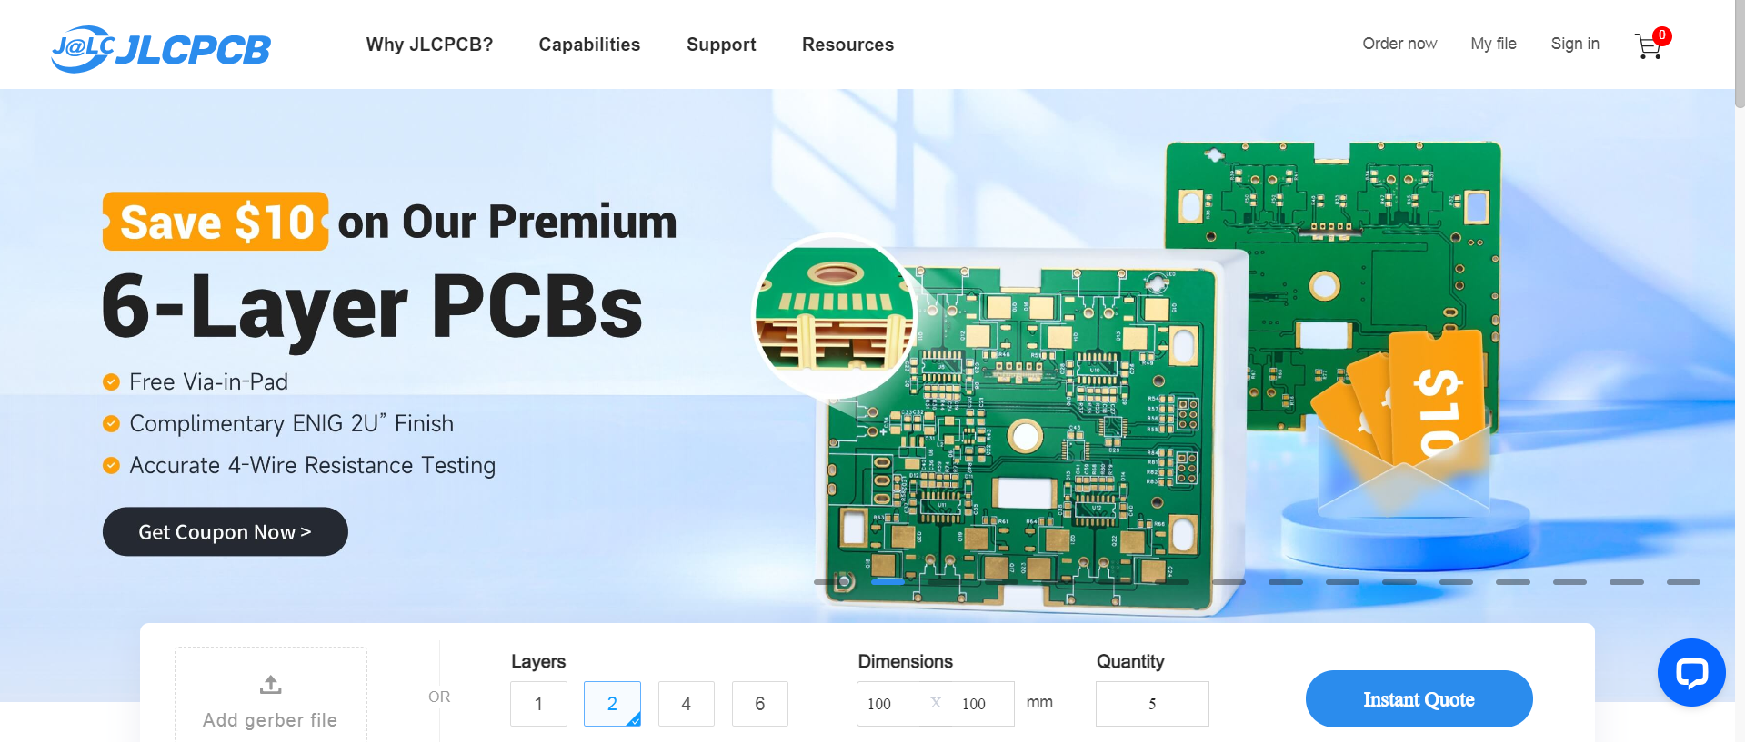
Get a quick quote
The homepage features a convenient quote calculator. Enter details like your PCB's size, quantity, number of layers, and desired thickness to get an instant estimated price. Alternatively, you can access the dedicated ordering page at [JLCPCB quote page].
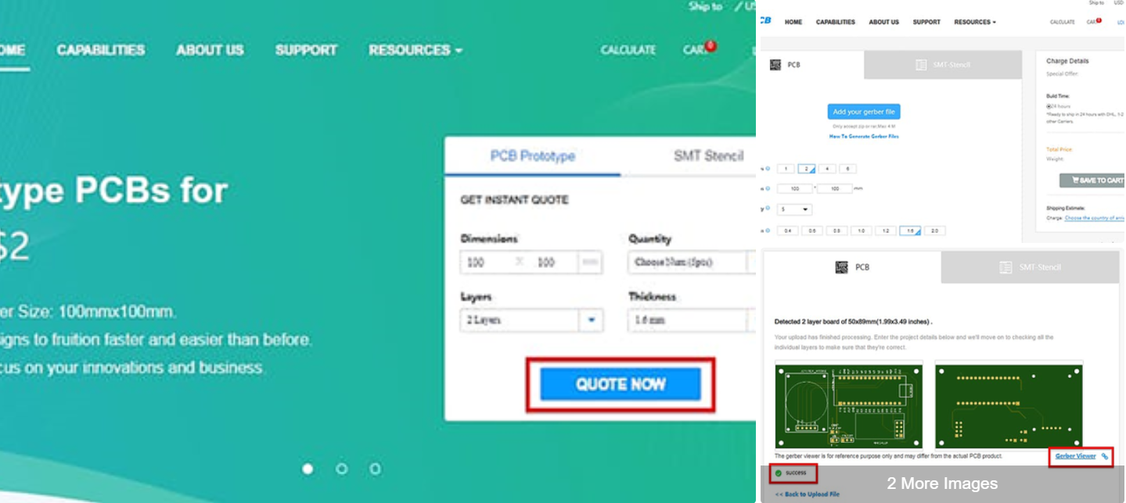
Order details and file upload
Provide specifics about your PCB in the online quote calculator. Click "Add your Gerber file" to upload the Gerber files generated by your design software. These files are essential for manufacturing your PCB. JLCPCB assigns a unique Customer ID for identification purposes. If you prefer a specific location for this ID, simply add the text "JLC" within your design.

Review and confirmation
JLCPCB's system automatically analyzes your uploaded Gerber files, detecting board dimensions and layer count. After successful upload, a "Gerber Viewer" option allows you to verify your design for any errors. Once you're satisfied, click "Save to Cart" to proceed

Adding multiple PCBs and checkout
Need to order several PCBs? Click "Add new item" and repeat steps 3 and 4. Once all your PCBs are in the cart, proceed to checkout securely. Here, you can enter your shipping address and choose a shipping method (shipping rates vary depending on your location).

Payment and production
After successful payment, JLCPCB prioritizes your order for manufacturing as soon as possible. You'll be notified about the progress, and soon, your custom PCBs will be ready to bring your electronics project to life!

JLCPCB: Your PCB Partner
JLCPCB stands out as a leader in the PCB prototyping and small-batch production industry. With over 14 years of experience, they've earned the trust of over 800,000 customers worldwide. Their commitment to quality, competitive pricing, and rapid turnaround times makes them an excellent choice for hobbyists, entrepreneurs, and businesses alike.

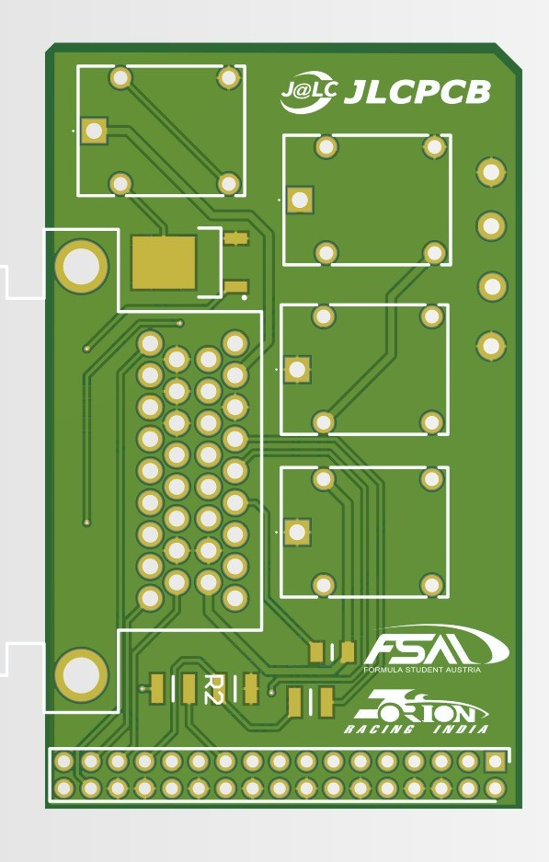
So, unleash your creativity! Design your dream PCB using user-friendly software and embark on the exciting journey of transforming your ideas into reality with JLCPCB as your reliable manufacturing partner.

