【Ai-Thinker Radar Rd-03L_V2 User Guide – Ultra-Low Power Human Presence Detection, Quick Setup via PC Software, Ready to Use】

### Introduction

The **Rd-03L_V2** is an ultra-low power millimeter-wave human presence sensor module developed by Ai-Thinker. It features a simplified 24GHz radar sensor hardware and a low-power human presence detection algorithm firmware.

Equipped with the AloT millimeter-wave sensor SoC **ICL1112**, a high-performance 24GHz 1T1R antenna, and peripheral circuits, the module utilizes distance measurement technology combined with advanced proprietary radar signal processing and low-power control technology from the ICL1112 chip to accurately detect moving, micro-moving, and stationary human bodies.

This low-power detection algorithm is mainly designed for indoor applications to sense whether there are moving or micro-moving human bodies within the area, continuously updating the detection results in real time under low-power mode.

## 1. Rd-03L_V2 Appearance and Pin Description

### 1.1 Appearance Display

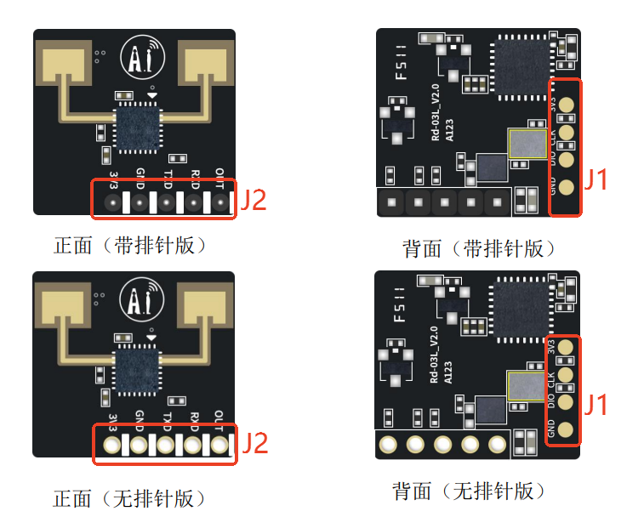

### 1.2 Pin Description

⚠️ **Note**: The debugging interface and programming interface cannot be used simultaneously.

#### Debugging Interface (TTL-USB Debugger)

| **J2-Pin#** | **Name** | **Function** | **Description** |
| --- | --- | --- | --- |
| J2-Pin5 | OUT | IO, reports detection status; high level = presence, low level = absence | 0~3.3V |
| J2-Pin4 | RX | UART_RX | 0~3.3V |
| J2-Pin3 | TX | UART_TX | 0~3.3V |
| J2-Pin2 | GND | Ground | - |
| J2-Pin1 | 3V3 | Power Input | 3.0~3.6V, Typ. 3.3V |

#### Programming Interface (J-Link Debugger)

| **J1-Pin#** | **Name** | **Function** | **Description** |
| --- | --- | --- | --- |
| J1-Pin4 | 3V3 | Power Input | 3.0~3.6V, Typ. 3.3V |
| J1-Pin3 | CLK | SWD Clock Line | 0~3.3V |
| J1-Pin2 | DIO | SWD Data Line | 0~3.3V |
| J1-Pin1 | GND | Ground | - |

## 2. Rd-03L_V2 Operating Steps

### 2.1 Download PC Software and Related Materials

Download link: [Click to download](https://docs.ai-thinker.com/_media/icl_xend106ltool_v1.3.3.2.zip)

Or visit the Ai-Thinker docs page for more resources on Rd-03L_V2: **[Rd-03 Series](https://docs.ai-thinker.com/_media/21090017-rd-03l_v2specification_en_20250425.pdf)**

### 2.2 Module Wiring

| **Rd-03L_V2 Module** | **USB to TTL Converter** |
| --- | --- |
| 3V3 | Vo (3V3) |
| GND | GND |
| TX | RXD |
| RX | TXD |

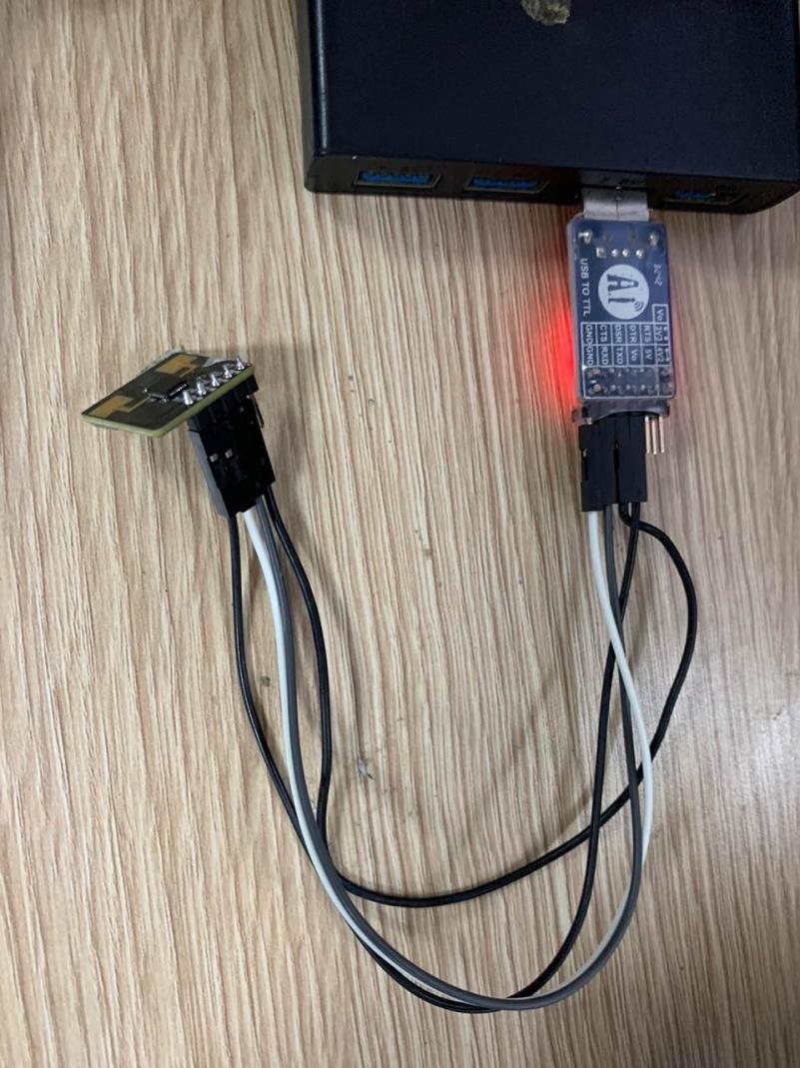

### 2.3 Module Installation

The Rd-03L_V2 radar module is designed for wall-mounted installation at a height of **1.5–2m**. The installation orientation is shown below:

* **X-axis: 0°**,
* **Z-axis: 90°**,
* **Y-axis** is perpendicular to the X-Z plane (normal direction).

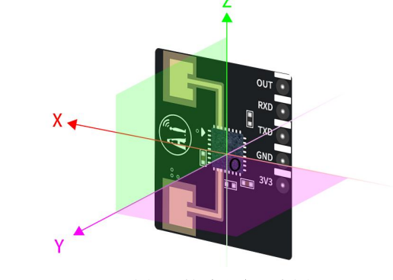

When wall-mounted at 1.5m, the default detection range is a conical space with a **6m distance in the normal direction** and **±60° angle in the horizontal and pitch directions**.

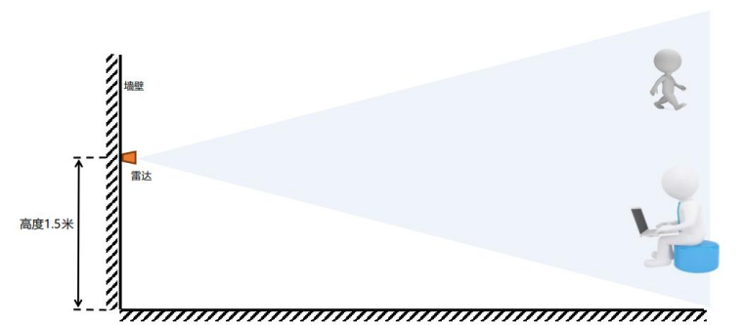

### 2.4 Quick Setup via PC Software

**Note**: The Rd-03L_V2 PC software and serial port tool cannot be used simultaneously.

After completing wiring (Step 2) and proper installation (Step 3), open the PC software:

1. Refresh the port list (bottom left corner);
2. Select the correct COM port;
3. Set baud rate to **256000 bps**;
4. Click **Connect Device**.

After successful connection, click **Auto Threshold Generation**.

The radar will scan the environment during this process — **ensure no human presence within the detection area during the 120–240 second scan period**.

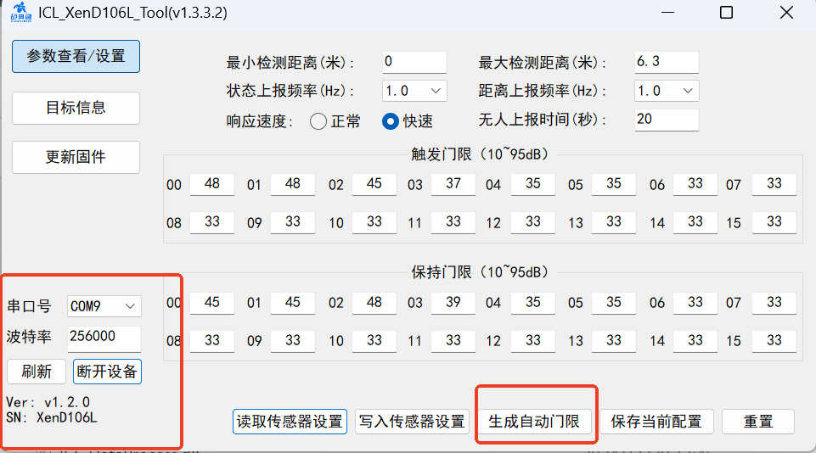

After scanning, the thresholds are applied automatically. Close the window to finish.

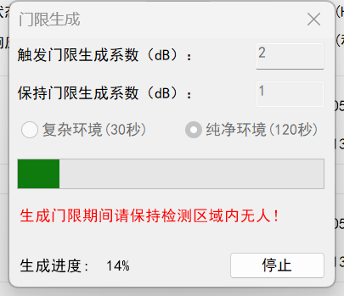

After successful threshold generation, the threshold values for each distance gate will change according to the algorithm.  
**Note**: Manually adjust the trigger and hold thresholds of distance gates 00 and 01 to around **42** after auto-generation.

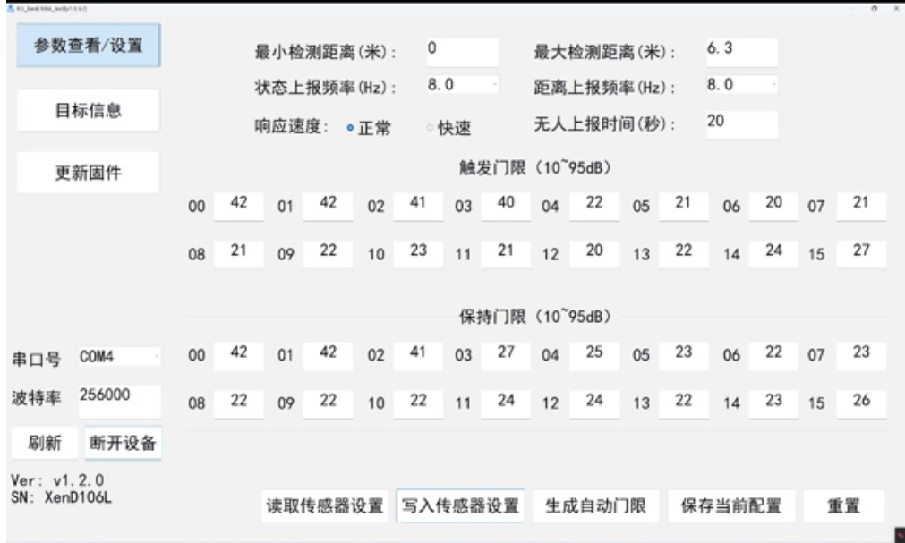

Additional settings allow for defining minimum and maximum detection distances (up to **6.3m**), adjusting reporting frequencies:

* **Distance reporting frequency**: 1–8Hz (max 8Hz);
* **Status reporting frequency**: multiple of the distance reporting frequency (e.g., if set to 4Hz, status reporting can be 4Hz or 8Hz).

Response time can be set to **Normal** or **Fast** to define the time the sensor reacts when a person enters the detection zone.  
**No-person reporting delay**: adjustable between **10–120 seconds**, determines the delay before switching status from presence to absence.

After adjustment, click **Write to Sensor** to save the settings.

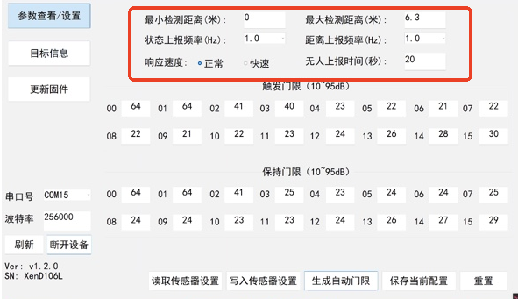

### 2.5 View Data via PC Software

Once parameters are set, real-time radar detection data can be viewed in the **Target Information panel**. Clicking "Start" shows energy values for each distance gate. When a gate is triggered, the status indicator turns red, target state shows "Presence", and distance is displayed.

Below, the software estimates **average current consumption** based on the reporting frequency.  
Higher reporting frequency results in higher current and power consumption, while lower frequency reduces both.

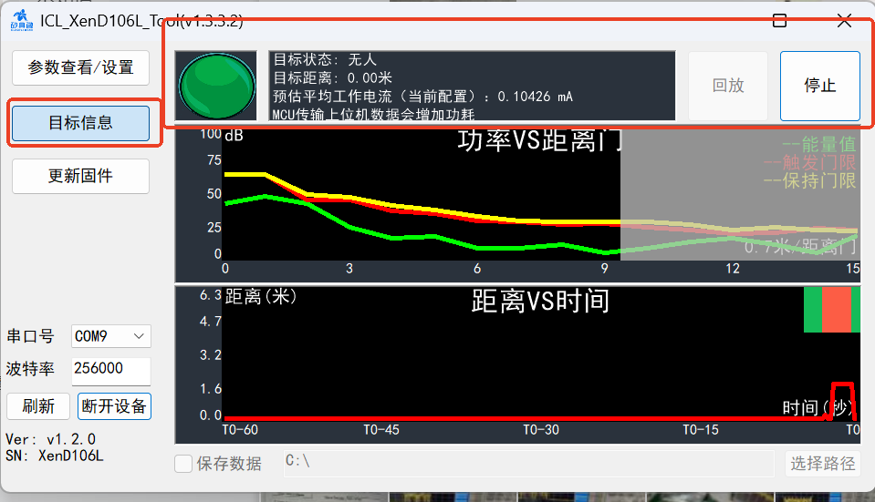

## 3. Power Consumption Test

Rd-03L_V2 achieves ultra-low power consumption by adjusting the reporting frequency. Ai-Thinker has tested and provided reference current values under different frequencies:

* **Test Equipment**: KEYSIGHT_N6705C Current Analyzer

