Dirt Cheap Robot
Assembly Instructions
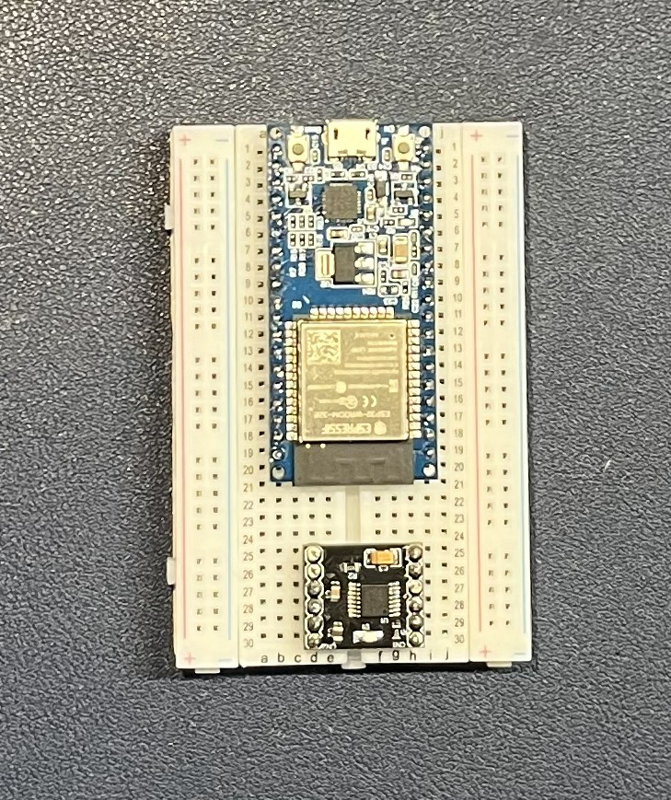
- Place the ESP32 board into the breadboard as shown.

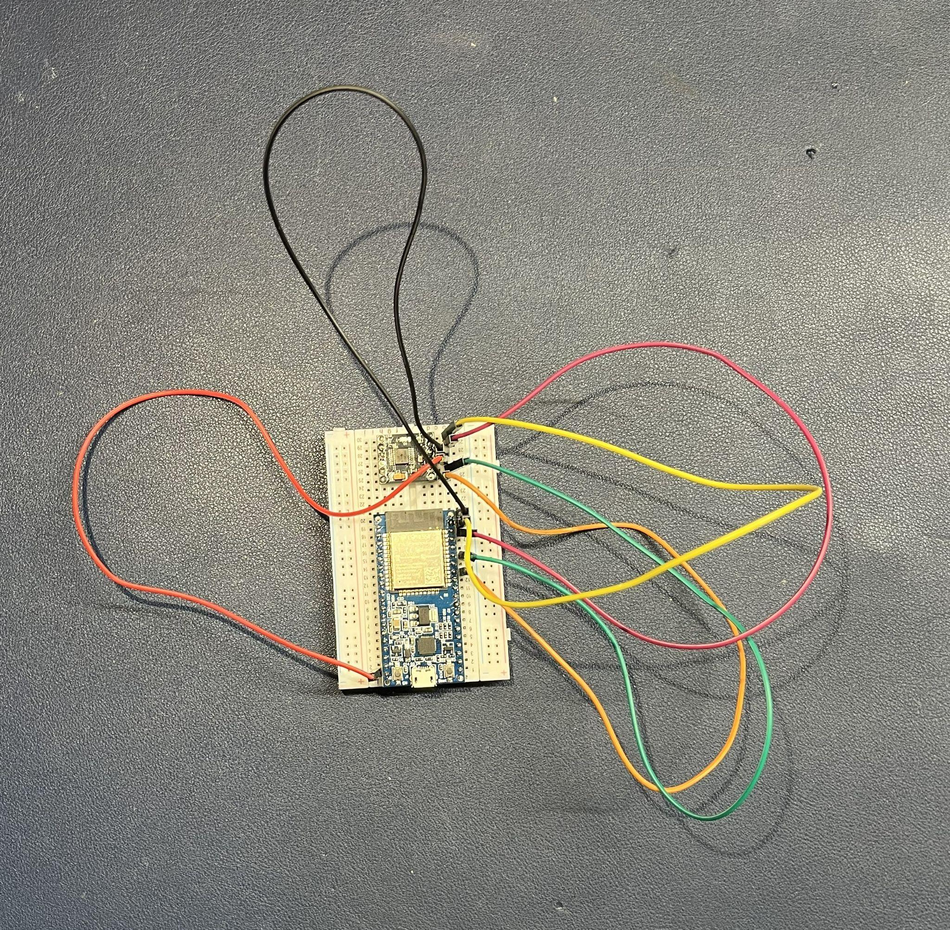
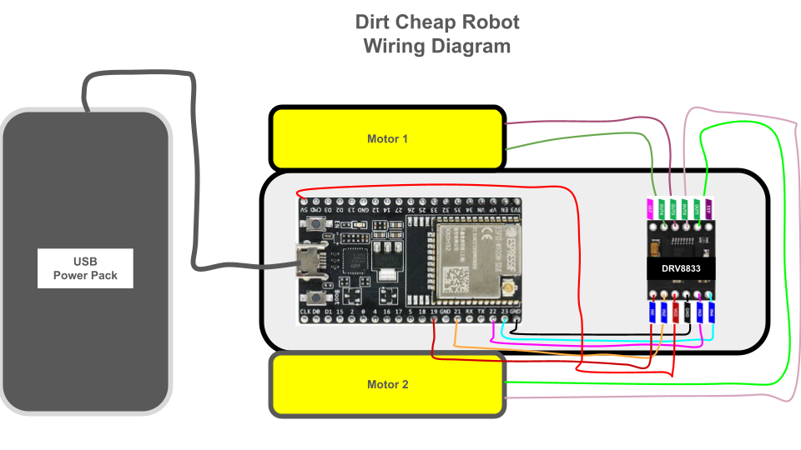
- Attach the wires as shown in the wiring diagram and picture.

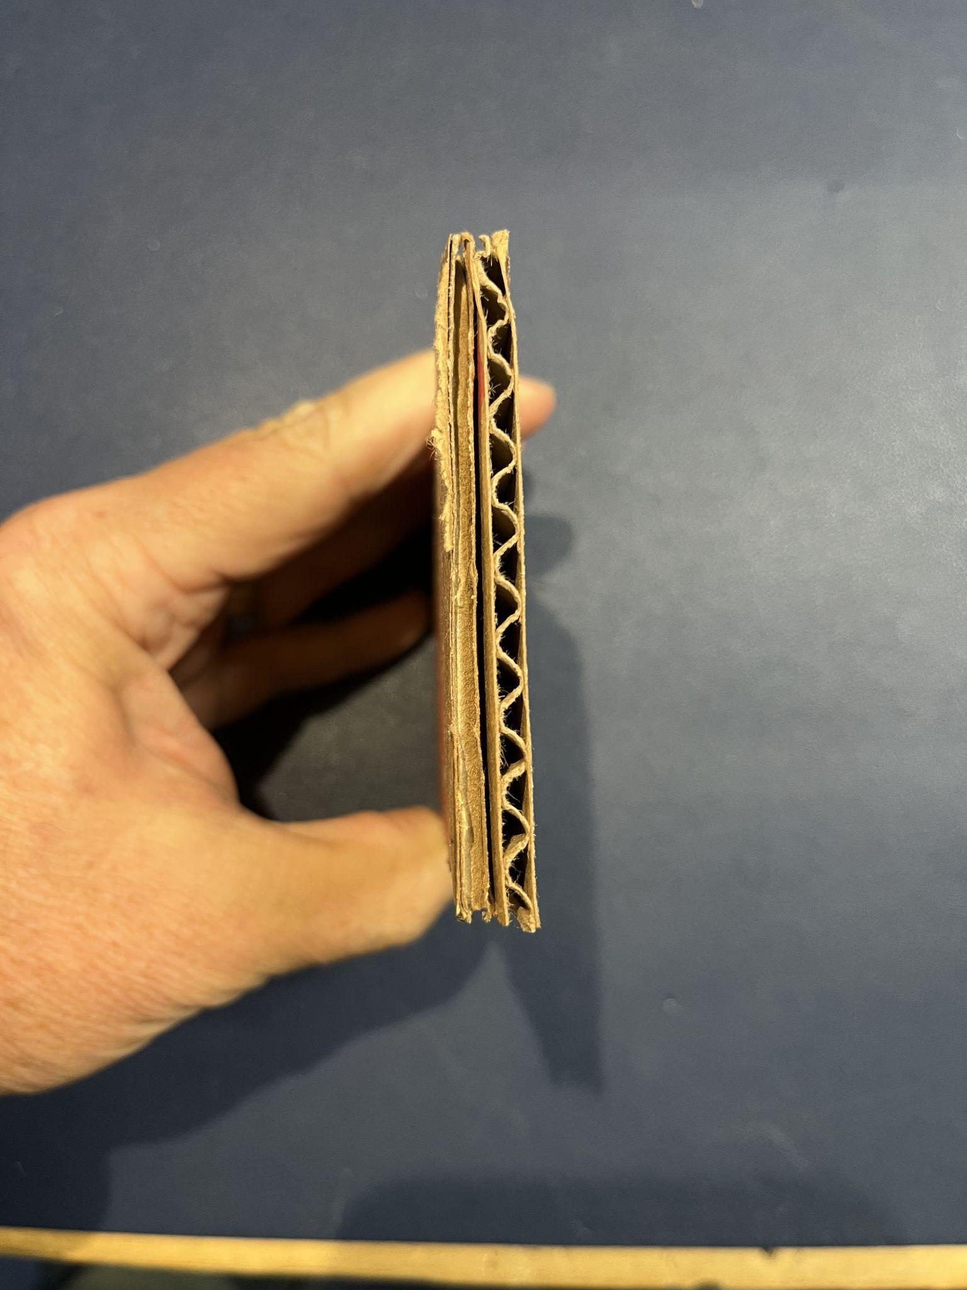
- Cut two pieces of cardboard into rectangles 3” x 5 ½” in size. Make sure the two pieces of cardboard are opposite grains to add strength (See picture).

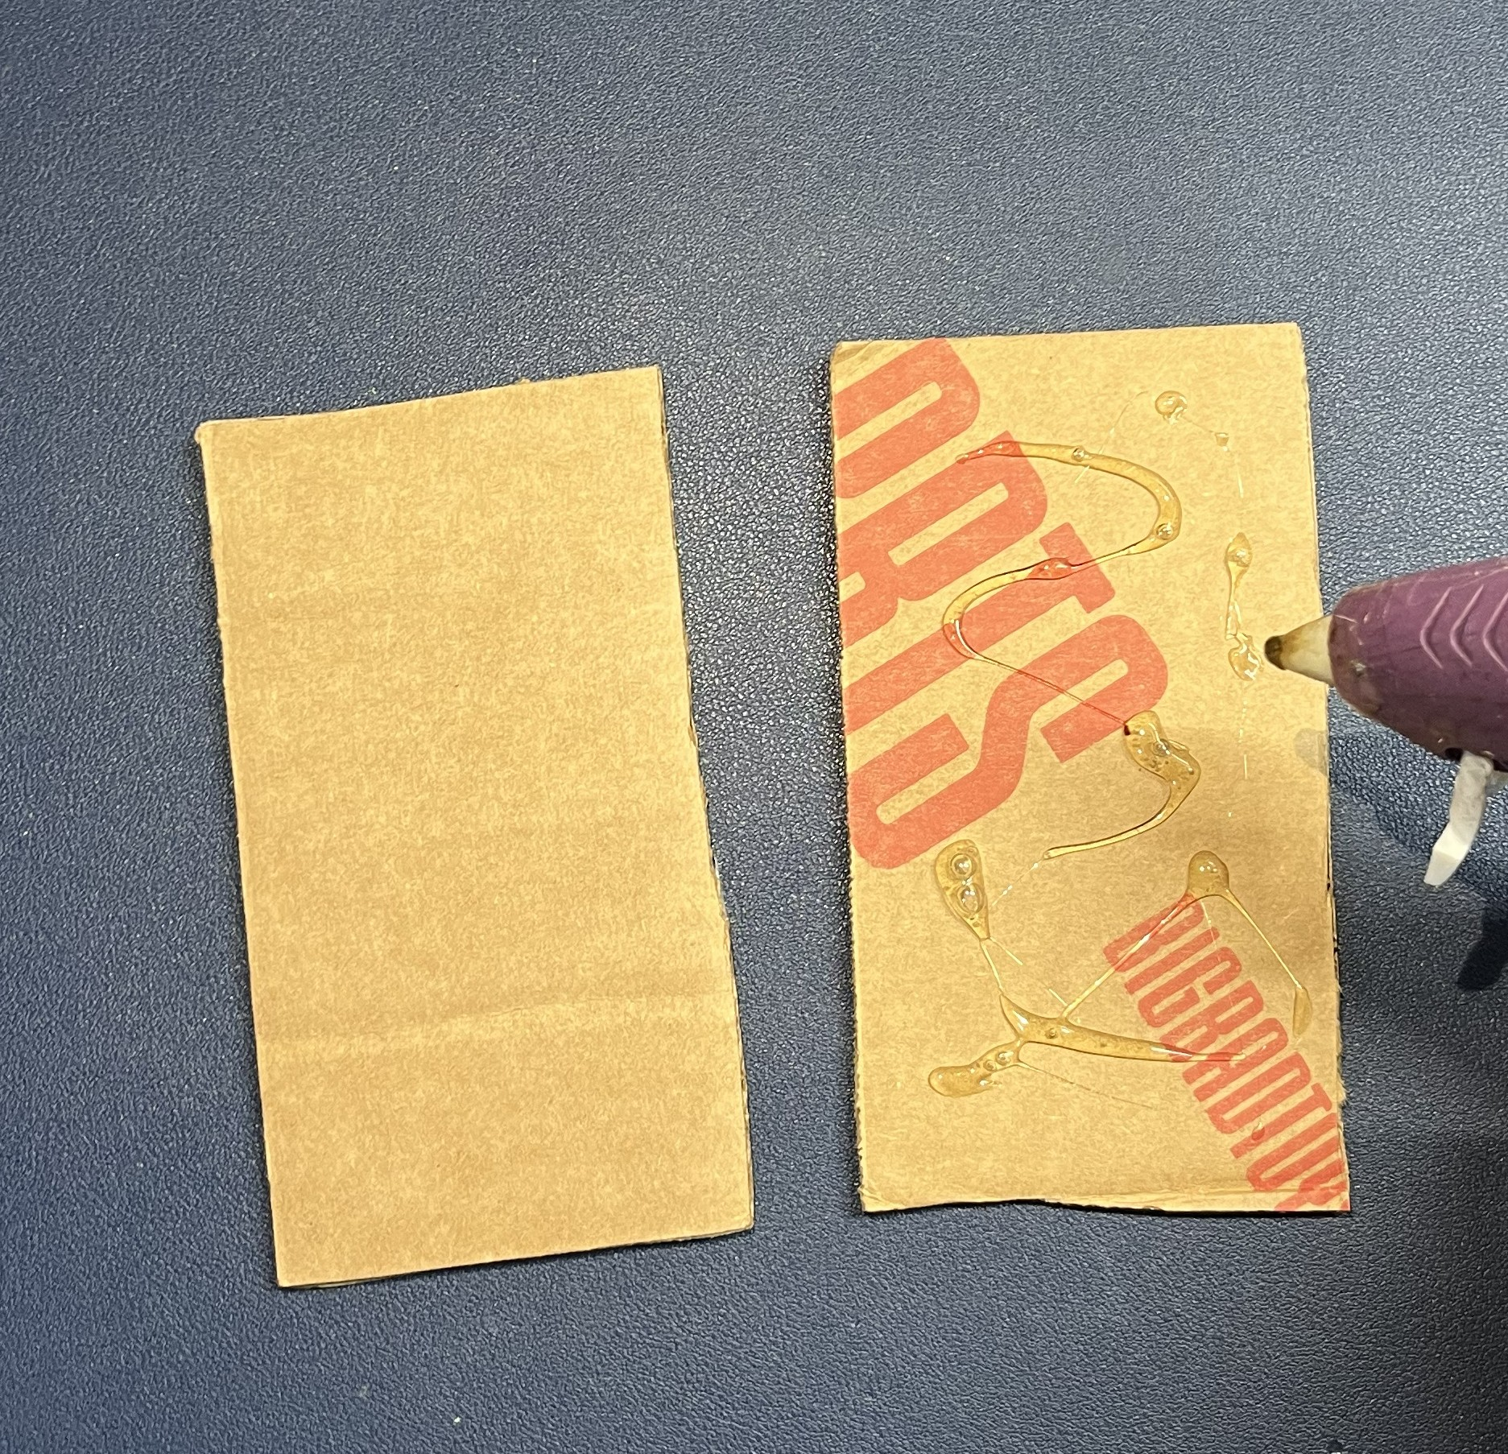
- Hot glue the two pieces together.

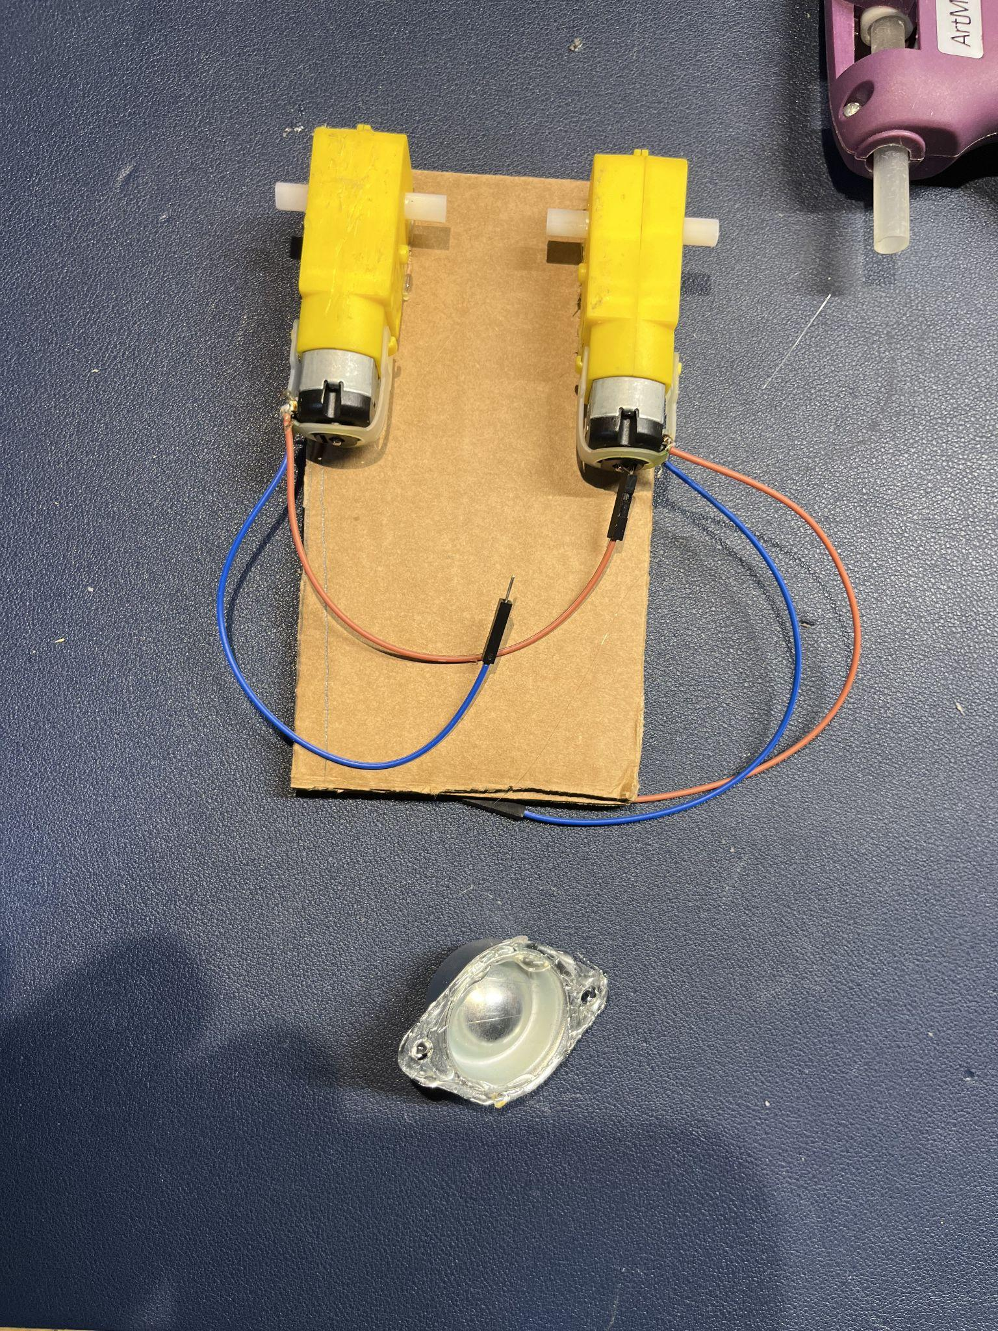
- Hot glue the Motors to the Cardboard.

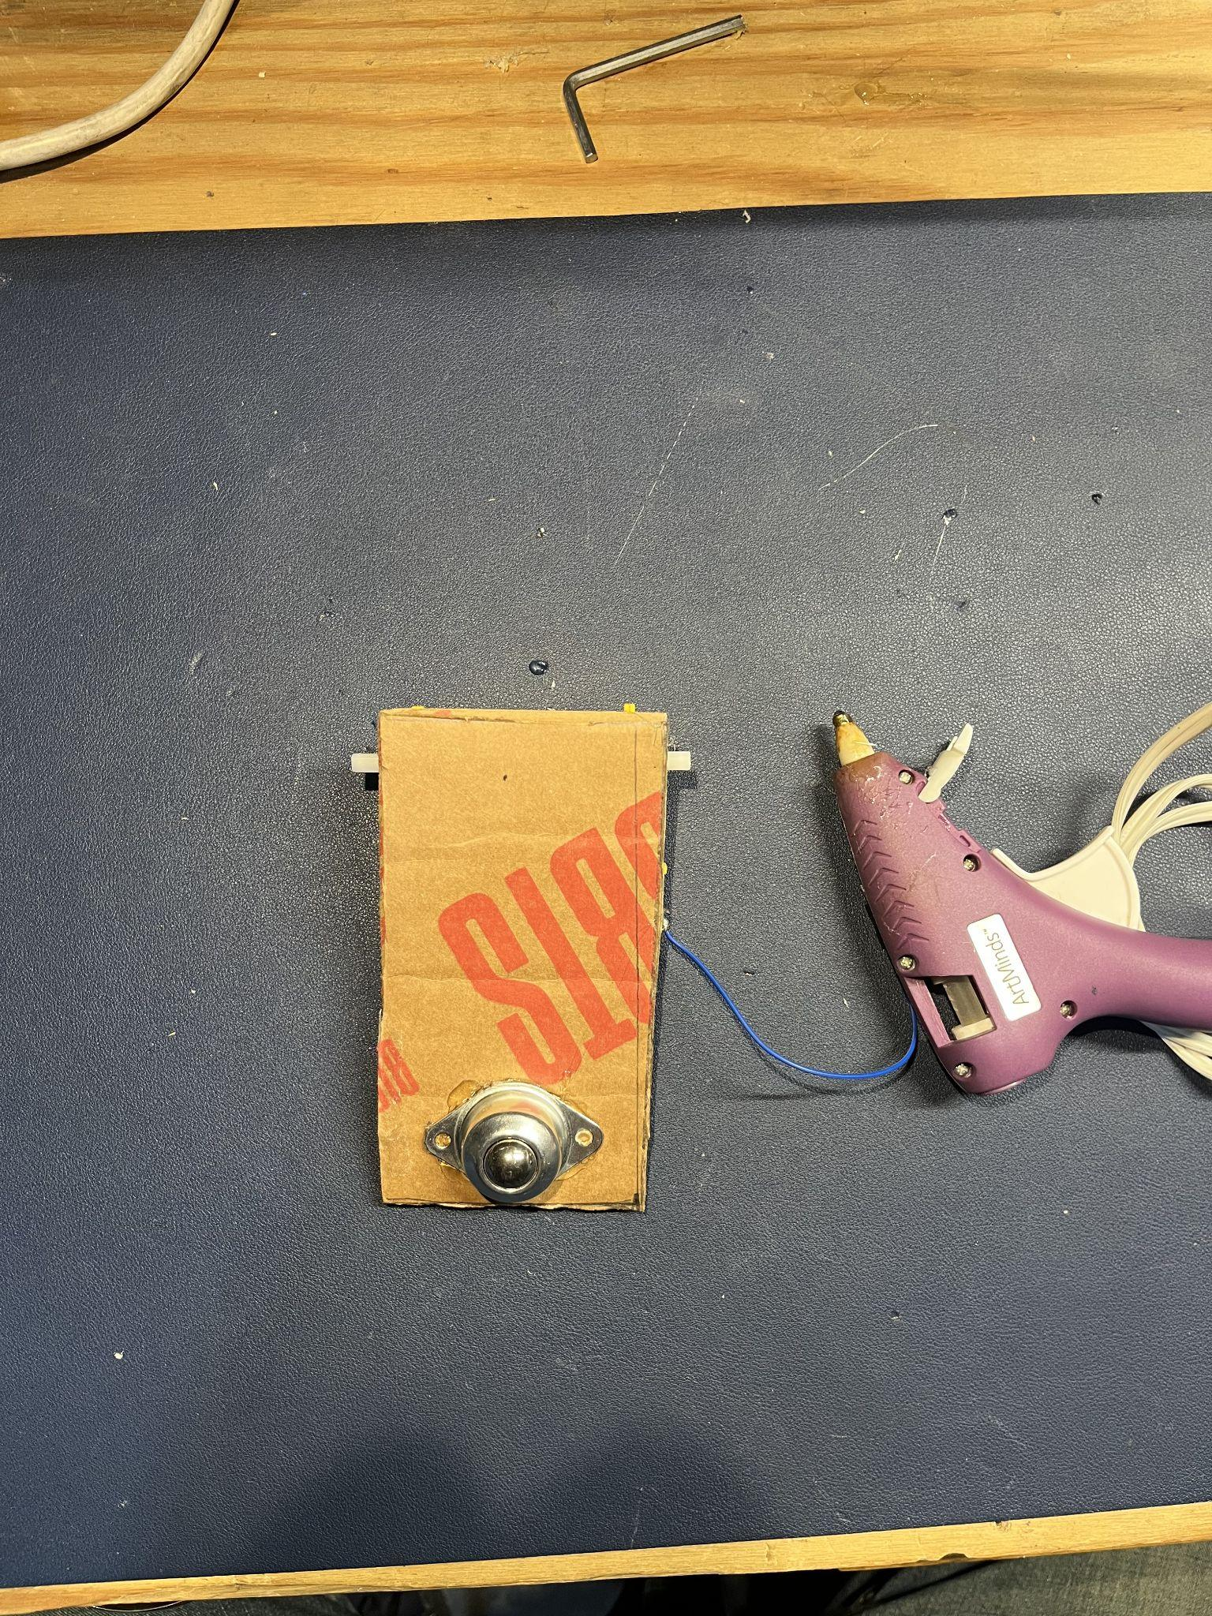
- Hot glue the roller ball bearing to the other side of the cardboard.

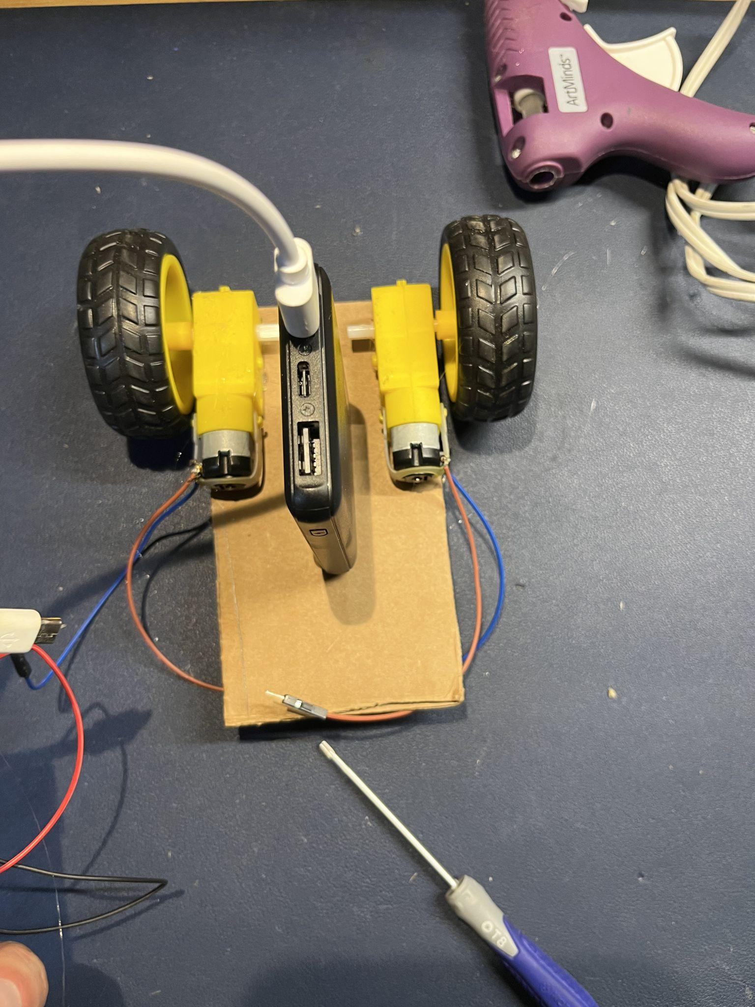
- Hot glue the USB Battery Bank to the cardboard.

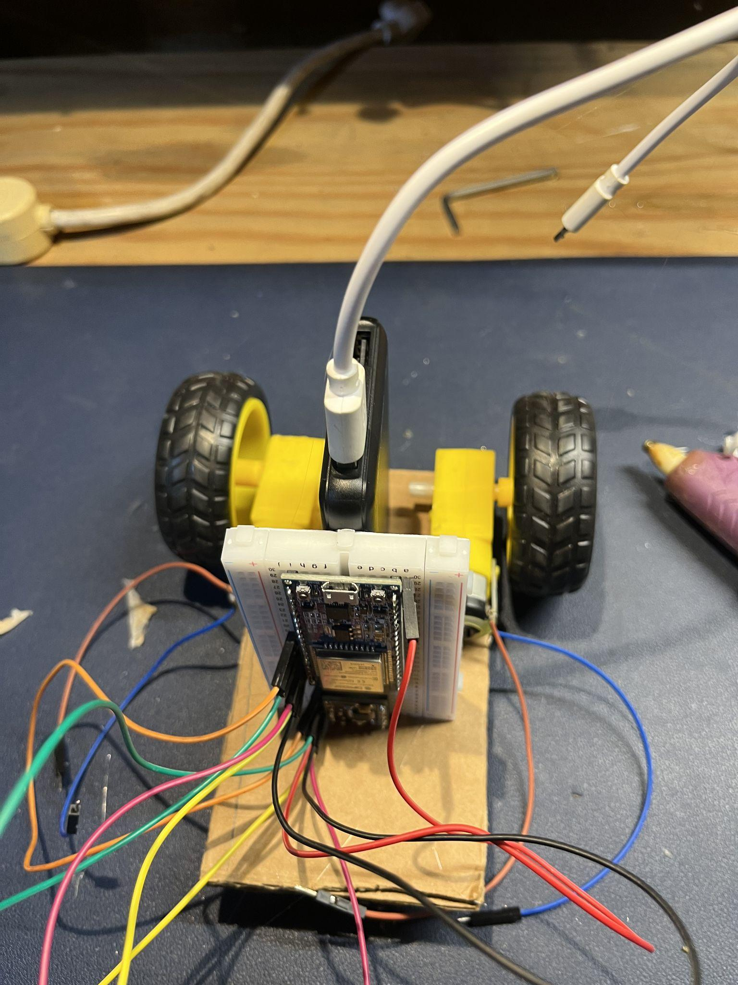
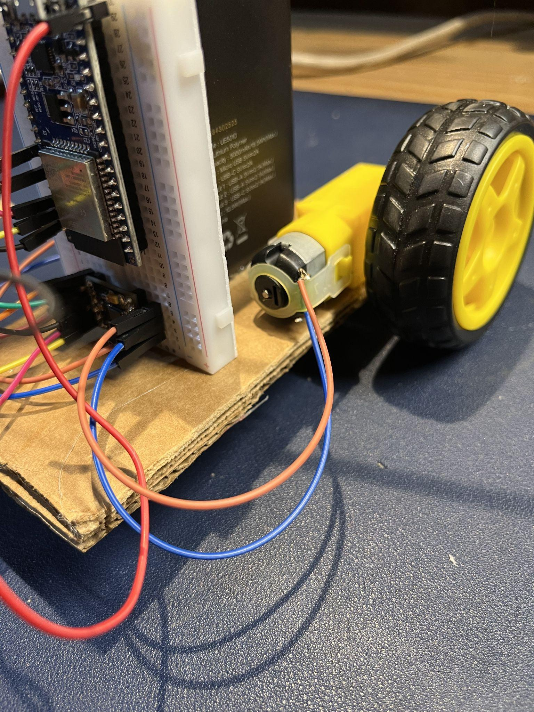
- Hot glue the Breadboard to the battery bank and the cardboard.

- Connect the motor wires to the breadboard as shown in the wiring diagram.

- Connect the ESP32 to a laptop using the USB cable.
- Open the DirtCheapRobot.ino file in the Arduino IDE
  - Create a folder called DirtCheapRobot
  - Copy the DirtCheapRobot.ino file into this folder
  - Open the DireCheapRobot.ino file in the Arduino IDE (File/Open)
- Prepare the Arduino IDE application.
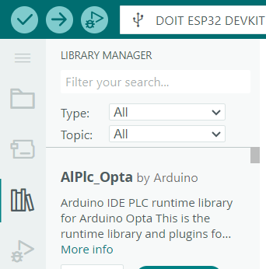
  - Install the bluepad32 library


    - Click the —--------------------------------------->

    - Select File/Preferences in the Arduino IDE

    - Click the  at the bottom right to open the “Additional Boards Manager URLs”
    - In the space below “Enter additional URLs, one for each row” paste “https://raw.githubusercontent.com/ricardoquesada/esp32-arduino-lib-builder/master/bluepad32_files/package_esp32_bluepad32_index.json” on a new line..
    - Click “Ok”
    - Click “Ok”
  - Select the correct ‘Comm Port’
    - Tools>
    - Comm: Port ?
    - Select the correct Comm Port from the list provided
Note: For additional help see:
Select board and port in Arduino IDE – Arduino Help Center
  - Select the correct ‘Board’
    - Tools>
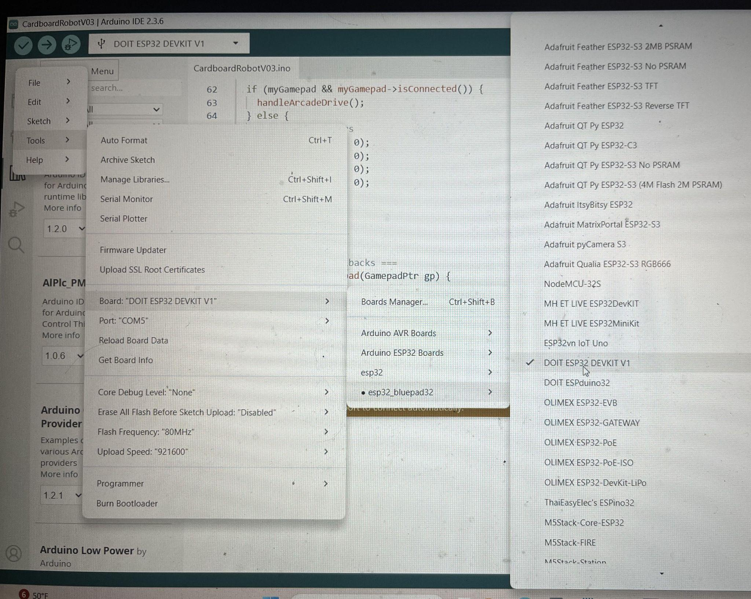
    - Board: ‘Current selected board’
    - esp32_bluepad32
    - Select “DO IT ESP32 DEVKIT V1”


- Compile and Load the DirtCheapRobot.ino file onto the ESP32.
  - Click the Upload button at the top right of the Arduino IDE.

  - The file should compile and load without errors.
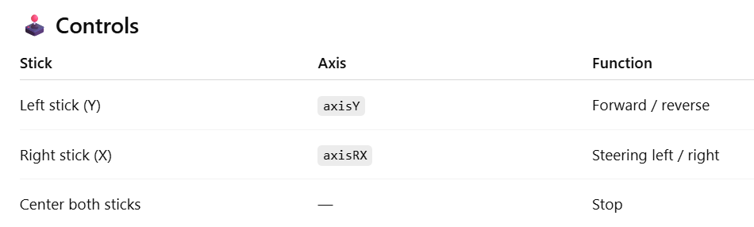
- Pair your Game Controller with the ESP32 - PS4
  - Push and Hold the Share Button and the PS4 Button
  - The light on the front will blink then go solid.
  - Release both buttons when the light goes solid
- Unplug the USB cable from the laptop and plug it into the Battery Bank. The Robot is ready to use.

