Scorpion 3.0 Electrical Engineering Test Plan
Developed in Ukarumpa PNG

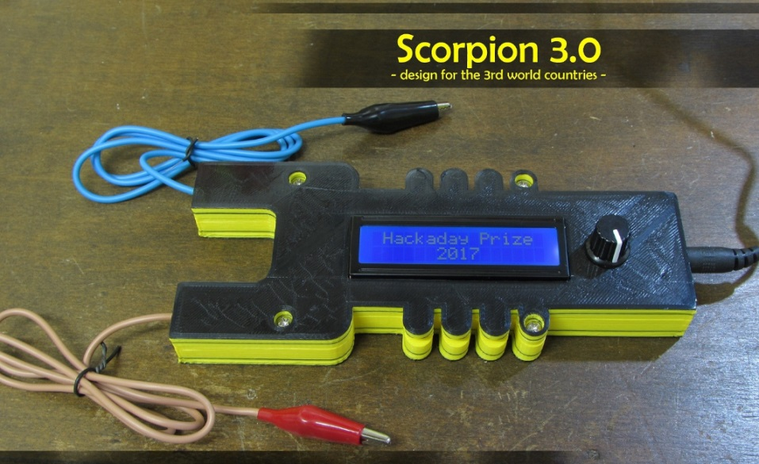

Test period Sept- Oct 2017

 | Name | Date
EE Design: | Marius Taciuc | Jul 2017
Prototype concept  and idea: | Marius Taciuc | Jun 2017
Case design: | Marius Taciuc | Aug 2017
Tested by: | Marius Taciuc | Oct 2017
Approved by:

Contents
Test result overview 3
Abbreviations and acronyms used in this document 4
Introduction 5
Technical specification of the Scorpion 3.0 based on the LM2596 IC 5
Sample information 5
Test equipment information 5
Defined functionality classes 6
Test setup description 7
Tests 10
Operating voltages 10
Real solar panel operation 10
Slow decrease/ increase voltage 11
Voltage reset behaviour 12
Reverse polarity connection 12
Overload output 13
Short circuit output 14
Intermittent output 15
Observations and final conclusions 16

Test result overview
Test description | Date tested | Result | Observations
Operating voltages
Real solar panel operation
Slow increase/ decrease voltage
Voltage reset behaviour
Reverse polarity connection
Overload output
Short circuit output
Intermittent output

Abbreviations and acronyms used in this document
Acronym | Description
DUT | Device under test
IC | Integrated circuit
EE | Electrical Engineering
Min | Minimum
Typ | Typical
Max | Maximum
MCU | Microcontroller Unit

Introduction
This test report has the purpose of ensuring proper functionality in different environmental situations. Testing the reliability of the product can provide in some cases, real and accurate information and feedback about the product quality. The goal is to have a product that the final user can actually rely on. The tests were conducted using calibrated equipment and meters. Testing procedures were conducted using the international ISO 16750-1 and ISO 16750-2 standards for automotive electronic modules.
Reasons for choosing the ISO 16750-1 and ISO 16750-2 international standards: Given the fact that the device operates in most of the cases along an AGM battery, these standards proved to be most reliable in mid-range complexity equipment with mid-range requirements. From the entire standard documentation, only the needed tests were chosen. The tests like Superimposed alternating voltages, Crank pulses or others, were left out because they don’t represent the actual environment and functionality of the Scorpion 3.0 module.

Technical specification of the Scorpion 3.0 based on the LM2596 IC
 | Min | Typ | Max | Unit | Comment
Operating voltage | 6 | 22 | 40 | V
Output voltage | 4.98 | 5 | 5.057 | V
Input current | - | - | 3 | A
Output current |  |  | 2.5 | A
Operating frequency |  | 150 |  | KHz
Shut down junction temperature |  |  | 125 | ⁰C
Maximum device temperature |  |  | 90 | ⁰C | For 10 min

Sample information
The tested samples are also called DUT in this test report and this refers to Device Under Test.
The sample number and information is described in the chart below:
Device name | Case color | Observations
DUT1 | Yellow/ black | -
DUT2 | Black | -

Test equipment information
Used equippment | Make | Model no | Observations
Variable bench power supply | GW | GPR-3060 | Held to maximum available current setting
Multimeter | Fluke | 87V | calibrated
Mobile phone real load (1) | Motorola | C139
Mobile phone real load (2) | Samsung | J1 | Android power management software
Fixed resistive load | - |  | Up to 50W
Solar panel |  |  | 15W

Defined functionality classes
According to ISO 16750-1
Class A | All functions of the device/system perform as designed during and after the test.
Class B | All functions of the device/system perform as designed during the test. However, one or more may go beyond the specified tolerance. All functions return automatically to within normal limits after the test. Memory functions shall remain Class A.
Class C | One or more functions of a device/system do not perform as designed during the test but return automatically to normal operation after the test.
Class D | One or more functions of a device/system do not perform as designed during the test and do not return to normal operation after the test until the device/system is reset by simple “operator/use” action.
Class E | One or more functions of a device/system do not perform as designed during and after the test and cannot be returned to proper operation without repairing or replacing the device/system.

Specific definition of functionality class that matches the design
Class A | All functions of the device/system perform as designed during and after the test.  No other behaviour of the mobile phone load than charging  All the Scorpion 3.0 functions remain within the normal operating conditions and parameters  The output voltage can vary with ±50mV outside the normal operating output voltages
Class B | All functions of the device/system perform as designed during the test. However, one or more may go beyond the specified tolerance. All functions return automatically to within normal limits after the test.  Output voltage might vary with maximum ±150mV, but the voltage should return to normal after the end of the test
Class C | One or more functions of a device/system do not perform as designed during the test but return automatically to normal operation after the test.  Output voltage might vary below -500mV but NOT above +150mV. The voltage should return to normal after the end of the test
Class D | One or more functions of a device/system do not perform as designed during the test and do not return to normal operation after the test until the device/system is reset by simple “operator/use” action.  (burned fuse on the voltage source)
Class E | One or more functions of a device/system do not perform as designed during and after the test and cannot be returned to proper operation without repairing or replacing the device/system.  (damaged unit, or damaged phone)

Test setup description
Test setup picture

Test setup and connection modes of the Scorpion 3.0
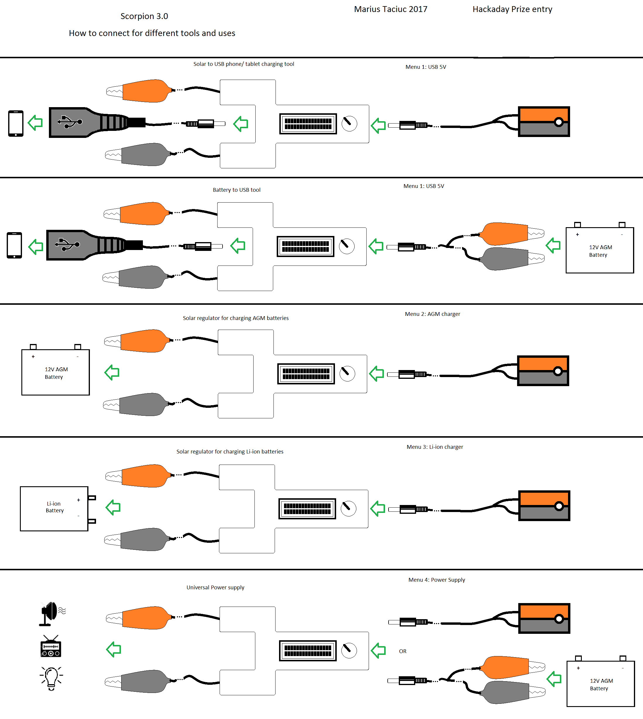

Block Schematic of the Scorpion 3.0
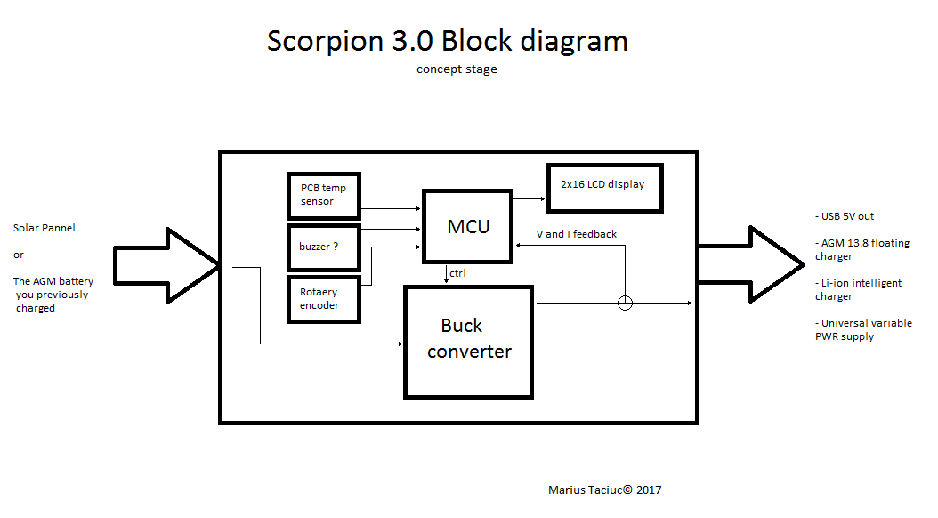

Overall picture of the Scorpion 3.0 module And inside PCB view
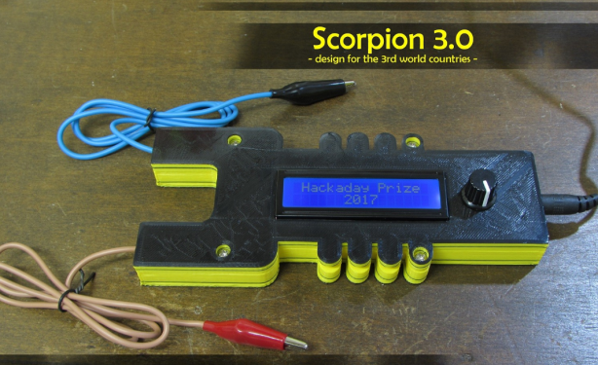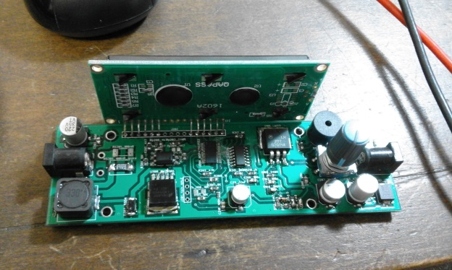
Note:
At the beginning of each functional test that has been listed in this document, a functionality test shall be performed to make sure that the DUT and the load performs according to the specifications.

Tests

Operating voltages
Test method:
Connect the DUT to the power supply for the following voltages and keep the DUT powered for 10min: 6.5V, 12V, 14V, 22.5V, 35V. Real phone should be used for this test.
Requirements:
The DUT and the phone shall remain class A
Test:
Unit | Time per voltage range | Functionality class at: |  |  |  |  | Result | Comment
 |  | 6.5V | 12V | 14V | 22.5V | 35V
DUT1 | 10 min
DUT2 | 10 min

Real solar panel operation
Test method:
Connect the DUT to the solar panel and keep the DUT powered for 30min. Real phone should be used for this test. The test shall be performed in full sun conditions and the shading of the solar panel shall be changed every 10min. In the last third part of the test, the solar panel shall be completely covered for 2 minutes and then fully exposed for 8 minutes.
Requirements:
The DUT shall be class C and the phone must remain Class A
Test:
Unit | Time operating | First  10min | Second  10min | Covered  2min | Full sun 8min | Result | Comment
DUT1
DUT2

Slow decrease/ increase voltage
Purpose
This test simulates a gradual discharge and recharge of the battery or the slow fading and dawning of the solar input power during normal daylight conditions.
Test method
Apply the following test simultaneously to all applicable inputs (connections) of the DUT.
Decrease the supply voltage from 22.5V to 2.5V V, then increase it from 2.5V to 22.5V, applying a change rate of (0,5 ± 0,1) V/min.
Requirement
The functional status inside the 7V - 22.5V interval shall be class A.
Outside these voltage ranges, the functional status of the DUT shall be minimum class C.
The phone (load) shall sustain no damage during this test and shall remain class A through-out the entire testing period.
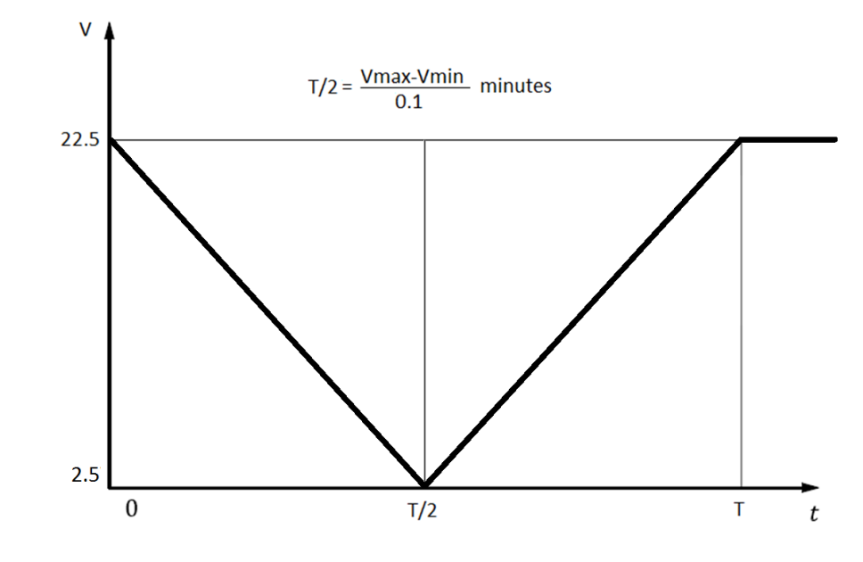
Test results

Unit | Result | Observations
DUT1
DUT2

Voltage reset behaviour

Reverse polarity connection
Purpose
This test checks the ability of a DUT to withstand against the connection of a reversed battery or input power source in case of using a custom solar panel connector or a reverse connected battery.

Test method
Set the power supply to the specified voltage of 22.5V and connect the DUT to the output of the power supply for the specified number of seconds. Repeat the same test with a real AGM battery
Requirement
Functional class of the DUT shall be A after proper reconnection and Functional class of the phone, shall remain A during the test and after the test.
Unit | Voltage (V) | Time (sec) | Functional class after reconnection | Test result | Observations
DUT1 | 22.5 | 60 |  |  | Power supply
 | 13 | 30 |  |  | Battery
DUT2 | 22.5 | 60 |  |  | Power supply
 | 13 | 30 |  |  | Battery

Overload output

Short circuit output
Purpose
These tests simulate short circuits to the inputs and outputs of a device.

Test method
Connect all outputs of the DUT in sequence for duration of 60 s ±10 % to +(VCC)
and to ground. All other outputs remain open.
Perform this test with 22.5V input and 13.7V output voltages and with respectively 13V input and 5V output. During the test, the load(resistor or respectively, mobile phone) must remain connected in parallel to the shorted output. Class and functionality of the load shall be also investigated

Requirements
The functional status shall be minimum class C as defined in ISO 16750-1.

DUT1 input voltage (V) | Output terminals shorted |  | Functional class | Result | Observations
13 | +VCC | GND
 | +VCC | +VCC
 | GND | +VCC
 | GND | GND
22.5 | +VCC | GND
 | +VCC | +VCC
 | GND | +VCC
 | GND | GND

DUT2 input voltage (V) | Output terminals shorted |  | Functional class | Result | Observations
13 | USB+5V | GND
 | USB+5V | USB+5V
 | GND | USB+5V
 | GND | GND
22.5 | USB+5V | GND
 | USB+5V | USB+5V
 | GND | USB+5V
 | GND | GND

Intermittent output

Observations and final conclusions

