Captain Lark Game

Name (ID) : Anand Mahadevan SS (2014A3PS172P)
Name (ID) : Haroon Faisal (2014A3PS242P)

ABSTRACT
Game story: The game which we plan to implement is basically a shooting game with multiple levels of different difficulties. The character is a lark. The Mystic Owl stole the lark’s eggs while the lark was out for a battle and kept it inside a castle. The lark has come to take the eggs back only to face obstacles to enter the castle. The lark’s movement is restricted to a wing flap. The player has to control the movement rhythmically so that the lark stays in the play area. Obstacles are basically walls with holes big enough for the lark to pass through, with different covers. The hard cover (solid line depiction) can be shot down, other is transparent (dotted line). However if the lark shoots more than two bullets into the transparent cover, it becomes part of the wall, and a hole appears randomly on the wall, making the movement difficult. Only movement possible is the wing flap to rise. With this the player has to control the character to pass through obstacles successfully. No. of points equals the no. of normal obstacles passed + 2x no. of transparent cover turned random obstacles. Three lives are present at the starting of the game. You lose a life when the lark falls down or hits the wall. You lose the game when you have no lives left. After every fifty obstacles, the difficulty level changes. For example the obstacles come faster, covers will switch their types etc… In the final level, lark has to fight the Mystic Owl.

ILLUSTRATION
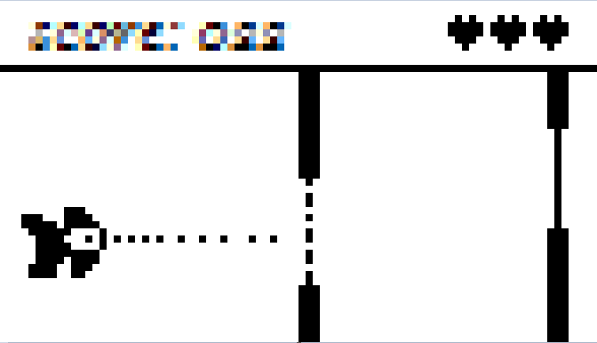
Above figure is a very crude drawing of the gameplay. The character shown is just a representation. The dotted line shows the transparent cover. Thick line is the permanent cover. Score and no. of lives are shown on top the screen.

HARDWARE IMPLEMENTATION
As of now, our plan is to implement this game using the LPC2148. For the display, the LCD 5110 screen or the 84x48 NOKIA LCD will be used.

